Contents
1. INTRODUCTION 3
1.1. Context 3
1.2. Main findings of the report 3
Cluster 2: Internal market 10
1.3. State of play of the accession negotiations 20
2. Cluster 1: The fundamentals of the accession process 21
2.1. Functioning of democratic institutions and public administration reform 21
2.1.1 Democracy 21
2.1.2. Public administration reform 24
2.2. Rule of law and fundamental rights 27
2.2.1. Chapter 23: Judiciary and fundamental rights 27
2.2.2. Chapter 24: Justice, freedom and security 41
2.3. Economic criteria 50
2.3.1. The existence of a functioning market economy 51
2.3.2. The capacity to cope with competitive pressure and market forces within the EU 56
2.4. Public procurement, statistics, financial control 58
Chapter 5: Public procurement 58
Chapter 18: Statistics 59
Chapter 32: Financial control 60
3. Good neighbourly relations and regional cooperation 61
4. Ability to assume the obligations of membership 62
Cluster 2: Internal market 62
Chapter 1: Free movement of goods 62
Chapter 2: Freedom of movement of workers 64
Chapter 3: Right of establishment and freedom to provide services 64
Chapter 4: Free movement of capital 65
Chapter 6: Company law 66
Chapter 7: Intellectual property law 66
Chapter 8: Competition policy 67
Chapter 9: Financial services 68
Chapter 28: Consumer and health protection 69
Cluster 3: Competitiveness and inclusive growth 70
Chapter 10: Digital transformation and media 70
Chapter 16: Taxation 71
Chapter 17: Economic and monetary policy 72
Chapter 19: Social policy and employment 73
Chapter 20: Enterprise and industrial policy 75
Chapter 25: Science and research 75
Chapter 26: Education and culture 76
Chapter 29: Customs union 78
Cluster 4: The green agenda and sustainable connectivity 79
Chapter 14: Transport policy 79
Chapter 15: Energy 80
Chapter 21: Trans-European networks 82
Chapter 27: Environment and climate change 83
Cluster 5: Resources, agriculture and cohesion 85
Chapter 11: Agriculture and rural development 85
Chapter 12: Food safety, veterinary and phytosanitary policy 86
Chapter 13: Fisheries and aquaculture 87
Chapter 22: Regional policy and coordination of structural instruments 88
Chapter 33: Financial and budgetary provisions 89
Cluster 6: External relations 90
Chapter 30: External relations 90
Chapter 31: Foreign, security and defence policy 91
Annex I – Relations between the EU and Albania 93
Annex II – Statistical data 96

1. INTRODUCTION

1.1. Context
Following the second intergovernmental conference of 15 October 2024, which opened accession negotiations on cluster 1 – fundamentals, four intergovernmental conferences were convened leading to the opening of negotiations on four clusters. Albania continued to implement the Stabilisation and Association Agreement, and the joint bodies under the agreement met.
The firm political commitment of the Albanian authorities to the strategic goal of EU integration has been consistently stated as the country’s key priority, and a high level of ambition to move forward in the accession negotiations has been generally maintained. The ongoing momentum in the accession negotiation process needs to lead to faster EU-related reforms. Albania maintained its record of full alignment with the EU’s common foreign and security policy, aligning with the EU position, including on restrictive measures and sanctions against Russia. Albania’s stance sends a strong signal of its strategic choice of EU accession and of its role as a reliable partner.
Albania has actively engaged and started delivering on the implementation of the new Growth Plan for the Western Balkans across the four pillars: (i) gradual integration with the EU single market; (ii) regional economic integration; (iii) fundamental reforms; and (iv) increased financial support. Under the Reform and Growth Facility (RGF), a performance-based EU instrument supporting the EU accession process, the country adopted its reform agenda, which covers reforms in the areas of: (i) business environment; (ii) human capital; (iii) digitalisation; (iv) energy and green transition; and (v) fundamental rights and the rule of law. After initial delays in setting up internal coordination structures, Albania appointed a RGF national coordinator and continued to work towards the reform agenda targets.
The Commission’s 2025 rule of law report covered Albania for the second time.

1.2. Main findings of the report
Cluster 1: The fundamentals of the accession process
Democracy
The overall framework allows for generally free and fair elections. The parliamentary elections held on 11 May 2025, which followed a partial electoral reform, resulted in a fourth consecutive term for the ruling party. The preliminary conclusions of the Organization for Security and Co-operation in Europe (OSCE) / Office for Democratic Institutions and Human Rights (ODIHR) election observation mission noted that elections were competitive and professionally conducted, but identified some shortcomings, including the lack of a level playing field and abuse of public resources. The partial electoral reform amended the Electoral Code but failed to address a number of longstanding recommendations from the OSCE/ODIHR and the Venice Commission. A comprehensive electoral reform is needed.
Parliament can exercise its powers in a partially effective way. Political polarisation, lack of genuine political dialogue and clashes between the ruling majority and parts of the opposition continued to affect Parliament’s activity, while public consultation processes remained limited. Parliament is also hampered by limited oversight over the executive, while the politicisation of parliamentary appointments to top positions in constitutional bodies or independent institutions established by law remains a serious issue. Concerns were noted regarding the work, methodology and impact of the ad hoc parliamentary committee on deepening reforms for good governance, rule of law and anti-corruption. Following the 11 May elections, the number of standing committees increased from eight to eleven, of which four are chaired by opposition.
The government continued to show its commitment to EU integration. Following the 11 May parliamentary elections, a new government took office in September 2025. The division of responsibilities between local and central government remains an issue
Albania’s bodies in charge of the EU integration process are in place. They successfully coordinated national positions, leading to the opening of negotiations on five of the six clusters during the reporting period. EU integration expertise, planning and interinstitutional mechanisms will need to be further strengthened to sustain Albania’s ambition to speed up the reforms required by the EU accession process. The EU integration process needs to be more inclusive, cross-party, and supported by effective consultation mechanisms. Communication efforts on EU integration should intensify.
Civil society organisations (CSOs) operate in a partly enabling environment. They face challenges regarding registration requirements and limited public funding, along with an increase in negative narratives and online smear campaigns.
Public administration reform
Albania remains moderately prepared in the area of public administration reform (PAR). It made some progress during the reporting period, resulting in the adoption of the new Intersectoral Strategy Against Corruption (ISAC) 2024–2030 and Medium-Term Revenue Strategy 2024–2027 in December 2024, and of the Cross-Cutting Strategy on Public Administration Reform 2025-2030 in July 2025. Amendments to the laws on civil service and on the organisation of state administration remain to be adopted, with the latter submitted for public consultation. The practice of budget revisions carried out through normative acts adopted by the executive continues. Clear political steer for the PAR agenda from the Minister of State for Public Administration and Anti-Corruption continued.
The Commission’s recommendations from last year were partially implemented and remain mostly valid. In the coming year, Albania should in particular:
- start implementing the new public administration strategy and review the effectiveness of the current monitoring structures; limit the use of normative acts for budget revisions and pursue a return to regular budget revision processes;
- adopt and implement a new legislative framework for the civil service, which includes revised rules on merit-based recruitment, promotion and dismissal in the civil service law at all levels, especially senior level, and begin automating the payroll system again;
- adopt and implement revised legislation properly regulating the typology and criteria to set up subordinated institutions and clarifying lines of accountability.

Chapter 23: Judiciary and fundamental rights
Albania is moderately prepared in the area of judiciary and fundamental rights and has made some progress during the reporting period.
Functioning of the judiciary
Albania is between having a moderate and a good level of preparation and has made some progress on the functioning of the judiciary. Albania continued implementing the justice reform. The vetting process for all judges and prosecutors was finalised in first instance, further strengthening judicial independence and accountability. Vetting procedures on appeal have increased in pace and are now on track to meet the constitutional deadline of June 2026. The High Judicial Council (HJC) has adopted by-laws enhancing its procedures and standards applicable to its members and to judges. The High Prosecutorial Council (HPC) has also enhanced standards applicable to magistrates. The HJC has proceeded with new appointments of magistrates, contributing to a reduction of vacancies at first instance level. Challenges in the appointments of non-magistrate members of the HJC and HPC, and in conducting timely and qualitative evaluations, appointments, promotions, and transfers of magistrates remained. While the resilience of the judiciary has improved overall, increased attempts by public officials or politicians to exert undue interference and pressure on the judicial system remained an issue of serious concern. A new Cross-Sector Justice Strategy for 2024-2030 was adopted. Sufficient budget was allocated to develop a modern, integrated, electronic case management system, but full establishment is currently foreseen only for 2030. Pressing issues on judicial efficiency, quality and integrity still need to be addressed, in line with the best European standards and practices.
Sustained reform efforts are needed to continue to strengthen the judicial system and maintain high standards of integrity after the completion of the vetting process. The Commission’s recommendations from last year were partially implemented and therefore remain largely valid. In the coming year, Albania should in particular:
- further strengthen accountability by: (i) finalising the vetting process; (ii) enhancing asset and background assessment standards, ensuring high-quality and speeding-up evaluation reports for all magistrates; (iii) aligning rules applicable to all non-magistrates of the HJC and HPC with those applicable to magistrates, as regards asset declaration and background checks; (iv) filling the magistrate-inspector vacancies at the High Justice Inspectorate, and (v) reducing political interference on the judiciary and prosecution services;
- improve the quality of justice by: (i) filling vacancies for court chairs, magistrates, legal advisers and court staff at all levels of the judiciary and increasing the total number of magistrates and legal advisers at all levels, towards the EU average; (ii) comprehensively revising the School of Magistrates’ entrance exam and initial and continuous training curricula; and (iii) increasing the quality and integrity of the School of Magistrates’ staff;
- improve judicial efficiency by: (i) adopting comprehensive legal and regulatory measures to increase efficiency at all levels, and to further reduce backlog, in line with the Roadmap for Judicial Efficiency, the principles of justice reform and European standards; (ii) finalising the procurement for and first piloting of the integrated case management system modules and (iii) expanding the online notification system for access to court files and processes to all courts of general jurisdiction.
Fight against corruption
Albania is moderately prepared and has shown some progress. The Anti-Corruption Strategy for 2024-2030 has been adopted. The Specialised Structure Against Organised Crime and Corruption (SPAK) further consolidated its positive results in fighting high-level corruption and made tangible progress towards a solid track record in the fight against corruption. However, corruption remained widespread across vulnerable sectors, affecting both the public and private spheres. The institutional framework for prevention of corruption continued to have a limited impact and coordination with law enforcement remained weak. Shortcomings regarding transparency and effectiveness of asset declaration checks still need to be addressed.
The Commission’s recommendations from last year were partially implemented and therefore remain largely valid. In the coming year, Albania should in particular:
- continue to strengthen the investigation, prosecution and adjudication of corruption cases and secure more final convictions, in particular at high-level, including the seizure and final confiscation of criminal assets resulting from corruption-related offences, and increase proactive referrals by relevant state institutions and law enforcement agencies to SPAK;
- complete and simplify legislation on preventing corruption in line with European standards, and address the remaining recommendations of the Council of Europe’s Group of States against Corruption (GRECO); conduct in-depth risk assessments in vulnerable sectors, implement effectively integrity plans at corruption-prone institutions, such as the State Cadastre Agency, and increase the capacity of the General Directorate on Anti-Corruption (GDAC);
- make asset declaration checks by the High Inspectorate of Declaration and Audit of Assets and Conflicts of Interest (HIDAACI) more effective and transparent by updating procedures and ensuring sufficient resources, addressing undeclared or concealed assets and by ensuring that asset declarations of politically exposed persons are publicly available online.
Fundamental rights
Albania’s legal framework sets out a generally good basis for the protection of fundamental rights. Significant achievement was made during the reporting period with the adoption of a new Law on personal data protection and seven of its ten accompanying pieces of implementing legislation, in full alignment with the EU acquis, as well as the adoption of implementing legislation on the rights to persons belonging to national minorities, in the core areas of self-identification and the use of minority languages, consistent with European standards. The enjoyment of media freedom and pluralism, of the right to property and of the rights of persons belonging to minorities remain problematic. Implementation efforts need to intensify overall.
The Commission’s recommendations from last year were only partially implemented and remain mostly valid. In the coming year, Albania should in particular:
- ensure effective implementation of the legal framework on the rights of persons belonging to minorities and increase the capacity and resources of the State Committee on National Minorities and of local authorities;
- expand the enjoyment of the right to property and legal certainty by: (i) making progress on first registrations; (ii) digitising ownership titles, documents, and maps; (iii) improving the quality and accuracy of cadastral data; (iv) enhancing integrity, transparency, and effectiveness in delivering public services at the State Cadastre Agency; and (v) advancing on compensations and guaranteeing the right to a fair trial in cases of expropriation and removal of properties;
- further align with and implement the EU acquis on equality and non-discrimination including as regards sexual orientation and gender expression, ensure that the upcoming Law on gender equality maintains a high level of ambition in line with EU standards, and demonstrate good implementation capacity of the new Law on personal data protection, implement effectively the National Agenda on Child Rights and complete the deinstitutionalisation of children.
Freedom of expression
Albania is between having some and a moderate level of preparation in the area of freedom of expression and made limited progress during the reporting period. The situation remains largely unchanged, with media independence and pluralism continuing to be affected by the overlap of business and political interests, the lack of transparency of financing sources, the high concentration of media ownership, intimidation and precarious working conditions for journalists. The launch of a structured dialogue between Albanian institutions and media actors as well as the adoption of soft measures on journalise safety were positive developments. Concerns were raised, however, regarding the legality and due process observed during the eviction by the authorities of a media outlet from the public-owned offices it occupied.
The Commission’s recommendations from last year were not implemented and remain valid. In the coming year, Albania should in particular:
- adopt a major reform of the legal and regulatory framework to: (i) strengthen transparency of media ownership, media plurality and editorial independence; (ii) strengthen transparency of media financing from private and state resources; (iii) strengthen the autonomy of the media regulator and the independence of the state broadcaster; (iv) fully repeal criminal provisions on insult and defamation; and (v) align civil aspects of defamation with European standards;
- ensure zero tolerance for intimidation and effective enforcement in cases of attacks against journalists, including judicial follow-up; ensure increased capacities of law enforcement bodies to handle cases of violence, including on the margins of protests, and other criminal cases involving journalists, notably by ensuring high human rights compliance in handling incidents involving journalists, through binding instructions, data collection and capacity building measures;
- improve Albanian journalists’ working conditions, in particular by strengthening the protection of journalists’ employment and social rights and ensuring that the Labour Code is applied consistently.
Chapter 24: Justice, freedom and security
Albania is moderately prepared in aligning with the EU acquis in the area of justice, freedom and security and has made good progress in this area. The capacity and effectiveness of the Specialised Structure Against Organised Crime and Corruption (SPAK) to disrupt organised crime groups increased and the use of financial investigations improved. Although their full functionality still needs to be demonstrated, an asset recovery office and a national early warning system on the detection of new psychoactive substances were set up within the Albanian State Police. A national drugs observatory has been established within the Ministry of Health, though it is still to become operational. Albania continued to implement its migration strategy, which is aligned with EU priorities. Further efforts are needed to improve access to asylum and to align the country’s visa policy with the EU’s.
The Commission’s recommendations from last year were partially implemented and remain valid to a significant extent. In the coming year, Albania should in particular:
- further develop the systematic use of financial investigations when dealing with serious and organised crime, including illicit trafficking, terrorism and money laundering;
- operationalise the national drugs observatory and increase the functioning and output of the national early warning system on the detection of new psychoactive substances, including by strengthening cooperation with the EU Drugs Agency;
- improve the asylum referral system and access to asylum procedures, continue to address the issue of unfounded asylum applications of Albanian nationals in Schengen and associated countries, ensure that legal pathways developed for third-country nationals in Albania prevent irregular secondary movements to the EU, and further align the country’s visa policy with the EU list of visa-required third countries.
Fight against serious and organised crime
Albania is moderately prepared in the fight against organised crime. Good progress was made in meeting last year’s recommendations by increasing SPAK’s capacity in financial investigations, strengthening the fight against money laundering and seizing assets linked to organised crime. SPAK has also further consolidated cooperation with its international counterparts, in particular with EU Member States and EU agencies, to investigate and crack down on high-risk criminal groups with initial tangible results. Albania needs to speed up work on aligning its legal framework on organised crime with the EU acquis, strengthen law enforcement capacity and improve the efficiency of investigations, including through the development of criminal and financial analysis capabilities.
The Commission’s recommendations from last year were partially implemented and remain largely valid. In the coming year, Albania should in particular:
- continue to strengthen its track record of investigations, prosecutions and final convictions in all fields of serious and organised crime, including drug trafficking, money laundering and terrorist financing through continued cooperation with EU Member States and EU agencies, and by increasing capacity to deter organised crime and ensuring further alignment with the EU acquis, notably on the criminalisation of money laundering and combating child sexual abuse and exploitation online and offline;
- improve the efficiency of the asset recovery system, by strengthening the functioning of the asset recovery office responsible for identifying and tracing criminal assets within the Albanian state police, notably its operational cooperation with asset recovery offices in EU Member States, by improving the implementation of instruments to confiscate proceeds of crime and property derived from criminal activities, and by better managing frozen and confiscated property also for social reuse;
- improve criminal and financial analysis capacity, including through reinforced inter-agency cooperation and methodologies to tackle complex criminal cases.
Economic criteria
The existence of a functioning market economy
Albania has a good level of preparation in developing a functioning market economy and made some progress in this area. The economy maintained a strong growth momentum in 2024 thanks to robust domestic demand and tourism. Inflation fell below the central bank’s target while fiscal consolidation accelerated, and the public debt ratio continued to decline. Despite increases, government revenue as a share of GDP remains low, while spending on public investment is repeatedly under-executed. The labour market situation improved, but structural problems persist. The banking sector remained stable, well capitalised and liquid, while lending to the private sector increased. The business environment remains affected by a weak rule of law, limited access to finance, and shortcomings in the oversight and governance of state-owned enterprises.
The Commission’s recommendations from last year were partly addressed and remain largely valid. In the coming year, Albania should in particular:
- implement the Medium-Term Revenue Strategy and prepare proposals to reduce tax expenditure, prioritising the elimination of exemptions lacking sound policy justification;
- increase the transparency and accountability of state-owned enterprises, including by publishing their annual financial performance reports;
- enhance the operationalisation of the public investment management framework, including the National Single Project Pipeline, and ensure that the projects entering the Medium-Term Budget Programme are mature and of good quality, in order to avoid the under-execution of public investments.
The capacity to cope with competitive pressure and market forces within the EU
Albania has some level of preparation to cope with competitive pressure and market forces within the EU and made limited progress in this area. The education system still faces numerous challenges, skills gaps persist, and the youth not in education, employment or training (NEET) rate remains a concern. Transport and digital infrastructure improved, but infrastructure gaps remain. Albania remains competitive as a tourism destination, offering an expanding scope of services, but industry and agriculture remain low-productivity sectors that have been contracting. Manufacturing exports fell due to weak demand, exchange rate appreciation, and businesses’ low pricing power.
The Commission’s recommendations from last year were partially implemented and remain mostly valid. In the coming year, Albania should in particular:
- continue to improve and better promote the vocational education and training (VET) system in order to increase the number of graduates from VET schools and ensure that labour skills align with job market demands;
- improve the quality and inclusiveness of the education system and advance its digital transformation;
- strengthen infrastructure, including building cyber-resilience.
Chapter 5: Public procurement
Albania is moderately prepared in public procurement. Limited progress was made in the alignment of the legal framework for public procurement.
The Commission’s recommendations from last year were partially implemented and remain mostly valid. In the coming year, Albania should, in particular:
- continue efforts to improve competitive procurement procedures;
- further align the legislative framework with the EU acquis in the area of concessions and public-private partnerships, and start work on further alignment with the EU acquis in the field of defence and security procurement;
- ensure compliance with the EU acquis and the Stabilisation and Association Agreement (SAA) on intergovernmental agreements concluded with third countries in the area of public procurement.
Chapter 18: Statistics
Albania is moderately prepared in the area of statistics. Some progress was made in improving the compilation of macroeconomic statistics in line with the European System of National and Regional Accounts (ESA 2010), the publication of the detailed data of the 2023 population and housing census, and by continuing to improve data transmission to Eurostat.
The Commission’s recommendations from last year were partially implemented and remain largely valid. In the coming year, Albania should in particular:
- continue increasing the production and dissemination of timely and high-quality data and make government finance statistics (GFS) data publicly available;
- prepare the 2026 agricultural census in line with the relevant EU acquis;
- ensure adequate staffing at the Institute for Statistics (INSTAT).
Chapter 32: Financial control
Albania is moderately prepared in the area of financial control and partially aligned with the EU acquis. Despite the adoption of the anti-fraud strategy, limited progress was made in this chapter during the reporting period.
The Commission’s recommendations from last year were partially implemented and remain mostly valid. In the coming year, Albania should in particular:
- focus on delegating more financial and management responsibilities to improve managerial accountability;
- build on the initial work of the parliamentary subcommittee on audit, with a particular focus on ensuring oversight of the executive’s implementation of audit recommendations;
- strengthen controls and consolidate capacities to protect EU financial interests, ensure appropriate reporting of irregularities, and implement the anti-fraud strategy.

Cluster 2: Internal market
Chapter 1: Free movement of goods
Albania is between having some and a moderate level of preparation in the area of free movement of goods. No progress on alignment with the EU acquis was achieved in the reporting period.
The Commission’s recommendations from last year were not implemented and remain valid. In the coming year, Albania should in particular:
- complete the alignment of its legislation with the relevant EU acquis on quality infrastructure, i.e. on accreditation, conformity assessment and market surveillance;
- significantly strengthen the enforcement capacity of the market surveillance inspectorate;
- finalise and adopt an action plan to comply with Articles 34-36 of the Treaty on the Functioning of the European Union (TFEU), fully covering the non-harmonised area, with a timeframe for screening all legislation and practices, and introducing mutual recognition clauses or repealing and/or amending legislation and practices as necessary.
Chapter 2: Freedom of movement for workers
Albania is between having some and a moderate level of preparation in the freedom of movement for workers. Some progress was achieved by concluding bilateral social security agreements with EU Member States and further advancing the preparations to connect Albania’s employment services system to the European network of employment services (EURES).
The Commission’s recommendations from last year were partially implemented and remain mostly valid. In the coming year, Albania should in particular:
- continue developing the employment services IT system to enable its connection to EURES upon accession;
- strengthen the enforcement of the Law on foreigners as per the National Migration Strategy 2024-2026;
- continue negotiating and concluding new bilateral agreements on social security, notably with EU Member States, and develop IT infrastructure for European Health Insurance Card (EHIC) and Electronic Exchange of Social Security Information (EESSI) purposes, as well as administrative capacities for joining the EESSI network.
Chapter 3: Right of establishment and freedom to provide services
Albania is moderately prepared in the right of establishment and freedom to provide services. No progress was achieved in the reporting period.
The Commission’s recommendations from last year were not implemented and remain valid. In the coming year, Albania should in particular:
- start amending the legislation to address the barriers to the freedom of establishment and free movement of services identified in the 2023 self-screening exercise;
- continue efforts to align its legislation with the EU acquis and ensure appropriate institutional capacity in the area of mutual recognition of professional qualifications.
Chapter 4: Free movement of capital
Albania is between a moderate and good level of preparation in the area of free movement of capital. Some progress was made towards closer alignment with the EU acquis on payments, which enabled Albania to join the geographical scope of the Single Euro Payments Area (SEPA) schemes in November 2024, which became effective in October 2025. Albania has continued its action against money laundering, in particular with the adoption of the National Strategy on the Fight Against Money Laundering and Terrorist Financing 2024-2030.
The Commission’s recommendations from last year were partially implemented and remain mostly valid. In the coming year, Albania should in particular:
- ensure equal treatment of EU citizens and Albanian citizens on the acquisition of land, in line with Albania’s obligation under the SAA;
- take action to ensure that the provisions of the EU acquis on the cross-border regulation, the SEPA regulation, the Instant Payment Regulation and interchange fees are implemented;
- continue to implement the 2024-2030 Anti-Money Laundering and Terrorism Financing Strategy and National Risk Assessment Action Plan 2024-2027.
Chapter 6: Company law
Albania is moderately prepared in the field of company law. Limited progress was made in the reporting period through the adoption of the Law on auditing and accounting, aimed to further align with the EU acquis.
The Commission’s recommendations from last year were partially implemented and remain mostly valid. In the coming year, Albania should in particular:
- make progress in aligning with the EU acquis, including by introducing amendments on the use of digital tools, cross-border conversions, mergers and divisions, and on encouraging long-term shareholder engagement;
- continue to implement the amended Law on auditing and continue efforts to further align the legal framework for accounting and audit with the latest EU acquis in these areas.
Chapter 7: Intellectual property law
Albania is moderately prepared in the area of intellectual property rights (IPR). Some progress was made with the adoption of the new laws on trademarks and patents. The new draft law on copyright was prepared and submitted for consultation and approval.
The Commission’s recommendations from last year were partially implemented and remain mostly valid. In the coming year, Albania should in particular:
- ensure alignment with the relevant EU acquis on IPR, and start to implement the new laws on copyright, trademarks and patents;
- continue to improve the functioning of CMOs, especially in terms of enforcement and collection of royalties and payments to rights holders;
- strengthen the enforcement of all aspects of the IPR system through monitoring, budgeting, increased awareness, strengthened institutional capacity and training.
Chapter 8: Competition policy
Albania is between having some and a moderate level of preparation in competition policy. There was limited progress during the reporting period, including on legislative alignment with the EU acquis in the area of case referrals in relation to concentrations.
The Commission’s recommendations from last year were implemented only to a limited extent and remain valid. In the coming year, Albania should in particular:
- ensure the operational independence of the State Appeal Commission (SAC) and significantly increase the administrative capacity of the SAC’s secretariat;
- further align the legislative framework in the area of State aid with the EU acquis;
- step up efforts to raise awareness among the judiciary, line ministries and regional and local authorities of competition law and State aid rules, to ensure that the SAC is notified in advance of aid measures and to strengthen the enforcement of competition rules and State aid rules.
Chapter 9: Financial services
Albania is between a moderate and a good level of preparation in the area of financial services. Some progress was made in further aligning the country’s legislation with the EU acquis on private pension funds.
The Commission’s recommendations from last year were partially implemented and remain mostly valid. In the coming year, Albania should in particular:
- continue working towards fully aligning Albania’s banking regulation with the amended versions of the Capital Requirements Directive (CRD)/Regulation (CRR), the Bank Recovery and Resolution Directive (BRRD), and the Deposit Guarantee Schemes Directive (DGS) and the EU acquis on capital markets, including securities markets, investment funds and financial market infrastructures;
- complete alignment with the EU acquis on insurance, including the Solvency II Directive;
- ensure that the Albanian National Development Bank is well regulated and supervised, including its deposit-taking activities.
Chapter 28: Consumer and health protection
Preparations are at an early stage in the area of consumer and health protection. There was no progress on alignment with the EU acquis in this area.
The Commission’s recommendations from last year were not implemented and remain valid. In the coming year, Albania should in particular:
- make progress on aligning consumer law with the latest EU acquis to address developments in this area;
- complete alignment with the EU acquis on medicinal products for human and veterinary use, medical devices and on tobacco control;
- increase the financial and human resources in the health sector, specifically in primary healthcare and all-hazard health emergency preparedness, and guarantee equal access to quality health services for vulnerable populations, in particular women and girls who belong to these groups.

Cluster 3: Competitiveness and inclusive growth
Chapter 10: Digital transformation and media
Albania is between a moderate and a good level of preparation in the field of digital transformation and media and made limited progress during the reporting period. The current Law on cybersecurity enabled further alignment with the EU Directive on measures for a high common level of cybersecurity across the Union (NIS 2 Directive). In June 2025, Albania adopted an updated list of Critical and Important Information Infrastructure Operators. The new Cybersecurity Strategy 2025-2030 and its Action Plan for 2025-2027 have been adopted.
The Commission’s recommendations from last year were partially implemented and remain largely valid. In the coming year, Albania should in particular
- adopt the decision to extend the roll-out of the 112 emergency number to the whole country;
- finalise the implementing legislation for the Law on electronic communications and the Law on cybersecurity;
- improve access to the use of e-services, build this capacity and step up the collection of statistical data on digital performance and digital competitiveness as per the Digital Economy and Society Index.
Chapter 16: Taxation
Albania is moderately prepared in the area of taxation. Some progress was made in the reporting period, mainly through the adoption of the Medium-Term Revenue Strategy and the report on evaluation of tax exemptions, paving the way for improved tax policy measures and reform in the next years.
The Commission’s recommendations from last year were partially implemented and remain mostly valid. In the coming year, Albania should in particular:
- reduce the number of tax exemptions in line with the adopted Medium-Term Revenue Strategy, and pursue the gradual alignment of VAT and excise duties legislation with the EU acquis;
- simplify the taxation system to further encourage tax compliance, and further improve the use of third-party data in the fight against tax fraud and evasion;
- continue preparations towards achieving interconnection and interoperability with the common EU taxation IT systems.
Chapter 17: Economic and monetary policy
Albania is between a moderate and a good level of preparation in the area of economic and monetary policy and made some progress as the Bank of Albania maintained price stability. Albania continued its fiscal consolidation and complied with the fiscal rule.
The Commission’s recommendations from last year were partially implemented and remain mostly valid. In the coming year, Albania should, in particular:
- fully align the Law on the Bank of Albania with the EU acquis;
- adopt the law to establish an independent fiscal institution;
- align Albania’s budget legislation and practices with the requirements of the EU acquis.
Chapter 19: Social policy and employment
Albania is moderately prepared in the area of social policy and employment and made limited progress during the reporting period. No measures are in place to set up and implement an indexation mechanism for the benefits of economic aid. More work is needed on advancing legislative alignment with the EU Labour Law and occupational health and safety acquis, and with EU acquis in the area of non-discrimination and equality, including gender equality.
The Commission’s recommendations from last year were partially implemented and remain mostly valid. In the coming year, Albania should:
- set up the Interministerial Council of Occupational Health and Safety and its secretariat, including drafting the respective sets of rules/procedures and building the capacity of its members, increase and strengthen cross-sectoral coordination, and boost municipal capacity and staffing;
- roll out the Youth Guarantee and its Implementation Plan to more regions, taking the lessons learned from its pilot phase into account;
- further increase budget allocation, social services provision and monitoring of the Social Fund, strengthen the capacity of local governments to secure sufficient funding, and develop a coordinated social service referral system, consistently implemented at local level.
Chapter 20: Enterprise and industrial policy
Albania is between a moderate and a good level of preparation in the area of enterprise and industrial policy and made some progress, in particular through revising the Business and Investment Development Strategy (BIDS).
The Commission’s recommendations from last year were partially implemented and remain mostly valid. In the coming year, Albania should, in particular:
- accelerate addressing the main challenges to the business environment while improving the predictability of regulatory measures and improve the implementation of the BIDS, notably by ascertaining the needed funding of foreseen actions;
- speed up the full alignment with the EU acquis on late payments Directive;
- draft and adopt a unified investment law that would address current challenges faced by investors, and secure legally sound property titles.
Chapter 25: Science and research
Albania is between having some and a moderate level of preparation in the area of science and research. Some progress was made with the approval of the Smart Specialisation Strategy and the adoption of the Law on science and scientific research, which is aligned with the relevant EU acquis, as well as the first successful call managed by the Albanian Start-Up Agency. Albania still needs to adopt the required implementing legislation to ensure effective implementation of the 2023-2030 National Strategy on Scientific Research, Technology and Innovation.
The Commission’s recommendations from last year were partially implemented and remain mostly valid. In the coming year, Albania should in particular:
- increase investment in research, in line with its own commitments and the new European Research Area priorities, with a view to reaching 1% of GDP by 2030;
- implement the Smart Specialisation Strategy and Action Plan;
- produce reliable statistics and data on innovation, science and technology with a view to improving Albania’s classification in the European innovation scoreboard.
Chapter 26: Education and culture
Albania is between a moderate and good level of preparation in the field of education and culture. Some progress was made with the implementation of the National Strategy for Education 2021-2026 and the adoption of legislative acts to reform higher education. Albania still needs to strengthen the quality and inclusiveness of education. The implementing legislation of the Law on cultural heritage and museums has yet to be finalised.
The Commission’s recommendations from last year were partially implemented and remain mostly valid. In the coming year, Albania should in particular:
- further optimise the VET system in line with labour market needs;
- further improve the professional development and training of teachers and trainers, with a focus on (i) pedagogical skills to implement the competence-based inclusive approach and (ii) digitalisation from pre-primary to university levels, including VET education;
- adopt the implementing legislation for the Law on cultural heritage and museums.
Chapter 29: Customs union
Albania is between a moderate and a good level of preparation in the area of the Customs Union. Some progress was made with the amendments to the legal provisions for the customs code, the development of the new computerised transit system (NCTS) and digitalisation of more customs services.
The Commission’s recommendations from last year were partially implemented and remain valid. In the coming year, Albania should in particular:
- adopt and implement the legal provisions on the common transit procedure at national level and finalise the development of the national component of the NCTS, as well as continue preparations for achieving the interconnection and interoperability of its national customs IT systems with the EU electronic customs environment;
- continue the fight against the smuggling of illicit goods, including tobacco products, corruption and imports of counterfeit products, including by strengthening administrative capacity and improving cooperation between the authorities involved, as well as with the European Anti-Fraud Office (OLAF);
- complete the legal adjustments necessary to keep up with developments of the EU customs acquis, in particular the acts implementing the Union Customs Code as well as other EU legislation enforced by customs
l
Cluster 4: The green agenda and sustainable connectivity
Chapter 14: Transport policy
Albania has some level of preparation in the area of transport policy, with limited progress achieved in the reporting period. Albania adopted legislation to separate its railway company into distinct entities and set up a road traffic monitoring centre with intelligent transport systems (ITS).
The Commission’s recommendations from last year were partially implemented and remain mostly valid. In the coming year, Albania should in particular:
- adopt the new National Transport Strategy, and its accompanying Action Plan, and the new Road Safety Strategy in line with the EU acquis and the Transport Community Road Safety Action Plan;
- finalise the reform of the Albanian Road Authority to enable the smooth progression of Service Level Agreement;
- implement legislation on the railway sector reform, in line with the Transport Community Rail Action Plan.
Chapter 15: Energy
Albania has a good level of preparation in the area of energy. It made good progress, in particular on the internal electricity energy market.
The Commission’s recommendations from last year were partially implemented and remain largely valid. In the coming year, Albania should in particular:
- accelerate the adoption of the updated 2021-2030 National Energy and Climate Plan (NECP) in line with the 2030 Energy Community targets and recommendations;
- strengthen the capacity of the Energy Efficiency Agency, continue drafting and adopting implementing legislation (including setting up the energy efficiency obligation scheme), in line with its obligations under the Energy Efficiency Directive, and adopt the implementing regulations on labelling;
- continue implementing the Electricity Integration Package and, in particular, join the EU Day-ahead market coupling by June 2026.
Chapter 21: Trans-European networks
Albania has some level of preparation in trans-European networks. Some progress was made in developing transport and energy networks, and work to prepare projects is still ongoing.
The Commission’s recommendations from last year were partially implemented and remain mostly valid. In the coming year, Albania should in particular:
- speed up the implementation of the TEN-T (trans-European transport networks) five-year rolling workplan of the Transport Community Treaty and continue developing the core energy networks in line with the national strategies and infrastructure investment prioritisation, under the single project pipeline;
- continue to align its legal framework with the EU acquis and the regulations on TEN-T and TEN-E (trans-European energy networks), including fully aligning with guidelines on trans-European energy infrastructure, and strengthen administrative capacity;
- accelerate the preparatory work and initiate investments to complete the projects on the Western Balkans – Eastern Mediterranean European Transport Corridor.
Chapter 27: Environment and climate change
Albania has some level of preparation in this area, and it made noprogress over the reporting period. The country needs to adopt its draft laws on integrated waste management and on extended producer responsibility. In March 2025, the new ‘mountain package’ law was adopted, with the stated intention of promoting investment projects in forests and pastures through fiscal incentives and land acquisition facilities for investors. This could have significant implications for local land use and environmental management. No major developments were reported on water quality, where the relevant implementing legislation is still under preparation, nor on air quality or civil protection. No particular development was reported on addressing climate change. Albania should adopt the updated National Energy and Climate Plan (NECP) 2021-2030, since the consultation phase has been completed. Further efforts are still needed on implementation and enforcement of the environment and climate acquis. The Law on water resources and the Law on the marine environment protection strategy entered into force in October 2024. The creation of a portfolio of minister for the environment in the new government is a welcome development.
The Commission’s recommendations from last year were therefore implemented to a limited extent and remain valid. In the coming year, Albania should, in particular:
- achieve full alignment, implementation and enforcement of the Directives on Environmental Impact Assessment (EIA) and Strategic Environmental Assessment (SEA) and ensure that all infrastructure investments comply with the EU environment and climate acquis and national and international nature and water obligations, and ensure public participation;
- take immediate measures to fight environmental crime and achieve full alignment with the Environmental Crime Directive and the Environmental Liability Directive, and strengthen policy implementation and law enforcement for nature and biodiversity protection, especially in protected areas;
- update and implement the National Adaptation Plan, accelerate the adoption of the updated 2021-2030 NECP, align with the Monitoring, Reporting, Verification and Accreditation (MRVA) acquis for the purpose of introducing carbon pricing and aligning with the EU Emission Trading System (ETS).

Cluster 5: Resources, agriculture and cohesion
Chapter 11: Agriculture and rural development
Albania has some level of preparation in agriculture and rural development. There was limited progress in building administrative capacity and on legislative alignment.
The Commission’s recommendations from last year were partially implemented and remain mostly valid. In the coming year, Albania should in particular:
- ensure that the preconditions for the entrustment of budget implementation tasks under the Instrument for pre-accession assistance for rural development (IPARD) III programme are met in line with the principles of sound financial management;
- ensure that there is the administrative capacity and technical support needed to set up the farm sustainability data network (FSDN);
- complete legislative alignment with the EU acquis, in particular on quality policy.
Chapter 12: Food safety, veterinary and phytosanitary policy
Albania has some level of preparation in the area of food safety, veterinary and phytosanitary policy. Limited progress was made over the reporting period. The Animal Health and Plant Health laws were adopted. However, further efforts are still needed to align the legislation under this chapter with the EU acquis and enforce it. Albania should implement the adopted national food safety sectoral policy.
The Commission’s recommendations from last year were partially implemented and remain mostly valid. In the coming year, Albania should in particular:
- work on alignment of national legislation with the EU food acquis in general and, specifically, on adopting the laws on official controls and animal welfare and the General Food Law Regulation, and prepare a national plan for the upgrade of establishments producing food, feed and animal byproducts to meet EU structural standards;
- ensure that Albania’s competent authorities have the appropriate resources needed to properly implement and enforce the laws, including resources for official controls, and ensure sufficient laboratory capacities as well as a clear separation between risk management and risk assessment within the National Food Authority;
- strengthen its capacity to design and implement effective surveillance, monitoring and vaccination programmes for the main infectious animal diseases, including rabies.
Chapter 13: Fisheries and aquaculture
Albania is moderately prepared in fisheries and aquaculture. It made some progress in particular by continuing to operate the vessel monitoring system (VMS) effectively. As a contracting party of the General Fisheries Commission for the Mediterranean (GFCM), Albania continues to actively implement the recommendations for monitoring its fishing activities.
The Commission’s recommendations from last year were partially implemented and remain mostly valid. In the coming year, Albania should in particular:
- strengthen the administrative capacity needed for inspection and control capacities, and for data collection and scientific advice, in line with the EU’s common fisheries policy and the GFCM and other international agreements;
- implement the regional action plan for small-scale fisheries;
- adopt measures to support the fishery sector under State aid.
Chapter 22: Regional policy and coordination of structural instruments
Albania is moderately prepared in the area of regional policy and coordination of structural instruments. Some progress was made during the reporting period, notably by moving towards fulfilment of enabling conditions, introducing legislative changes and building administrative capacity.
The Commission’s recommendations from last year were partially implemented and therefore remain mostly valid. In the coming year, Albania should in particular:
- prepare for the effective implementation of the EU acquis under Chapter 22 and strengthen preparations and capacities for the future cohesion policy in terms of programming, implementation, monitoring, evaluation, communication, financial management, control and audit, enabling conditions and the partnership principle; as well as guarantee mechanisms to ensure co-financing of multi-annual programmes in view of the preparation and execution of project pipelines for future cohesion policy, including those related to sustainable urban development;
- strengthen administrative capacity for programmes under indirect management by beneficiary country and territorial cooperation programmes with Member States and neighbouring non-Member States, prepare the roadmap for administrative capacity building at central, regional and local level in the cohesion policy ecosystem, and adopt a comprehensive retention policy and ensure stability and continuity of the structures, in particular senior management, in preparation for the future cohesion policy;
- ensure coordination between competent authorities to strengthen the protection of the EU’s financial interests through coordinated implementation of national legislation, policies and action plans to manage irregularities, including the fight against corruption and fraud, preventing and managing conflicts of interest, and protecting persons who report breaches of EU law.
Chapter 33: Financial and budgetary provisions
Albania has some level of preparation in the area of financial and budgetary provisions. Limited progress was made on alignment with the EU acquis in the underlying policy fields that affect the functioning of the EU funding system. Methodological improvements continued on alignment with European system of accounts (ESA) 2010 standards. There were some limited improvements to the data transmission of the excessive deficit procedure (EDP) and government finance statistics (GFS) tables. However, data remains marked as non-publishable.
The Commission’s recommendations from last year were partially implemented and remain mostly valid. In the coming year, Albania should in particular:
- continue aligning data on national accounts to ESA 2010 and improve the comprehensiveness of data transmission to Eurostat, including on the EDP and government finance statistics, as well as transparency by removing the flag non-publishable;
- align its legislation with EU rules on VAT and customs duties and strengthen efforts to tackle tax evasion and informality;
- improve administrative capacity and coordination mechanisms among key stakeholders in the own-resources system.

Cluster 6: External relations
Chapter 30: External relations
Albania has a good level of preparation in external relations. Some progress was made during the reporting period, in particular by adopting and implementing the Central European Free Trade Agreement (CEFTA) protocols and through efforts to develop its export control system.
The Commission’s recommendations from last year were partially implemented and remain mostly valid. In the coming year, Albania should in particular:
- continue to implement CEFTA Additional Protocol 5 on Trade Facilitation, Additional Protocol 6 on Trade in Services, and Additional Protocol 7 on Dispute Settlement, and implement actions under the new Common Regional Market action plan for 2025-2028;
- align the national legislation on the screening of foreign investments with the EU FDI Screening Regulation and ensure full alignment of domestic legislation with the EU Regulation on dual-use goods;
- set up the legal framework covering international cooperation and development policy and humanitarian aid, in line with EU policies and principles.
Chapter 31: Foreign, security and defence policy
Albania has a good level of preparation in the field of foreign, security and defence policy. The country continued to make good progress, maintaining its full alignment with relevant High Representative statements on behalf of the EU and relevant Council decisions, including EU restrictive measures. In December 2024, the EU-Albania Security and Defence Partnership was signed. Albania also stepped up its participation in EU crisis management missions and operations under the common security and defence policy (CSDP).
The Commission’s recommendations from last year were implemented. In the coming year, Albania should in particular:
- maintain full alignment with the EU’s common foreign and security policy and strengthen its capacity to enforce restrictive measures;
- consider further increasing its participation in EU crisis management missions and operations;
- adopt a new national small arms and light weapons (SALW) strategy aligned with the revised Roadmap for the control of SALW in the Western Balkans (2025-2030).

1.3. State of play of the accession negotiations
Following the second intergovernmental conference of 15 October 2024 that opened accession negotiations on cluster 1 – fundamentals, four intergovernmental conferences were convened leading to the opening of negotiations on four clusters.
Clusters | Chapters/areas | Date cluster opened/chapter closed
1. Fundamentals  All chapters open | 23-Judiciary and fundamental rights  24-Justice, freedom, security  5-Public procurement  18-Statistics  32-Financial control  …Economic criteria  …Functioning of democratic institutions  …Public administration reform (PAR) | Cluster opened on 15 October 2024
2. Internal Market  All chapters open | 1-Free movement of goods  2-Freedom of movement for workers  3-Right of establishment and freedom to establish services  4-Free movement of capital  6-Company law  7-Intellectual property rights  8-Competition  9-Financial services  28-Consumer and health protection | Cluster opened on 14 April 2025
3. Competitiveness and inclusive growth  All chapters open | 10-Digital transformation and media  16-Taxation  17-Economic and monetary policy  19-Social policy and employment  20-Enterprise and industrial policy  25-Science and research  26-Education and culture  29-Customs union | Cluster opened on 22 May 2025
4. Green Agenda and sustainable connectivity  All chapters open | 14-Transport policy  15-Energy  21-Trans-European networks  27-Environment and climate change | Cluster opened on 16 September 2025
5.Resources, agriculture and cohesion | 11-Agriculture and rural development  12-Food safety, veterinary and phytosanitary policy  13-Fisheries and aquaculture  22-Regional policy and coordination of structural instruments  33-Financial and budgetary provisions | Draft EU common position in Council
6. External relations  All chapters open | 30-External relations  31-Foreign, security and defence policy | Cluster opened on 17 December 2024

∗ ∗ ∗

2. Cluster 1: The fundamentals of the accession process

2.1. Functioning of democratic institutions and public administration reform

2.1.1 Democracy
The functioning of democratic institutions in Albania is partially challenged, due to, among other factors, a deeply polarised political situation, the need for further electoral reform, failure by Parliament to implement certain Constitutional Court rulings, limited effective parliamentary oversight over the executive, the lack of meaningful public consultations.
Elections
The Electoral Code was amended in July 2024 and February 2025, partially responding to Constitutional Court rulings, and reflected in the May 2025 parliamentary election: the amendments enabled out-of-country voting, changed the preferential voting system, increased campaign spending limits, modified electoral deadlines and addressed airtime for candidates. However, further amendments to the electoral framework are needed to address outstanding OSCE/ODIHR recommendations and further align with democratic standards.
The parliamentary elections held on 11 May 2025 saw the Socialist Party secure 53.2% of the vote, translating to 83 seats in Parliament, up from 74 in the previous term. The Democratic Party led coalition obtained only 32.9% of the vote, falling to 50 seats, down from 63 in the previous term. Among the smaller parties, Albania Becomes secured one seat, the Opportunity Party two seats, the Social Democratic Party (SDP) three seats, and the Together Movement one seat.
The OSCE/ODIHR election observation mission’s preliminary conclusions indicated that the elections were competitive and professionally conducted but took place in a highly polarised environment and contestants did not enjoy a level playing field. Still, candidates were generally able to conduct their campaigns freely. The introduction of out-of-country voting was well managed and widely regarded as a landmark electoral development. The Specialised Structure Against Organised Crime and Corruption (SPAK) adopted a strategy to investigate electoral corruption. The new coordination mechanism between SPAK, the Central Election Commission (CEC) and the General Prosecutor’s Office led to better information sharing on electoral crimes and was seen as having a possible deterrent effect. Only limited changes to campaign financing have been enacted since 2020, with key OSCE/ODIHR and Venice Commission recommendations remaining unaddressed. Although most political parties signed a voluntary code of conduct on digital campaigns prior to the campaign, several contestants shared divisive, discriminatory and manipulative content. Monitoring efforts remained limited in scope and effectiveness.
Worrying developments were also observed, notably the fact that the ruling party benefited from the widespread use of administrative resources and institutional leverage, as well as concerns about the influence of patronage networks.
During the parliamentary election, 787 female candidates ran for a seat in Parliament (38.47% of all candidates). While this is a positive development, the OSCE/ODIHR election observation mission highlighted persistent gender stereotyping and discriminatory rhetoric against politically active women as significant barriers to participation.
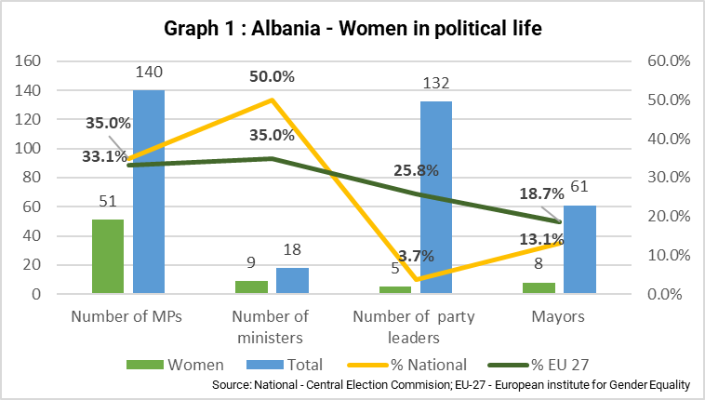
Parliament
Parliament sessions continued to be marked by tensions, offensive language and occasional incidents. In October 2024, following a request by the majority, Parliament’s Ethics Secretariat temporarily suspended 23 members of the opposition for alleged violent acts in plenary session. This led to further disruptions, including frictions between opposition MPs and the Republican Guard.
Parliament failed to implement certain Constitutional Court rulings within the applicable deadline. In an opinion on the matter, the Venice Commission confirmed that the decisions of the Constitutional Court were compulsory for all state bodies, including Parliament. Parliament has not yet followed up on this Venice Commission opinion.
Parliament’s oversight of the executive remained weak. Most legislative initiatives are tabled by the Council of Ministers. In January 2025, Parliament adopted amendments to its Rules of Procedure to introduce a corruption prevention reassessment procedure and post-legislative scrutiny mechanisms. In September 2025, Parliament voted to change the architecture of the parliamentary standing committees for the new legislature.
During the reporting period, Parliament made a number of appointments to independent institutions, including the High Judicial Council (HJC) and the High Prosecutorial Council (HPC). It also appointed a commissioner for the right to information and protection of personal data, and a public broadcaster steering committee. The appointments of an ombudsperson and a commissioner for protection from discrimination are still pending.
Parliament’s implementation of the legal framework for public consultation processes does not consistently lead to timely and transparent follow-up. In April 2025, Parliament introduced a new tool for public consultation.
Following the elections, women remain under-represented in Parliament, holding 51 of the 140 seats.
The current legal framework regarding political party financing lacks effectiveness due to the lack of a ceiling for candidate expenditure and the lack of clear regulation on advertising.
Concerns were also raised regarding the ad hoc parliamentary committee on deepening reforms for good governance, rule of law and anti-corruption. The risk of duplication with other parliamentary bodies dealing with European integration was noted. It is important that the work of the parliament in this area is inclusive, transparent and consistent with the positive results of the 2016 justice reform, guaranteeing the independence of justice institutions.
Governance
A new government took office following the 11 May 2025 parliamentary elections, composed of nine men and nine women. The appointment of a minister for the environment is a welcome development. A virtual entity was given the portfolio of Minister of State for Artificial Intelligence and Public Procurement under the authority of the Prime Minister.
During the reporting period, the ruling majority and the main opposition party employed rhetoric that was unfavourable towards the judiciary. This raises concerns about the need to maintain a clear separation between the executive branch and the judiciary.
While continuing to put EU-related reform at the centre of its legislative and policy planning, the government needs to refrain from rhetorics and measures that are not in line with EU standards. The transparency and openness of decision-making by the government needs to be improved. Coordination between ministries and executive institutions remains an issue and limits the delivery of quality public services. Further efforts are required to streamline the legal framework for the functions of local government units, address the low level of digitalisation and develop inter-municipal cooperation.
On local self-government/decentralisation, while there has been limited progress on the implementation of the Cross-cutting Strategy on Decentralisation and Local Governance 2023-2030, some positive developments were noted. These include the 2024 municipal salary reform for civil servants and the ongoing impact of the 2015 territorial reform on increasing the financial autonomy and discipline of local governments with ad-hoc measures for 2025, though long-term solutions are needed. There is still a pressing need to increase local governments own revenues.
The wave of resignations and in some cases dismissals across local administrations that occurred in July 2025 following the central government public demand for management changes in municipalities raises concerns, including in view of the European Charter of Local Self-Government.
EU integration
Albania’s EU integration coordination structures, including the Minister of State / Chief Negotiator, the department in charge of EU integration in the Prime Minister’s Office, and the interinstitutional working groups, intensified their work during the reporting period. More financial and human resources are required to strengthen the European integration units in the line ministries and agencies.
The government adopted the National Plan for European Integration 2025-2027. Work continued on developing the National Programme for Accession to the European Union, which aims to align the domestic regulatory framework with the EU acquis and ensure its effective implementation.
Parliament’s Standing Parliamentary Committee on European Affairs delivered its opinions on draft negotiation positions on negotiating clusters, and in 2024 reviewed 13 draft laws aiming to approximate the EU acquis. This Committee has been merged into a new Committee on European and Foreign Affairs, which is no longer chaired by the opposition, despite the wide cross-party consensus on EU accession. The National Council of European Integration has continued its activities, including reviewing key documents, such as roadmaps on opening accession negotiations on the fundamentals cluster, and raising awareness about fulfilling EU accession obligations.
Communication on European integration has focused on the opening of negotiation clusters and on the Growth Plan’s benefits. Further efforts need to be made to ensure transparency and public involvement in EU-related reform process.
Civil society
CSOs operate in a partly enabling environment, but have faced an increase in negative narratives particularly during the reporting period, including smear campaigns targeting their impartiality and funding. The national electronic register of non-profit organisations scheduled for the end of 2023 is not yet fully operational, tax incentives remain marginal and public funding is insufficient. The lack of specific measures to protect them from intimidation and legal threats (e.g. strategic lawsuits against public participation (SLAPP)) contributed to this situation. The role and protection of civil society should be further strengthened and the structures to meaningfully engage with civil society need to be reinforced and made fully operational, especially in the context of EU accession negotiations. The first meeting in April 2025 of the EU-Albania Joint Consultative Committee, which provides a new platform to Albanian CSOs, is an encouraging sign.

2.1.2. Public administration reform
Strategic framework for public administration reform
The strategic framework for public administration is in place.
The new Intersectoral Strategy Against Corruption (ISAC) 2024–2030 was adopted in December 2024 (see under ‘anti-corruption’ in Chapter 23). The Cross-Cutting Strategy on Public Administration Reform 2025–2030 was adopted in July 2025. Further progress was made on implementing the 2022-2026 Digital Agenda, but digital security and equal access for vulnerable groups remain an issue. Limited progress was made on implementing the 2023-2030 Strategy on Decentralisation and Local Governance. Institutional building, data collection, analysis, and aggregation capacities need to be further developed.
The revised civil service legislation for improving merit-based and senior-level recruitment and the amending legislation to regulate subordinated bodies remains to be adopted. The structure of the Integrated Policy Management Group is still under review and is largely not functional. The financial sustainability of reforms continues to depend heavily on external funding and needs to be improved.
Policy development and coordination
Policy development and coordination aspects still need to be developed.
The legal basis and the institutional set-up for consistent policymaking are in place, with room for improvement. More than one third of the approved draft laws in 2024 continued to originate from outside the Government Analytical Programme. The Strategic Planning Committee met regularly and steered the policymaking process. The Integrated Planning System (IPS) currently in place remained unused, mainly due to supporting IT systems being non-operational and the complexity of IPS requirements. Consistency between policy planning and budgeting remains to be improved. Further action is still needed to strengthen the administrative capacity of line ministries and the Prime Minister’s Office and make management more accountable. (See Chapter 32 – Financial control).
The administrative capacity for evidence-based policymaking and legislative development requires further improvement. In 2024, the use of regulatory impact assessments (RIAs) was limited to half of the approved draft laws based on the Council of Ministers’ interpretation of the criteria set out in the Council of Ministers’ rules of procedures. The government reported 53 RIAs in 2024 and 20 RIAs in the period from January to August 2025. The quality of the RIAs requires improvement. The percentage of legal acts undergoing public consultation needs to be further increased, based on a more comprehensive interpretation of the criteria set out in the Law on public consultation. In 2024, 78 acts were subject to consultation, out of a total of 80 adopted legal acts. Secondary legislation remains exempt from the application of the existing rules on public consultations and RIAs. More action is needed to further strengthen the quality control of consultations and ensure proper follow-up. The participation of stakeholders, in particular civil society, in public consultations needs to be further encouraged. Public scrutiny of government work is still weak, and parliamentary scrutiny of the government’s decision-making remains limited.
Public financial management
Public financial management (PFM) structures are broadly in place but need to be improved. The legal basis for PFM is mostly in place, with a comprehensive organic budget law. In December 2024, the government adopted a Medium-Term Revenue Strategy 2024 -2027 detailing tax policy, including the revision of tax exemptions, tax administration and customs reforms, with the objective of raising fiscal revenue/GDP by 2.5% by 2027.
The provisions of the organic budget law are largely followed. However, budget revisions are still carried out exclusively through normative acts adopted by the executive. More decisive action is needed to return to regular budget revision processes through Parliament. Some budgetary reforms continued, including ongoing efforts to better integrate medium-term budgets with the single project pipeline. The link between the strategic priorities and budget programmes should be further strengthened. The application of gender responsive budgeting continued in 2024, with approximately 9.3% of the budget being dedicated to gender-based public policies. The traceability of the gender-based budget allocations needs to be strengthened. The level of arrears has fallen, but ongoing efforts to strengthen commitment compliance should continue. The debt strategy is being pursued by reducing public debt/GDP, lengthening debt maturities and lowering exchange risk exposure. Fiscal risk monitoring has been strengthened. However, fiscal risk reporting and risk assessment on fiscal risk related to state-owned enterprises and public-private partnerships remains to be further improved. An independent fiscal oversight institution (Fiscal Council) still needs to be set up.
Budget transparency is mostly satisfactory with all key budget documents regularly published. Yet, further improvements are needed on the production of consolidated financial statements, and on in-depth reporting on extra-budgetary entities.
Public services and human resources management
Public services and human resources management require further development. Rules on merit-based recruitment, promotion and dismissal are still applied inconsistently at all levels. The measures on salary increase taken at central level have been expanded to local administrations (See Section 2.1.1 Democracy, local self-government/decentralisation). Most civil servants continue to be recruited through a group or pool recruitment process. In 2024, from the total number of appointed candidates, 61% were women and 39% men. From January to August 2025, out of 248 appointments, 163 were women and 85 were man. Overall, the gender distribution is 66% female and 34% male. Women account for 59% of middle-level managerial positions and 44% of senior-level managerial positions. About one third of senior positions are still vacant despite the availability of a pool of candidates from the top management corps group. Recruitment for managerial positions still does not properly comply with the legislation in place in terms of opening vacancies to external candidates, which should remain only an exception. In 2024, there were 14 dismissals from the civil service, compared with 27 in 2023. The enforcement rate of final court decisions on dismissals and reinstatements increased to 86.6% in 2024, compared with 84.2% in 2023. However, government reactiveness to enforcing such decisions in a timely manner still needs further improvement. The current Human Resources Management Information System (HRMIS) still does not cover the entire public sector and cannot be used as an automated payroll system. Efforts to redesign the HRMIS accordingly remain needed. All Albanian ministries have an integrity plan. At local level, 35 out of 61 municipalities have integrity plans. However, the quality and implementation of integrity plans is still weak.
The Albanian School of Public Administration continued to deliver online training programmes for professional development. A new Director was appointed, and temporary physical premises have been made available for the administration staff only.
Accountability of administration
The accountability of the administration remains insufficient. The legal framework for the organisation of the central administration still lacks a foundation for the establishment and accountability of subordinated institutions and autonomous agencies. The typology laid down in the law is still applied inconsistently. The organisational set-up of the administration has become further centralised, with 25 authorities/agencies subordinated directly to the Prime Minister’s Office. The amendments to the law on organisation of state administration were submitted for public consultation and remain to be adopted. The legal framework for ensuring managerial accountability still needs to be improved. More action is needed to further strengthen the right of citizens to good administration. Less than half of the recommendations made by the People’s Advocate (PA) and other independent institutions to the public authorities are implemented. This implementation rate needs to be improved. Cooperation between Parliament and the PA should be further strengthened and the public administration bodies’ lack of responsiveness further addressed. On transparency and access to information, the Commissioner for the right to information reported a steady number of around 1 000 complaints in 2024, often resolved after his intervention. Public entities still need to improve compliance with transparency requirements and be more responsive to requests for access to information.
Service delivery to citizens and businesses
Service delivery to citizens and businesses needs to be improved. The government continued to expand its offer of online services. However, outstanding accessibility issues for vulnerable groups, including persons with disabilities, remain unaddressed. On reducing administrative burdens, the Interinstitutional Working Group for the Regulation of Administrative Procedures in the Function of Public Services Offered to Citizens and Businesses remains operational.

2.2. Rule of law and fundamental rights

2.2.1. Chapter 23: Judiciary and fundamental rights
The EU’s founding values include the rule of law and respect for human rights. An effective (independent, high-quality and efficient) judicial system and an effective fight against corruption are of paramount importance, as is the respect for fundamental rights in law and in practice.
Functioning of the judiciary
Strategic documents
A new Cross-Sector Justice Strategy for 2024-2030 was adopted but implementation still needs to be improved. The quality of the strategy and its monitoring are generally satisfactory. The quality and timeliness of reporting have improved. However, the quality of statistical data remains poor.
Management bodies
The efficiency of the High Judicial Council (HJC) and the High Prosecutorial Council (HPC) in appointing, promoting, transferring and evaluating magistrates remains very low, which affects judicial quality and efficiency at all levels. The HJC finalised forty-one evaluation reports and the HPC forty. The HJC and the HPC should continue to reduce the backlog of evaluations and improve the quality of the evaluation reports and adopt and implement an evaluation plan every year. Important operating rules are still lacking, and overall coordination still needs to be reinforced.
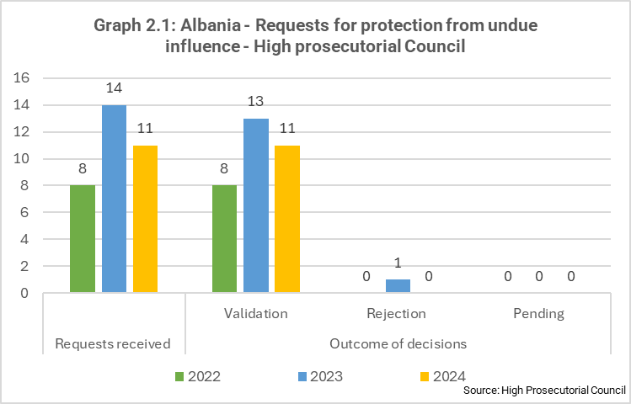
The 2016 justice reform strengthened the Councils’ independence. However, previously identified shortcomings remain regarding the appointment of non-magistrate members to the HJC and HPC. They are not subject to the same standards as magistrate members for background checks and asset verification, which affects the transparency and meritocracy of the process. The HPC and the HJC need to further strengthen ethical oversight of its members in practice. The HJC has adopted specific rules of procedure that regulate its own members’ conflicts of interest. The HJC has enacted regulations on minimum judicial timeframes and quantitative standards, and standard templates for judicial decisions. Strategic communication remains weak. The rules of procedure to ensure transparency in relation to promotions, appointments and transfers, including evaluations have been approved by the HJC and their implementation should be further ensured. The HPC adopted regulations on mentoring of prosecutor-magistrate candidates. Regulating the appointment of court chairs is also important. The HJC and the HPC need to urgently address the lack of specialised resources, notably seconded magistrates and staff needed to perform evaluation reports, in line with the high vetting standards. Councils lack an internal structure and staff to train non-magistrate staff in courts and prosecution offices, as provided for in the law.
Independence and impartiality
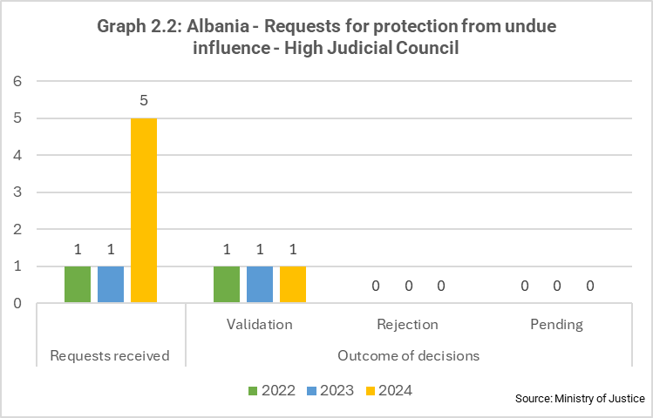
The independence and impartiality of the judiciary is satisfactory in the higher-level courts and in the courts of first instance. While the resilience of the judiciary has improved, attempts by public officials or politicians to exert undue interference and pressure have increased and raise serious concerns, notably the unprecedented public reactions and attempts to put pressure by the executive and legislative branches against the Specialised Structure Against Organised Crime and Corruption (SPAK) and the High Justice Inspector. Seven magistrates were placed under protection. The self-governing institutions were vocal in denouncing political pressure on the judiciary, issuing public statements.
Albania needs to ensure a competitive and high standard evaluation and appointment procedure of the Chief Special Prosecutor at the Special Prosecution’s Office, in line with the highest principles of merit and independence. While the appointment process of the new Director of the National Bureau of Investigations has been open and competitive so far, there have been delays in the final appointment and the HPC should adopt clear rules and procedures for future occasions. Legal uncertainty remained regarding the end of the mandate of two members of the Constitutional Court, due to diverging interpretations of the applicable provisions by Parliament and the High Court, respectively.
Despite strong legal safeguards, merit-based appointments and career development are weakened in practice by the HPC and HJC’s slow pace of qualitative evaluations for magistrates and the continued use of transfers as an alternative to merit-based promotions.
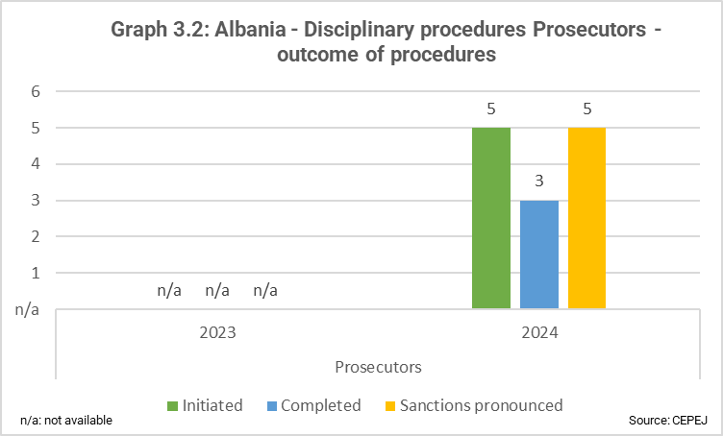
Accountability
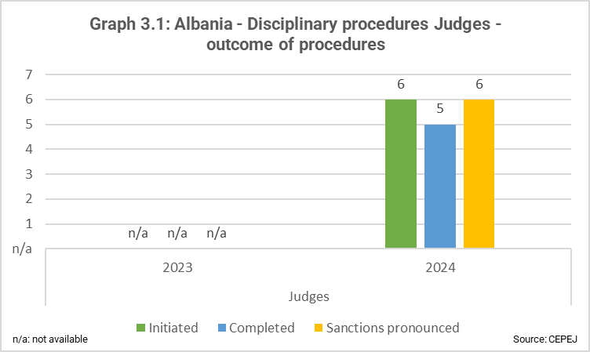
The accountability of the judiciary is overall satisfactory. The comprehensive transitional re-evaluation (vetting) of all judges and prosecutors, the operation of the High Justice Inspector (HJI) and the continued progress in implementing the justice reform have strengthened accountability. Efforts to prevent corruption post-vetting should be enhanced across the judicial system. The Councils and the HJI adopted a common regulation on cases of magistrates’ misconduct. The Councils have also approved the regulatory acts to make “asset and background” checks for the remaining first instance vetting cases.
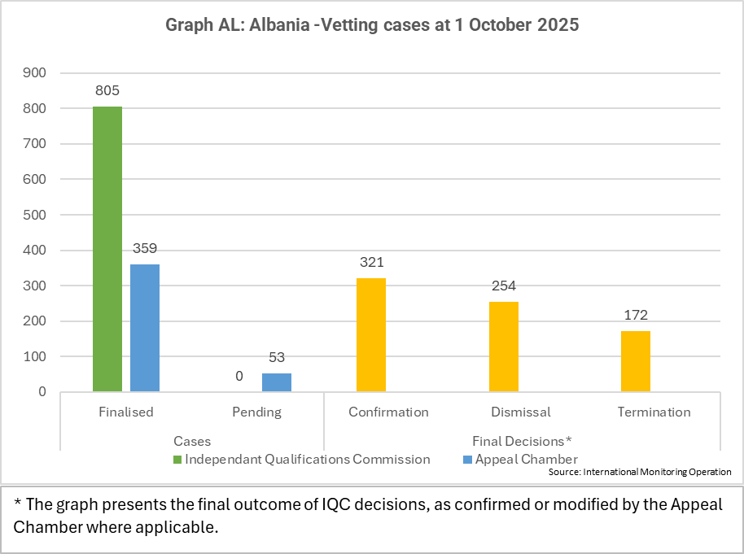
The vetting process has further advanced and is close to finalisation. The Appeal Chamber increased the pace of appeals and is currently on track towards meeting the constitutional deadline of June 2026. As of 1 October 2025 the final decisions resulted in 426 dismissals and terminations (52.9% of cases), and 321 confirmations in office (39.9% of cases). 53 appeals remain pending. The International Monitoring Operation (IMO) continued its oversight of the process. The IMO issued 42 recommendations for appeal and eight dissenting opinions against Appeal Chamber decisions.
Challenges persist regarding the attractiveness of the position for magistrate-inspectors at the HJI and legal changes are still expected to address the issue. The HJI needs to strengthen inspection protocols to tackle corruption cases within the judiciary. Thematic inspections remain a priority, including a plan to coordinate with all the relevant institutions on their follow-up. The HJI, HJC, HPC and the High Inspectorate of Declaration and Audit of Assets and Conflicts of Interest (HIDAACI) should update their internal procedures and ensure sufficient staff and resources to improve the quality and efficiency of integrity checks on magistrates and candidate-magistrates in line with high vetting standards.
Quality of justice
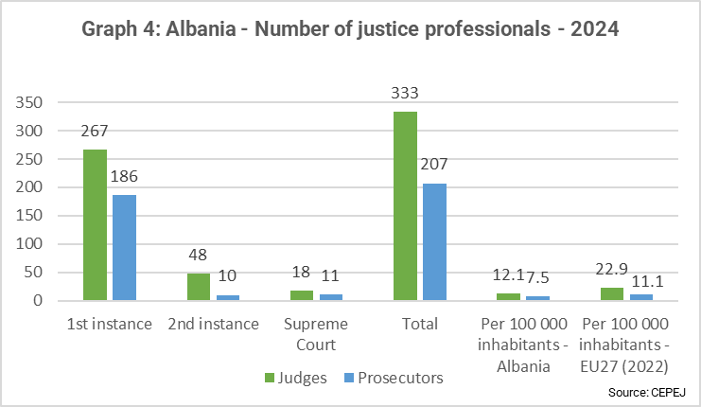
The quality of justice needs to be improved. Measures are still needed to address the previously reported issues, including (i) the quality of initial and continuous training; (ii) the consistency of case law; (iii) the high number of judicial vacancies and insufficient amount of court staff; (iv) the lack of a modern integrated electronic case management system in courts and prosecution offices; (v) the quality, consistency and timely publication of judgments; (vi) the quality of court infrastructure; and (vii) the reliability of statistical data.
Further improvements to the judicial training system are still necessary, including a comprehensive revision of the entry exam, despite limited changes made by the School of Magistrates. The review of continuous and initial training needs to be finalised to address quality limitations and the imminent needs of the judicial system. Legislation still needs to be adopted to ban vetted out magistrates or magistrates with a 15-year ban from high judicial office from taking up positions as training staff at the School for Magistrates. Common standards to consolidate drafting of judicial decisions still need to be adopted and implemented.
Judicial quality is seriously hampered by the lack of progress in appointing court chairs at all levels and the insufficient number of court staff, particularly legal assistants. The High Judicial Council has appointed 42 new judges in first instance courts of general jurisdiction. However, vacancies at the Appeal Court remain and should be completed as a matter of priority. Quotas determined by the HJC and the HPC for the School of Magistrates for the 2025-2028 class are an additional concern as they are largely insufficient to ensure that in the medium term, the needs of the system will be gradually addressed. Increasing the number and quality of candidate magistrates and legal assistants admitted to the SoM is essential.
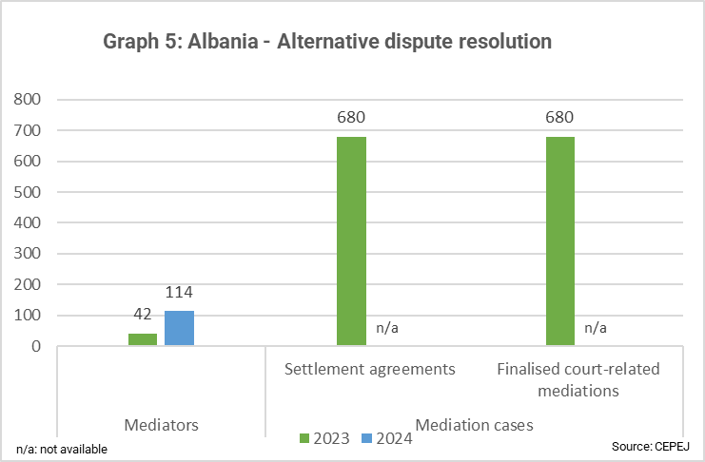
While the Government has allocated the necessary premises to the Court of Appeal, the quality of court infrastructure remains overall poor. This has led to overcrowding and the continued opaque practice of hearings taking place in judges’ chambers. No progress was made on providing adequate security standards for judges and prosecutors. The fatal shooting of the Tirana Appeals Court Judge during a court hearing has further emphasised concerns regarding the inadequacy of court infrastructure as well as detrimental personal attacks directed at judges and prosecutors and underscored the need for measures to guarantee the safety of magistrates. At SPAK level, there is scope for even greater transparency and verifiability of interrogations, notably through new interrogation rooms.
Decisive steps should be taken by the HJC and the HPC to ensure the consolidation, publication, reporting, consistency and reliability of statistical data across the judicial system, based on a coordinated and harmonised regulatory framework applicable to the whole system. HJC adopted a regulatory framework for setting up specialised chambers, which should be effectively implemented.
Alternative dispute resolution remains underused in practice. Training for mediators advanced, including an improved public campaign by the Mediation Chamber to increase awareness and visibility. Referral to mediation remains limited. Attempts to provide for consolidated information on the possibility to use mediation and increase quality of the service should continue further.
Efficiency
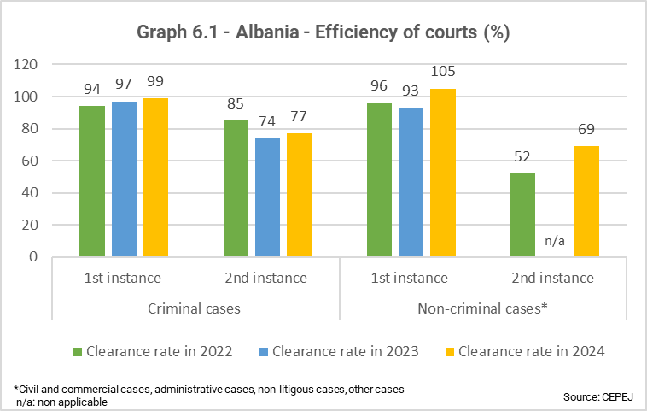
The efficiency of the justice system is limited. Efficiency is still hampered by the increased length of proceedings and a large backlog of cases, notably at appeal level. The publication of final decisions continues to exceed the legal deadline, and serious delays are caused by insufficient management of court hearings and absent defence lawyers. The HJC has adopted an efficiency roadmap, but needs to take further steps, including revision of legislation in line with the general principles of justice reform and European standards.
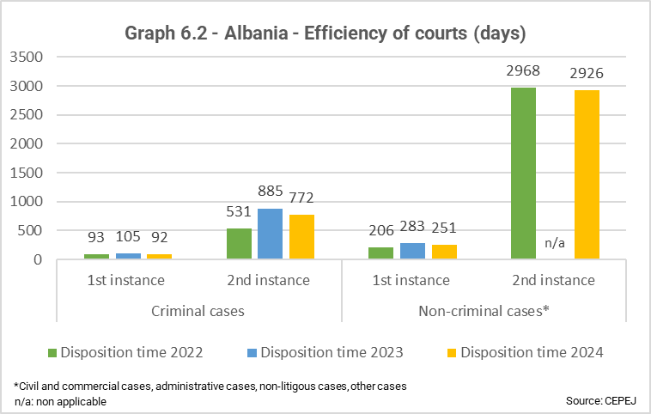
Sufficient budget has been allocated to set up a modern integrated electronic case management system in courts and prosecution offices, but full establishment is foreseen only for 2030. This timeline is detrimental to the overall quality of justice and needs to be advanced.
Significant efforts are needed to improve the digitalisation of justice systems. An electronic communication tool between the Tirana District Court and lawyers has been successfully piloted. However, the lack of funding to expand it to all courts, especially the General Appeal Court, is limiting its full potential to improve access to justice.
Fight against corruption
Track record
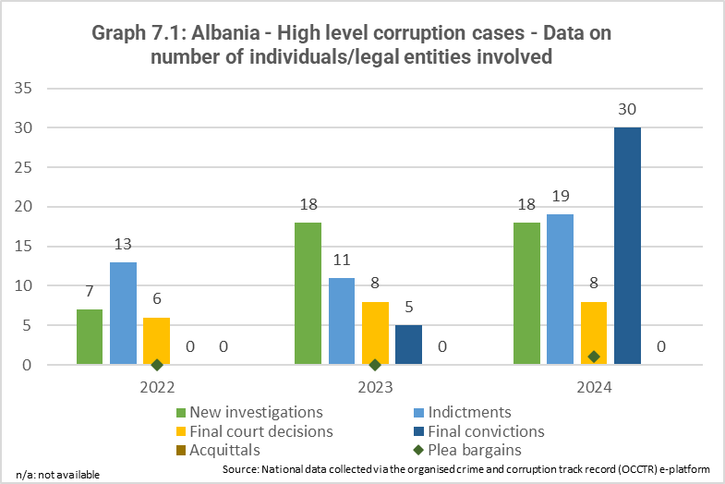
The track record in the fight against corruption has improved for high-level cases and has slightly deteriorated for non-high-level cases.
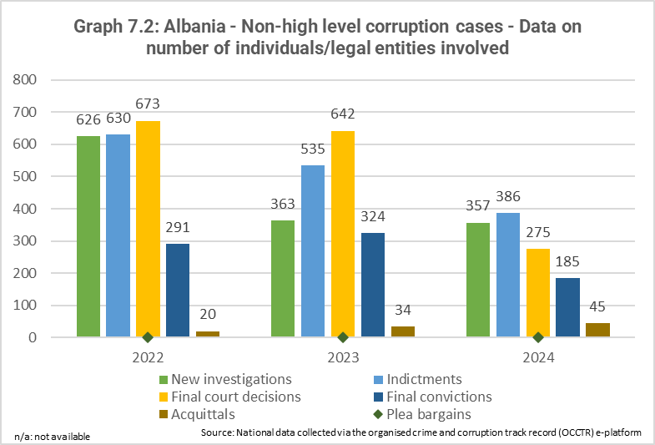
The Specialised Structure Against Organised Crime and Corruption (SPAK), comprising the Special Prosecution Office (SPO), the National Bureau of Investigation (NBI) and the anti-corruption and organised crime courts (SPAK courts of both first instance and appeal), further consolidated its positive results in the investigation, prosecution and convictions in high-level corruption cases, including those involving high-level politicians and officials as well as cases involving the protection of EU financial interests.
In 2024, the Special Court of Appeal for Corruption and Organised Crime (SPAK appeal court) delivered 24 final convictions with 106 persons convicted in final rulings in corruption cases, including 13 convictions in high-level cases. The Special Court for Corruption and Organised Crime (SPAK court of first instance) convicted 93 persons in cases of corruption. SPAK’s capacity in financial investigations has increased and the systematic use of financial investigations and asset confiscations has continued to improve. However, the number of referrals to SPAK from other authorities needs to increase and SPAK’s capacity and internal organisation to handle aa growing workload requires attention. (See also Chapter 24 – Justice, freedom and security).
Legal framework
The legal framework on the fight against corruption is broadly in place but needs to be improved regarding preventive measures. Some steps have been taken towards revising the conflict-of-interest legislation, although anti-corruption legislation remains complex and incomplete. Revised legislation on conflict of interest, whistleblowers protection, political party financing, lobbying, donations and sponsorships, anti-money laundering, internal control and financial inspection still needs to be adopted. The Law on the police has been revised, but the state police remain highly vulnerable to corruption.
Strategic documents
The strategic documents are in place and are adequate. Albania adopted the Anti-Corruption Strategy for 2024-2030, targeting vulnerable sectors such as property, public procurement, health, education, customs and tax, including local governance and the private sector. SPAK adopted a Backlog Reduction Strategy 2025-2027, which contributes to the implementation of the Cross-sector Justice Strategy and the National Strategy Against Organised Crime. However, further strengthening of institutional capacities, planning, coordination and monitoring mechanisms remain needed.
Institutional framework
The institutional framework for the fight against corruption is in place. Its preventive measures still need to be improved, and issues with its law enforcement aspects remain.
Since its establishment, SPAK has delivered positive results in fighting corruption. Other bodies tasked with fighting corruption, in particular the General Prosecution Office and the state police, still need to improve their results in fighting corruption.
Despite efforts, the state police remain highly vulnerable to corruption. The transitional and periodic evaluation of state police officers (‘police vetting’) and the process of integrity verification have continued, but their impact remains limited. In 2024, the Police Oversight Agency continued to receive a high number of complaints (over 5 000). The Agency recommended disciplinary investigations for 283 employees and referred 463 law enforcement employees to criminal prosecution. Following the resignation of the General Director in July, the appointment procedure for the new Head of Agency needs to be conducted in line with the highest principles of merit, competitiveness and transparency. Measures to improve the accountability, independence and integrity of the Albanian state police need to be further implemented.
The institutional framework for preventing corruption continues to have a limited impact, including in vulnerable sectors, and coordination with law enforcement remains weak. The position of Minister of State for Anti-Corruption and Public Administration has been maintained in the new executive. The General Directorate on Anti-Corruption (GDAC) staff are still limited to approximately 30 employees, supported by anti-corruption coordinators deployed across about 20 institutions, hindering capacities to effectively oversee the implementation and assessment of preventive measures, along with thorough risk assessments.
The High Inspectorate for the Declaration of Assets and Conflicts of Interest (HIDAACI) continued carrying out its mandate. Effectiveness and transparency of verifications of declarations of assets and interests by HIDAACI, including high-risk profiling, needs to be increased. The declarations of assets need to be made public online, in line with legal requirements. Coordination with law enforcement needs to further improve. HIDAACI introduced a search functionality to improve access to data yet still upon request, and signed a memorandum with the Financial Investigation Unit.
HIDAACI received 182 reports from public authorities and 258 from businesses last year. At the same time, the number of whistle-blowing cases remained low – HIDAACI reviewed six new whistleblower reports in 2024.
Public officials’ awareness of ethical standards and their enforcement needs to be improved. The quality and implementation of integrity plans, set up at central and local levels, still remains weak.
In March 2025, the Council of Europe’s Group of States against Corruption (GRECO) finished the fifth round compliance procedure for Albania, concluding that 18 out of 24 recommendations had been satisfactorily addressed. Albania still needs to ensure that rules on post-employment restrictions apply both to members of the Council of Ministers and to political advisers. In addition, legislation on contacts with lobbyists still needs to be enacted and the enforcement of rules to prevent conflicts of interest applicable to the Council of Ministers still needs to be demonstrated.

Fundamental rights
General framework
The general framework for fundamental rights needs to be improved. The implementation and enforcement of fundamental rights need to be improved.
International human rights instruments
Cooperation with international human rights monitoring bodies is satisfactory but the follow-up of their recommendations needs to be improved. Albania is party to the main international human rights instruments. However, the country has not signed the Optional Protocol to the International Convention on Economic, Social and Cultural Rights. Albania needs to develop a comprehensive monitoring and data collection system to assess the level of implementation of human rights legislation, policies, and strategies. Albania completed its fourth Universal Periodic Review, supporting 239 out of 253 recommendations received. Albania continued to benefit from its observer status at the European Union Agency for Fundamental Rights (FRA).
European Court of Human Rights
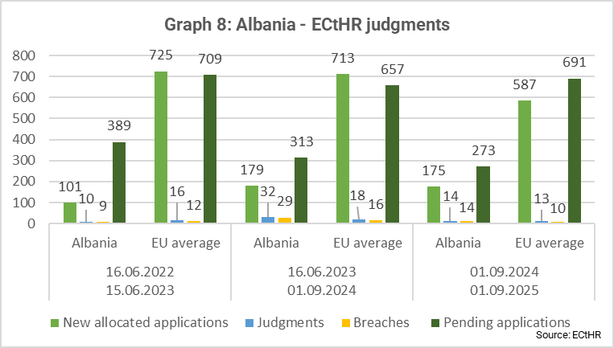
Albania continues to ensure good cooperation with the European Court of Human Rights (ECtHR). During the reporting period, the Court found breaches of the European Convention on Human Rights relating mainly to the right to respect for private and family life, the right to a fair trial, and the right to liberty and security. Albania faces challenges in implementing ECtHR judgments. On 1 January 2025, Albania had 25 leading ECtHR judgments pending implementation. There are currently 10 cases under enhanced supervision by the Committee of Ministers compared to 16 in 2024). Albania needs to ensure that these judgments are implemented, notably in the Strazimiri v. Albania case, regarding the inhumane and degrading treatment of forensic psychiatric patients and prisoners with mental disorders. Moreover, Albania has yet to clarify existing remedies to address unlawful expropriation and demolition of property in the Sharxhi and others v. Albania case.
Promotion and enforcement of human rights
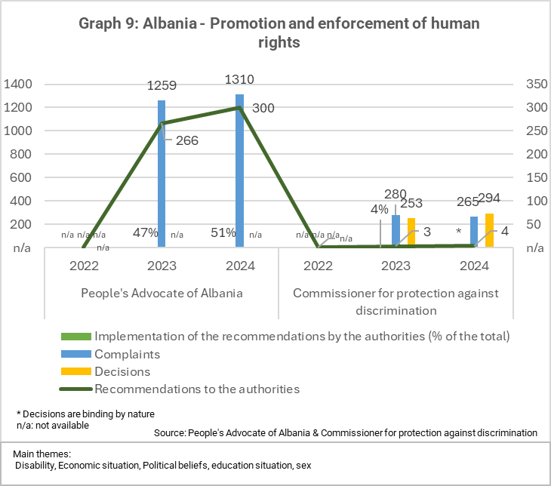
The legal and institutional framework for the promotion, protection and enforcement of human rights is incomplete and needs to be improved. Effective promotion and enforcement of human rights is challenging, especially on the right to property and children’s rights. The Ombudsperson (People’s Advocate) continued to exercise its mandate satisfactorily. It has been accredited at global level as an A-status National Human Rights Institution (NHRI) since 2014. Parliament has yet to reappoint an Ombudsperson and a Commissioner against Discrimination, as the mandates of the current heads of these institutions expired in 2022 and 2023, respectively, which risks to seriously weaken the legitimacy of these independent institutions. Human and financial resources shortages persist, affecting the functioning of the regional offices of both institutions. Overall, the largest number of complaints received by the Ombudsperson in 2024 concerned the limitation of personal freedom (295 complaints, 16% overall). Implementation of the Ombudsperson’s recommendations remains overall low, hampering oversight effectiveness and hindering redress for violations of human rights.
Prevention of torture and ill-treatment
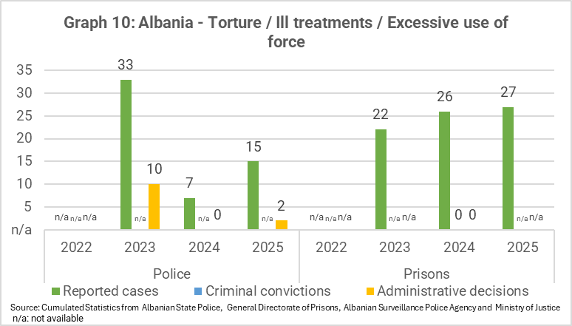
Albania provides adequate legal guarantees on the prevention of torture and ill-treatment and the follow-up of cases is adequate. Albania generally complies with its obligations on the prohibition of torture and ill-treatment. The functioning of the National Preventive Mechanism remained satisfactory; however, the follow-up of its recommendations is low. Albania’s action plan to address the main findings and recommendations of the European Committee for the Prevention of Torture and Inhuman or Degrading Treatment or Punishment (CPT) need to be implemented. No steps have been taken to address serious concerns over the conditions for prisoners with mental health issues and forensic patients. Overcrowding, a lack of medical and therapeutic staff, and inadequate facilities remain serious concerns.
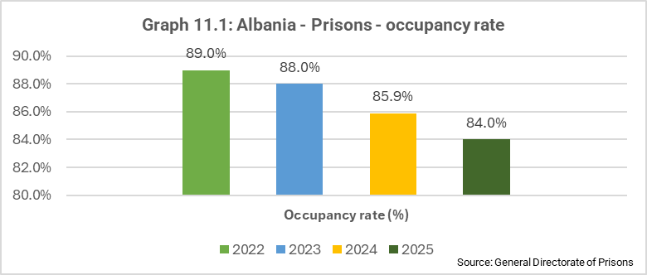
Execution of criminal sanctions
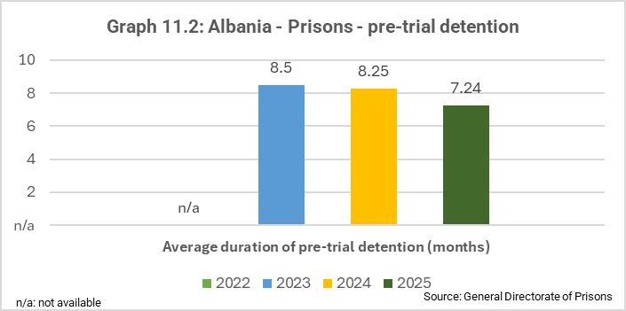
The system for execution of criminal sanctions (including probation) needs to be improved. Corruption, poor healthcare and a shortage of staff in the penitentiary system and detention centres remain a concern. While overcrowding remains a challenge, the occupancy rate has shown a steady annual decline, indicating gradual progress towards easing capacity pressures. The probation service is operational. However, prevention and rehabilitation need to be improved. The use of electronic monitoring has been suspended since 2017 and needs to be reintroduced urgently. Special attention should be paid to the deradicalisation of prisoners.
Protection of personal data
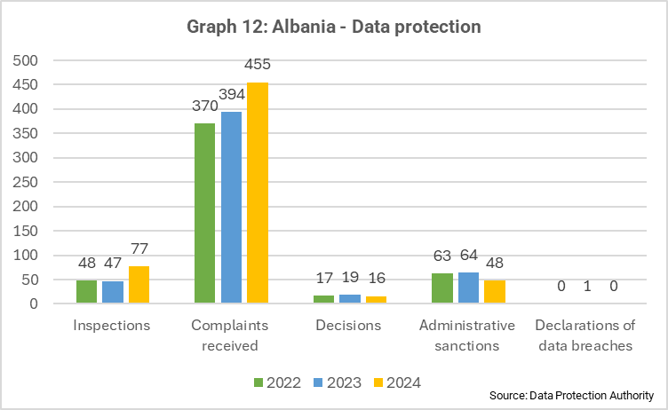
The legal framework for the protection of personal data is adequate but the capacities of the Data Protection Agency still need to be improved. Good progress was achieved with the adoption of the new Law on personal data protection in December 2024 in full alignment with the EU acquis. Seven out of ten accompanying pieces of implementing legislation have been adopted. Albania needs to ensure effective implementation, including administrative and budgetary capacity. Further action is needed to increase public awareness and public institutions’ preventive capacity. The Data Protection Commissioner is systematically consulted on draft legislation that can affect personal data, and its recommendations are broadly followed by public and private data controllers.
Freedom of religion or belief
Freedom of thought, conscience and religion is generally upheld in Albania. The restitution of properties belonging to religious groups that were expropriated during the communist era remains an unresolved issue. The dependence of some religious groups on financial support from third parties creates vulnerabilities.
---------------------------------------------------------------------------------------------------------------------------------------------------

Freedom of expression
Intimidation of journalists
The framework for the protection of journalists is in place, but verbal and physical attacks, smear campaigns and strategic lawsuits against public participation (SLAPP) targeting journalists continued. Media freedom organisations denounced 45 cases of violations of journalists’ safety in 2024 (down from 46 in 2023). Cases of intimidation and threats against journalists, including by high state officials and police officers and notably against investigative and female journalists, became more prominent though smear campaigns, politically motivated physical and verbal attacks, and disinformation.
In October 2024, the General Prosecutor’s Office appointed a media adviser as the contact person for reporting and following up on cases of attacks against journalists and media workers. A point of contact for the safety of journalists was established both at the Ministry of Interior and the police. Impunity persisted due to the continued lack of a robust track record of investigations and judicial follow-up. In April 2025, the Constitutional Court issued a decision in favour of a journalist, unanimously annulling previous judicial rulings that had authorised the seizure by the Special Prosecution Office of the journalist’s electronic devices, data and materials, on the grounds that the seizure constituted disproportionate interference in the right to protect the confidentiality of journalistic sources.
Concerns over the legality and due process of law were raised regarding the authorities’ action in preventing access of journalists from four media outlets to the premises they occupied. In August 2025, a first instance court assessed that restriction measures on journalists during the eviction of a media consortium from the state-owned premises were not proportionate and were contrary to constitutional and ECHR Article 10 obligations related to freedom of expression. The Court did not enter into the merits of the property dispute but ordered the return of the equipment and documents to journalists.
The number of digital threats, online harassment and smear campaigns increased. Privacy violations represent another serious concern, as journalists’ personal and professional data is misused by unauthorised entities. This situation is exacerbated by insufficient institutional mechanisms for reporting, addressing and mitigating these digital threats. There is still a lack of systemic monitoring and reporting on judicial cases involving journalists. Journalists have limited access to legal assistance and limited support from media outlets.
Legislative environment
Albania made no progress in aligning the legislative framework with the EU acquis and European standards. This includes no progress to address major challenges hampering media independence. High market concentration and lack of transparency of media ownership, financing sources and economic interests, including public funding, continued to negatively affect media independence and plurality. Defamation is still a crime punishable by particularly punitive criminal fines. The Criminal Code still does not provide for special protection for journalists against violence, attacks or threats while exercising their profession. The legal framework does not provide for safeguards against strategic lawsuits against public participation (SLAPP). A structured dialogue between Albanian institutions and media actors was launched in January 2025 with the aim of discussing key legislative and regulatory reforms to enhance freedom of expression, including media freedom and pluralism. Following a presentation of specific recommendations in June 2025, the work of the platform is still ongoing. It remains essential that the Venice Commission be consulted on the resulting legislative amendments before they are adopted. The Law on access to information is broadly aligned with European standards; however, shorter and binding deadlines for answers to journalists still need to be set based on best European practices.
Implementation of legislation/institutions
The independence of the Audio-Visual Regulatory Authority (AMA) is still not guaranteed as the potential for political and corporate influence with regard to the appointment procedures for AMA board members persists, while there have been shortcomings in enforcing the Broadcasting Code on media outlets that air pre-recorded political content during electoral campaigns.
The ad hoc parliamentary committee on tackling disinformation and foreign interference drafted the country’s first National Strategy against foreign interference and disinformation, adopted by Parliament in July 2025. In its implementation it is important that the strategy ensures a comprehensive approach and safeguards freedom of expression, media freedom, and pluralism in line with the EU acquis and best practices.
The implementation of the Law on access to public information remains weak. Public authorities continue the practice of withholding information on the basis of generic references to ‘public interest’ that have still not been clearly defined. In 2024, the Commissioner for the Right to Information and Personal Data Protection received 365 complaints from journalists concerning the refusal to provide information and official documents. Of these, 283 cases were resolved by granting the requested information during the administrative review process.
Public service broadcaster
Procedural irregularities in the election process for a new Director-General of the public broadcaster Radio Television (RTSH) in January 2025 further undermined the principles of merit-based selection and increased concerns over the independence of RTSH. In February, Parliament dismissed the entire RTSH Steering Council, in breach of applicable legislation, which only allows individual disqualification of Steering Council members subject to due process guarantees. The appointment of some members of the new Council, set up in March 2025, raised concern because of their political background. In April 2025, the new board elected the Director-General of RTSH.
Economic factors
High ownership concentration and opaque funding practices continue to compromise media independence and pluralism. In April 2024, the AMA started publishing on its website summarised information on ownership structures and beneficial owners of licensed audiovisual media. However, this webpage fails to indicate vested interests of owners, conflicts of interest, and possible influences on media owners or persons affiliated with them. The legal framework still lacks provisions to regulate the distribution of indirect subsidies or state advertising to media, and to extend transparency requirements to online media outlets. Albania has taken an initial step towards a transparent audience measurement system, which is key to ensuring accountability in public advertising. Concerns persist on the influence of politically affiliated business groups, particularly during the pre-electoral period.
Internet
In March 2025, the government decided to suspend access to a major social media platform nationwide for 12 months on the grounds of protecting children from harmful content. While there was no formal announcement on lifting of the ban, the platform is accessible across the country following an agreement to ensure filters for hate speech in Albanian. The cybersecurity capacity of media outlets is generally weak. Several cyberattacks against the media took place during the reporting period.
Professional organisations and working conditions
Self-regulation in the media sector remained weak and hindered by limited resources, a polarised media landscape and ongoing use of inflammatory rhetoric in public debate. It remains important to ensure support to self-regulatory initiatives and to promote sector-wide adherence to ethical codes.
Limited job security and poor working conditions for journalists, combined with self-censorship and pressure from political actors and media owners, continued to pose serious challenges to journalists. Issues remain with unpaid salaries, excessive workloads and job insecurity, particularly in local and online media. Media freedom organisations reported at least 13 new formal complaints to the State Labour Inspectorate between September 2024 and March 2025. Self-censorship remains widespread, driven by political pressure, legal threats and economic dependence.
----------------------------------------------------------------------------------------------------------------------------------------------------
Freedom of assembly and association is guaranteed by the constitution and continued to be generally respected.
Labour and trade union rights are covered in Chapter 19 - Social policy and employment.
Property rights
The legal and institutional framework to enforce property rights is broadly in place. The overall enjoyment of property rights is limited. Further progress has been made on digitalisation but thus far only 91% of lands have been registered. Digitalisation was completed only with respect to 43% of ownership titles, 69% of supporting documents and 10% of cadastral maps. Approximately 80% of previously registered data has still not been verified for accuracy. Significant challenges persist, including widespread corruption in service delivery, unclear ownership and overlapping property boundaries resulting from inconsistent interventions and faulty measurements in recent decades. Many title deeds and cadastral maps are still in paper format, and numerous property transactions are still conducted using outdated documents with unclear data, hampering legal certainty and economic development. In June 2025, the State Cadastre Agency (SCA) adopted a roadmap to finalise all digitisations by December 2026 and all first-time registrations of immovable property by December 2028. The process of legalising illegal construction projects due before the end of 2028 continued, with some 64% out of 400 000 applications legalised and 1% rejected.
In light of country-wide demolitions of allegedly illegal constructions launched by the authorities in the summer of 2025, it is important that legalisation, expropriation and demolition of buildings strictly comply with existing legal frameworks, including the principles of transparency and due judicial process.
In late 2024, a working group was established to develop an integrity plan at the SCA.
Compensations for properties confiscated during the communist era continued but at a slow pace. More than 26 000 requests for compensation have been accepted by the specialised Agency for Treatment of Property (ATP). ATP recognised ownership and compensation values in 19 000 cases and only effectively executed about 800 of them. One major issue is that only 10% of the property value can be compensated, and that value is still based on the government’s valuation map dating back to 2016, with prices often significantly below current market values.
Non-discrimination
The legal and institutional framework on non-discrimination is incomplete and the capacities of equality bodies need to be improved.
Limited steps were taken to fully align the legal and institutional framework for non-discrimination with the EU acquis - including on racial equality and on standards for equality bodies and European standards. In 2024, the Commissioner for Protection against Discrimination (CPD) continued to handle a stable number of cases, mostly in the areas of employment and services. Albania needs to consistently implement strategic measures on combating discrimination and strengthening the rights of LGBTIQ persons and persons with disabilities, including sectoral non-discrimination action plans.
Serious concerns remain with regard to the institutional and legal framework on hate crime and hate speech. Laws on hate crime and hate speech appear to be consistent with EU acquis and European standards. However, better enforcement capacity and greater awareness raising are needed, particularly in rural and remote areas. In 2024, the CPD handled twelve cases of hate speech, including on the grounds of race, gender and sexual orientation, confirming hate speech in two of the cases. From January to June 2025, the CPD handled eleven new cases, which are under review. Additional training, awareness raising and capacity building about hate crime is needed among law enforcement and justice professionals. The collection of data and statistics on hate crime is yet to be fully ensured. A total of seven cases of hate crime were reported to the police in the reporting period in 2024 and 8 from January to June 2025
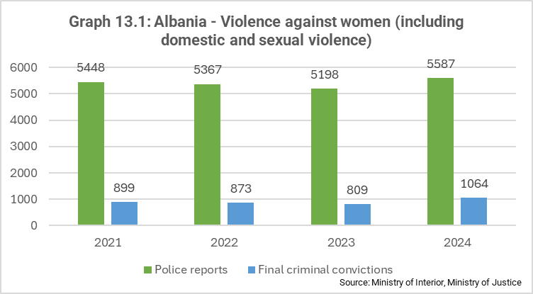
Gender equality
The legal and institutional framework for gender equality is partially in place, but legislative alignment with the EU acquis as well as implementation and enforcement need to be improved. Weaknesses remain in implementing the National Strategy for Gender Equality 2021-2030 and its Action Plan. Women living in rural and remote areas, Roma and Egyptian women, and lesbian, gay, bisexual, transgender, intersex and queer (LGBTIQ) persons continue to face multiple forms of discrimination. The activities in preparing Local Gender Action Plans continued.
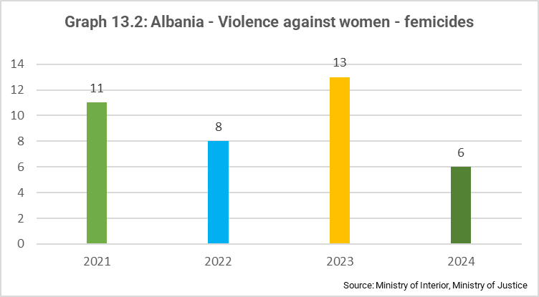
The legal framework for combating gender-based violence is not aligned with the Istanbul Convention or the EU acquis. Violence against women and girls and domestic violence remain a critical concern, with high levels of under-reporting due to social norms and associated stigma. 47% of women and girls report having been victims of intimate partner violence. The police’s weak enforcement and accountability in handling cases of violence against women remains a concern. The continued high number of femicides per capita is still a serious concern. Specialised support services for victims of violence continue to be donor driven and insufficient, particularly healthcare, the funding of shelters, free legal aid, and the reintegration and rehabilitation of victims of violence. Several key laws are currently being revised, including the Law on gender equality in society, the Criminal Code with regard to the crimes of femicide, sexual violence and cyber violence, and the Family Code concerning child marriages. It remains important that revisions are fully aligned with EU acquis and European standards.
Rights of the child
the legal and institutional framework on rights of the child is partially in place and implementation needs to be improved. Implementation efforts in children’s rights protection should also be in line with the EU acquis and draw guidance from key European Commission recommendations, in particular as concerns integrated child protection systems.
The National Agenda on the Rights of the Child (NARC) 2021-2026 is Albania’s central strategic framework for promoting and protecting children’s rights. Only 62% of the measures in the NARC had been fully implemented. Laws intended to protect minors from child marriage remain ineffective or applied inconsistently. Child protection services remain insufficient, including for child victims of violence and domestic violence. In 2024, 1 913 cases have been registered as victim of violence. Violence and sexual violence against children, including online, remain a critical area of concern. Child protection services remain insufficient, including for child victims of violence. The number of child protection workers (241 in all 61 municipalities) is far below the total number needed. In 2024, 2 451 cases were managed by Child Protection Units, 1 386 of which were newly identified cases receiving services according to their risk levels. In 2025, there were 1,940 cases of children in need of protection of which 264 newly identified cases. A national deinstitutionalisation plan is in place and currently being updated together with the development of the new alternative care law as well as measures to strengthen service delivery for children in need of family care. Access to justice for children is hindered by delays, limited legal aid, and inadequate institutional coordination. Despite the National social Protection Strategy 2024-2030 and Social Inclusion Policy 2024-2028, 70% of children remain at risk of poverty.
Persons with disabilities
The legal and institutional framework on the rights of persons with disabilities is incomplete and implementation and enforcement need to be improved. Albania’s framework legislation on the rights of persons with disabilities is only partially compliant with the UN Convention on the Rights of Persons with Disabilities (UNCRPD), and Albania has not yet ratified the Optional Protocol to the UNCRPD on an individual complaints’ mechanism. Limited action was taken to tackle discrimination against persons with disabilities, improve accessibility in line with the EU acquis, including as regards the European Accessibility Act and boost opportunities in employment, education and participation in political and public life. The quality of education for children with disabilities, especially children with a hearing impairment, continues to cause concern. There has been limited progress on deinstitutionalisation, which needs to be dealt with urgently to move towards independent living and inclusion of persons with disabilities. Some progress was noted on biopsychosocial assessment, but service provision needs to be strengthened.
LGBTIQ persons
The legal protection of the rights of LGBTIQ persons needs to be improved and further aligned with the EU acquis. Moreover, LGBTIQ persons face high levels of discrimination and there is a lack of inclusive data collection.
The legal and institutional framework for the rights of lesbian, gay, bisexual, transgender, intersex and queer (LGBTIQ) persons is incomplete and needs to be further aligned with the EU acquis and European standards. Albania still does not have legislation recognising civil cohabitation, same-sex marriage, parenthood by same-sex couples, or legal gender recognition. The medical protocol for transgender and gender-diverse persons has not been adopted yet. Most of the measures under the LGBTIQ National Action Plan 2021-2027 have not been implemented due to lack of resources and lack of political will.]. Discrimination against LGBTIQ persons is prevalent. Tirana Pride took place peacefully on 24 May 2025.
Procedural rights and victims’ rights
The legal framework on procedural rights for suspects and accused persons as well as the rights of victims of crime is partially aligned with the EU acquis.
The legal framework for legal aid is comprehensive, and primary and secondary legal aid are delivered at central and local levels. However, fees for legal aid cases are still not sufficient to attract high-quality legal representation. Measures to facilitate access to justice for the most vulnerable groups in view of the new judicial map are not yet in place. Shortcomings remain regarding sufficient budget and coordination to protect victims of crime. There was no progress from the 2024 report in addressing remaining issues related to the procedural rights of suspects and accused persons, including elements pertaining to the right to information in criminal proceedings, access to a lawyer and presumption of innocence. The budget for victim support, protection and victim compensation is still largely insufficient and needs to be enhanced.
Protection of minorities
The legal and institutional framework for the protection of persons belonging to minorities needs to be improved and further aligned with the EU acquis. Persons belonging to minorities face discrimination. A significant achievement was made with the adoption of three pieces of implementing legislation in December 2024, which were needed to ensure implementation of the relevant framework legislation. This implementing legislation addressed the crucial issues of free self-identification and the use of languages for persons belonging to minorities, ensuring alignment with European standards and the principle of free self-identification.
Albania still needs to ensure effective implementation of the legal framework, notably by allocating adequate financial and human resources to central agencies and local government, and by staffing and training local authorities, including on data collection, based on annual projections. Albania still needs to ensure that the State Committee on National Minorities has adequate resources and that procedures for selecting the members of the Committee on National Minorities are reviewed in line with the recommendations of the European Commission and of the Advisory Committee of the Framework Convention for the Protection of National Minorities.
Roma
The legal and institutional framework on Roma needs to be further improved and Roma continue to face discrimination. The overall employment rate of Roma and Egyptians remains very low. While access to basic public health services is ensured, access to additional out-of-pocket health services remains financially constrained for both vulnerable communities. The cost of civil registration remains a challenge when DNA testing is required. The implementation of the National Action Plan for equality, inclusion and participation of Roma and Egyptians in Albania (2021-2025) and the Poznan commitments needs to be significantly improved. The institutional capacity of the Ministry of Health and Social Protection remained weak throughout the reporting period, however, the appointment of a new Deputy Minister specifically in charge of vulnerable groups, including Roma and Egyptians was a positive sign. Additional efforts and resources are required to accelerate the inclusion of Roma and Egyptians, to tackle anti-gypsyism, discrimination and educational and physical segregation, to promote Roma participation, and to reduce the gaps with the rest of the population.
Citizenship rights
Albania needs to adapt its legislative framework to the EU acquis on EU citizenship rights, with the ultimate aim of full alignment ahead of accession. This should include carrying out an analysis of the alignment and implementation needs arising from the EU Directive on the right to citizens of the Union to move and reside freely in the Member States across all policy areas affected and planning timely alignment accordingly. To ensure full compliance with EU law, Albania will need to repeal the legal basis allowing for the development of an investor citizenship scheme, as such schemes breach EU law and pose risks as regards security, money laundering, tax evasion, terrorist financing, corruption and infiltration by organised crime.

2.2.2. Chapter 24: Justice, freedom and security
The EU has common rules for border and migration management, visa policy, and asylum.. Schengen cooperation entails the lifting of border controls inside the EU. There is also cooperation in the fight against serious and organised crime and terrorism, and judicial, police and customs cooperation, all with the support of the EU Justice and Home Affairs agencies.
Fight against serious and organised crime
The legal framework on serious and organised crime is partially aligned with the EU acquis. The capacity to fight against serious and organised crime needs to be improved.
Legal alignment, strategic and institutional frameworks
Albania is partially aligned with the EU acquis in the field of police cooperation and the fight against organised crime. Implementation of the 2021-2025 inter-sectoral strategy against serious and organised crimes and the 2023-2025 action plan is in its final stages. An evaluation report on their implementation should be prepared to inform the drafting of the new strategy for 2026-2030. The National Serious and Organised Crime Threat Assessment (SOCTA) for the period 2024-2025 was approved in September 2024 but is not publicly available. The assessment of its implementation as well as of its alignment with the national strategy against organised and serious crimes cannot therefore be carried out.
An Asset Recovery Office (ARO) has been set up within the Albanian State Police, although its full functionality remains to be demonstrated. The Law on the Asset Recovery Office was adopted in June 2025 and its full implementation, including the adoption of pending implementing legislation on the organisation and functioning of the office, should increase its capacities to identify and trace criminal assets.
With a view to alignment with the EU Directive on asset recovery and confiscation, the capacity of the Agency for the Administration of Seized and Confiscated Assets (i.e. the national Asset Management Office) is to be reinforced. In 2024 the Agency increased its human resources and set up an inventory of seized and confiscated assets. Operational procedures need to be further improved to ensure timely management of assets to preserve their economic value.
Regarding SPAK, the financial investigation unit of the Special Prosecution Office (SPO) continued operating, leading to tangible results, including in cooperation with international partners. The appointment of the Deputy Director of the National Bureau of Investigation (NBI) in December 2024 fulfilled a precondition, as envisaged by the SPAK Law, for the recruitment of judicial police services officers, but their recruitment is still pending. The number of state databases to which the SPO and NBI have direct access has increased to 19 and reached a sufficient level, but further improvements in analysis capabilities are needed.
District prosecution offices lack the staff, training and resources required to improve criminal and financial analysis capacity in complex criminal cases.
The 2024 Law on the Albanian State Police is providing the adequate legal framework to contribute to the reduction of corruption and conflicts of interest regarding donations, sponsorship and additional paid services. A system for confidential integrity counselling has been set up. While a whistle-blowing system and post-employment restrictions have now been implemented, integrity checks for at-risk functions need to be conducted regularly.
No progress was made on alignment with the EU acquis on cybercrime and criminalisation of child sexual abuse and exploitation both online and offline during the reporting period. The legal framework needs to be swiftly aligned with the Directive on combating the sexual abuse and sexual exploitation of children and child pornography.
The legal framework for trafficking in human beings is partially aligned with the EU acquis. It should be amended to align with the Directive on preventing and combating trafficking in human beings and protecting trafficking victims and the revised Directive which entered into force in July 2024. Domestic child trafficking forced begging and child labour are a concern despite policies that are consistent with international standards.
On small arms and light weapons, Albania should fully comply with the EU Directive on the control of acquisition and possession of weapons, as well as implementing legislation on alarm and signal weapons and marking of firearms.
Implementation and enforcement capacity
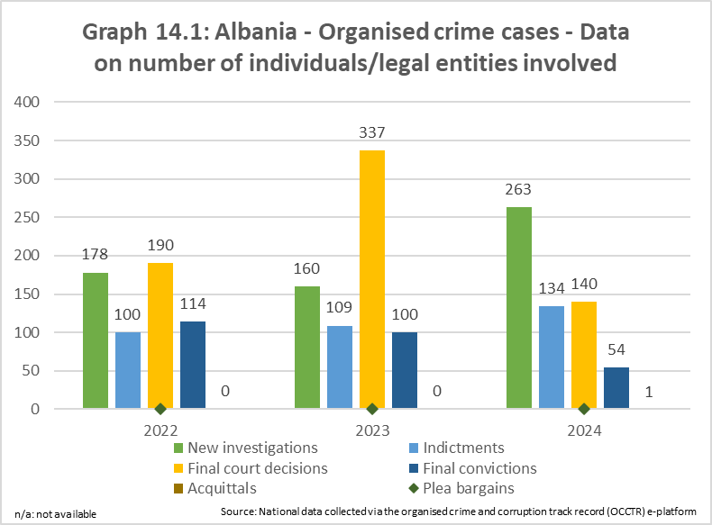
Criminal and financial investigation analysis and methodologies need to be strengthened. Albania is expected to increase its use of preventive seizure and confiscation of assets, including non-conviction-based confiscation and third-party confiscation. Financial investigations have been prioritised by SPAK, which is reflected in an increase in high-level cases.
Financial investigation techniques need to be improved, including on identification, analysis and preservation of digital evidence for cryptocurrency and virtual assets. The systematic use of financial investigations in parallel to serious and organise crime and money laundering cases should be ensured. The level of asset seizures and confiscations remained stable between 2023 and 2024. Albania reported about EUR 21 million worth of seized assets (EUR 21 million in 2023) and EUR 10 million worth of confiscated assets (EUR 11 million in 2023).
There is a need to guarantee the timely and proper management of seized and confiscated assets, including virtual assets and cryptocurrency, as no state-owned digital wallet is available.
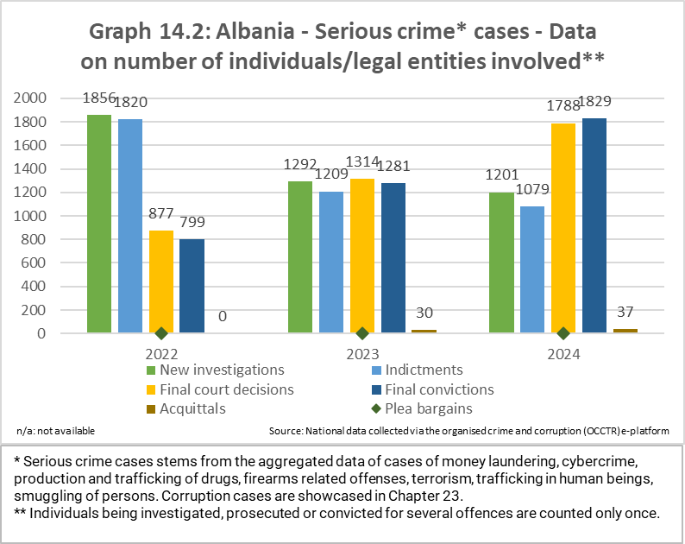
There is still no strategic or systematic approach to identifying and confiscating criminal assets that are abroad or unreachable. In 2024, SPAK issued seven decisions for the preventive seizure of assets for criminal offences related to organised crime. However, Albania needs to steadily implement rules on extended confiscation and precautionary asset freezing to prevent the assets losing any of their economic value.
The reuse of confiscated assets for social purposes remains largely ineffective.
On international police cooperation, a total of 108 police operations were carried out in cooperation with international partners in 2024. Albania should continue and strengthen its cooperation with international partners, in particular with EU Member States and EU agencies. There was a 6,2% increase in messages shared by the Albanian State Police with international partners via the Secure Information Exchange Network Application (SIENA) in 2024.
Albania continued its good cooperation with Europol and remains actively engaged in the European Multidisciplinary Platform against Criminal Threats (EMPACT): the country participated in 120 operational actions carried out in the period 2024-2025 (115 in 2023). Albania also participated in the INTERPOL I-24/7 system, with 25% more joint operations than in 2023.
Cooperation between Albania and the European Union Agency for Law Enforcement Training (CEPOL) continues, but Albania should make more use of it by integrating the gained knowledge and competencies into the national law enforcement training system. The revision of the Working Arrangement with CEPOL is ongoing.
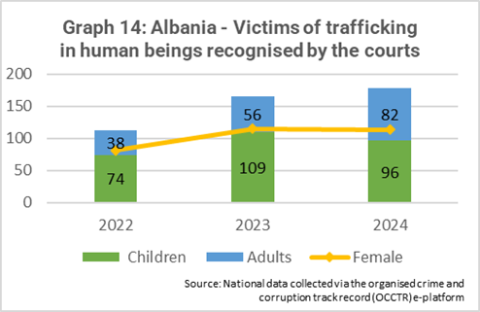
Albania continued to strengthen the fight against money laundering. The national strategy against money laundering and terrorist financing 2024-2030 adopted in July 2024 needs to be implemented effectively by all relevant actors in coordination with relevant law enforcement authorities. (See also Chapter 4 – Free movement of capital)
Albania should leverage its access to CEPOL trainings to must develop its capacity to investigate cybercrime to meet the EU’s 2022-2025 priorities for EMPACT.
Albanian authorities need to strengthen their capacity to detect, investigate and prosecute traffickers of human beings and fully implement the National Referral Mechanism for victims of trafficking. In 2024, Albania identified 178 victims, including 113 women and girls and 96 children.
On trafficking in firearms, Albania continued to strengthen its operational response, with progress noted on preventing, countering, investigating and prosecuting cases related to trafficking of weapons and ammunition. During 2024, 636 firearms, 32 411 pieces of ammunition and 2375 grams of explosives were seized. The number of domestic-violence-related firearms incidents remains high, and the capacities of law enforcement to handle cases of gender-based violence should be further improved.
Cooperation in the field of drugs
Cooperation in the field of drugs needs to be improved.
Legal alignment, strategic and institutional frameworks
Albania is partially aligned with the EU acquis in the field of drugs and still does not have a comprehensive and dedicated national drugs strategy.
Albania is party to the main international conventions on drugs but needs to ensure full alignment with these conventions with regard to the criminalisation of the trafficking of illicit drugs and on the transmission of samples of controlled substances. Albania should ensure full compliance with the EU acquis on criminal acts and penalties in respect of drug trafficking including in respect to new psychoactive substances.
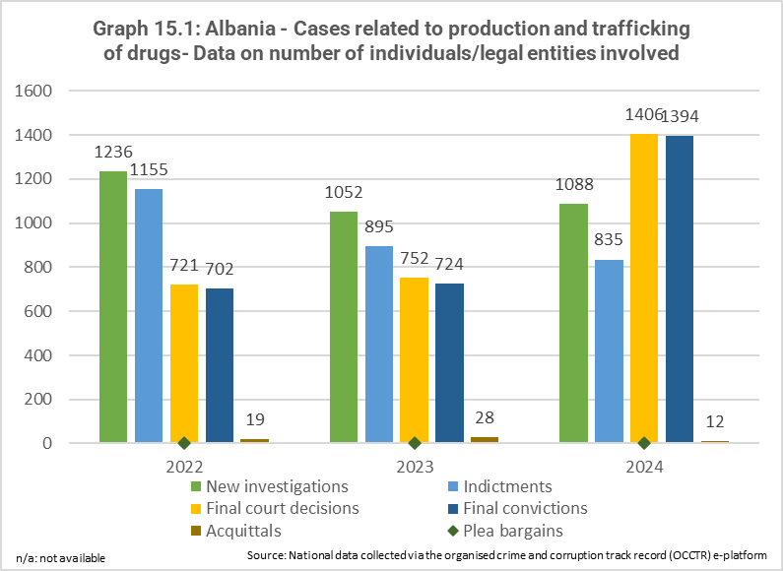
In July 2025, Albania formally established a national drugs observatory, which is still to become operational, while the functioning and output of the national early warning system on the detection of new psychoactive substances set up within the Albanian State Police needs to be increased. Further amendments to the Law on narcotic drugs and psychotropic substances were adopted in December 2024.
On the legal cultivation of cannabis for medical and industrial purposes, the National Cannabis Control Agency is active, and Albania has adopted 21 pieces of implementing legislation, including security-related provisions. Strong safeguards to prevent cannabis from being diverted to unintended use are essential and should be further developed and put in place strictly if cultivation starts in the upcoming period.
Implementation and enforcement capacity
International police and judicial cooperation are well established. Albania is actively engaged in EMPACT priorities in the field of narcotics. Most of the joint investigation teams in which Albania takes part are in the field of narcotics, confirming last year’s trend. Operational cooperation aimed at addressing drug production and trafficking in and via Albania and Albanian organised crime groups should be further enhanced.
Further efforts are needed in financial investigations to seize and confiscate the criminal assets of drug traffickers and increase the identification and the dismantling of Albanian criminal groups.
Implementation of the working arrangements with the EU Drugs Agency requires more proactive engagement, better interinstitutional coordination and regular information exchange.
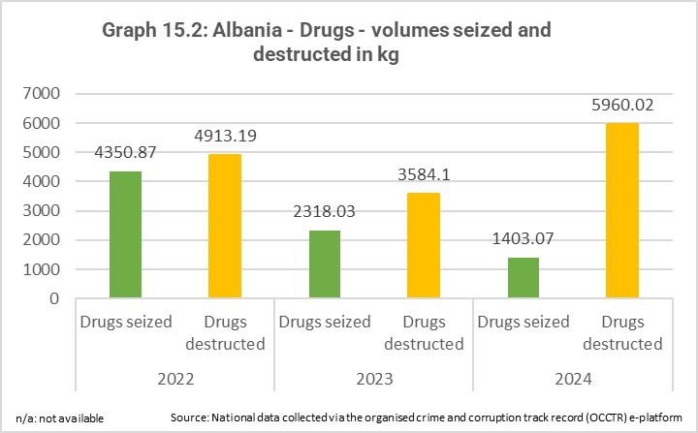
There has been a significant increase in drugs destruction in 2024, due almost exclusively to cannabis destruction. The number of cases of drug production and trafficking remained broadly stable in 2024 (compared to 2023), but with a substantial increase in the number of individuals and legal entities receiving a final court decision and/or a final conviction in 2024.
Fight against terrorism and prevention of radicalisation and violent extremism
The legal framework for the fight against terrorism and for countering violent extremism is partially aligned with the EU acquis. The fight against terrorism and the countering of violent extremism is broadly satisfactory.
The legal framework for critical infrastructure protection is not aligned with the EU acquis. The protection of critical infrastructure needs to be improved.
Legal alignment, strategic and institutional frameworks
Albania’s legal framework in the field of terrorism is partially aligned with the EU acquis. It needs to align its legislation on explosive precursors with the EU acquis. A cross-cutting strategy on prevention of violent extremism and counter terrorism 2023-2025 and related action plans, and a strategy against money laundering and terrorist financing 2024-2030 and related action plans are in place.
Albania has a national coordinator for countering violent extremism, who heads the Coordination Center for Countering Violent Extremism, created in 2017.
The level of preparation to protect critical infrastructure remained low during the reporting period. The Law on the protection of critical infrastructure is not yet adopted and should be aligned with the EU Directive on the resilience of critical entities. The protection of critical infrastructure in the area of cybersecurity is provided for by the 2024 Law on cyber security. An updated list of critical and important information infrastructure operators was adopted by the government in July 2025.
Implementation and enforcement capacity
The general terrorism threat level in Albania is assessed as low. Law enforcement and justice institutions in charge of counterterrorism work professionally and effectively. Albania has made progress in implementing the 2023-2025 Strategy to prevent violent extremism and fight terrorism, but the government needs to allocate adequate resources to implement this strategy and its related action plan. The Albanian State Police referred at least six cases of criminal offences with terrorist intent to the Special Prosecutors Office and the district prosecution offices in 2024 and 2025. Investigative and prosecutorial capacities need to be enhanced, especially at local level.
The rehabilitation and reintegration of the 38 Albanian foreign terrorist fighters and family members, officially returned from Syria/Iraq through repatriation processes is being handled effectively. Authorities should allocate an adequate budget for this work in order to ensure sustainability in the medium and long term. The government is continuing its efforts to repatriate those who remain in the Al-Hol and Al-Roj camps in Syria. Possibly over 70 Albanian citizens are still remaining in the camps.
The local dimension of prevention of radicalisation and the national-local coordination has been reinforced by the creation of the regional security councils, presided by the prefects.
Online radicalisation, radicalisation in prisons and terrorist content online remain major challenges. Monitoring of online content poses difficulties as institutional capacities and resources are limited. Albania also needs to improve its ability to monitor and combat the financing of terrorism, implementing the existing legal framework and taking into account the impact of new technologies (e.g. cryptocurrencies).
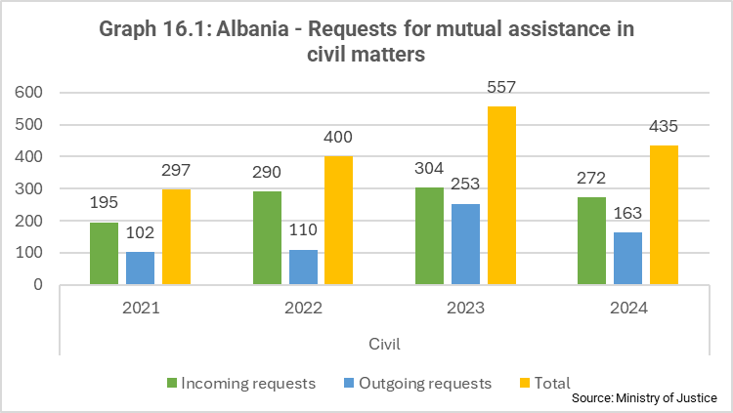
Judicial cooperation in civil and criminal matters
Judicial cooperation in civil and criminal matters with EU Member States, the European Public Prosecutor’s Office (EPPO) and Eurojust remains broadly satisfactory. In 2024, the EPPO sent three requests for mutual legal assistance to Albanian authorities. Albania was involved in 152 new cases at Eurojust related to organised crime, drug trafficking and money laundering, with a majority of them (89) opened at the request of the Liaison Prosecutor. The number of Eurojust supported joint investigation teams that Albania participated in is 25 for the period between 1st March 2024 and 31st July 2025. Most of the teams (16) continue to work in the field of narcotics.
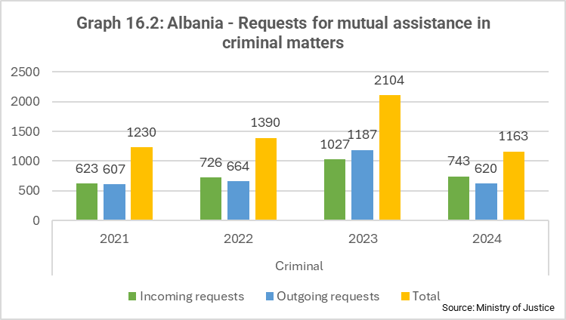
The legal framework for judicial cooperation in civil and criminal matters is partially aligned with the EU acquis to the extent that alignment is already possible. On 13 February 2025, Albania ratified the Hague Convention of 2 July 2019 on the Recognition and Enforcement of Foreign Judgments in Civil or Commercial Matters (the 2019 Judgments Convention) which will enter into force for Albania on 1 March 2026. The 2019 Judgments Convention, will strengthen cooperation between EU Member States and Albania, provide legal certainty and predictability to parties involved in cross-border transactions and will enhance access to justice.
Legal and irregular migration
The legal framework for migration is partially aligned with the EU acquis. The management of legal and irregular migration is broadly satisfactory.
Legal alignment, strategic and institutional frameworks
A revised Law on foreigners was adopted in June 2025. The implementation of a national migration strategy (2024-2030) adopted in May 2024 and its action plan (2024-2026) is currently being implemented. Continued coordination with all relevant services beyond the Ministry of Interior is needed. The strategy includes the main priorities and goals set out in the EU action plan on the Western Balkans presented by the Commission in December 2022, and is aligned with relevant national strategies and commitments made under the EU’s Global Alliance to Counter Migrant Smuggling.
Albania continues to take part in the Global Alliance to Counter Migrant Smuggling and is invited to renew its engagement at the occasion of the Global Alliance's second conference scheduled to take place at the end of 2025.
Albania obtained observer status in the European Migration Network in June 2025.
Implementation and enforcement capacity
Albania cooperated with the EU, its agencies and Member States in implementing the EU action plan on the Western Balkans, which helped further reduce the number of irregular migrants apprehended in Albania. Most irregular migrants were Syrians, Pakistani or Egyptians in 2024. A decreasing trend of irregular arrivals continued in 2025. The authorities’ regular and timely reporting on irregular migration flows and asylum continues.
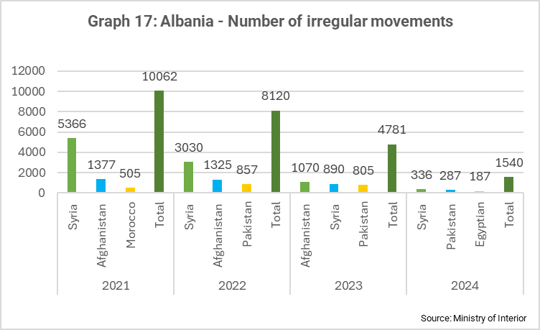
Albania currently has enough reception capacity with around 600 beds, including 220 beds in the asylum reception centre in Babrru. The long-awaited work on setting up separate reception and accommodation facilities for unaccompanied minors has started. Unaccompanied children need to be included in an effective national child protection system, and pre-screening procedures for all migrants at all border crossings need to be standardised.
The work towards an updated national contingency plan for the possible arrival of a substantial number of migrants and asylum seekers accelerated in 2025, with the assistance of the EU Agency for Asylum and European Border and Coast Guard Agency (Frontex) as well as the International Organization for Migration and the United Nations Refugee Agency. The contingency plan still needs to be adopted along with a corresponding budget.
The ability of border officers to identify vulnerable applicants for international protection and migrants needs to improve, as does their coordination with child protection and anti-trafficking units. Albania should increase the ability to conduct returns of migrants with no legal rights to stay in the country and address shortcomings identified in its return mechanism.
Albania has a readmission agreement with the EU, which is functioning well, and implementing protocols, further facilitating its implementation, signed with 14 Member States. According to data provided by the Member States to EUROSTAT in 2024, 15 125 Albanian nationals were ordered to leave the EU, and 7 805 were effectively returned. The electronic readmission case management system (e-RCMS) with Belgium has been installed but has not yet been put into operation. Cooperation between Albania and Frontex on return operations is very good.
The reintegration of returnees, especially the most vulnerable, needs to improve.
The number of nationals from non-EU countries voluntarily returned from Albania to their countries of origin remained very low: 24 assisted voluntary returns were processed in 2024 compared with 9 in 2023 (and 6 in 2022). Albania needs to make progress in establishing practical cooperation on returns of non-EU nationals with the main countries of origin and to actively step up engagement with these countries.
Albania should ensure that legal pathways developed towards third country nationals prevent irregular secondary movements to the EU.
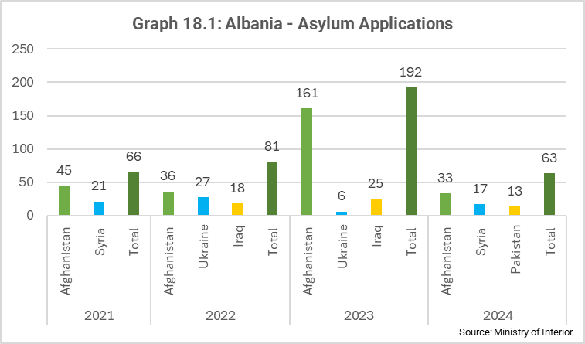
Asylum
The legal and institutional framework is in place, but asylum management needs to be improved in practice.
Institutional set-up and legal alignment
The Law on asylum is largely aligned with the EU acquis. Cooperation with the European Union Asylum Agency (EUAA) on its implementation continues under the second phase of the Albania-EUAA cooperation roadmap (2024-2027) endorsed in October 2024.
Albania has the required institutions in place to handle asylum claims. Asylum laws and its bylaws still need to be implemented effectively. This requires additional investment in administrative capacity and the development of a well-functioning asylum system.
Implementation and enforcement capacity
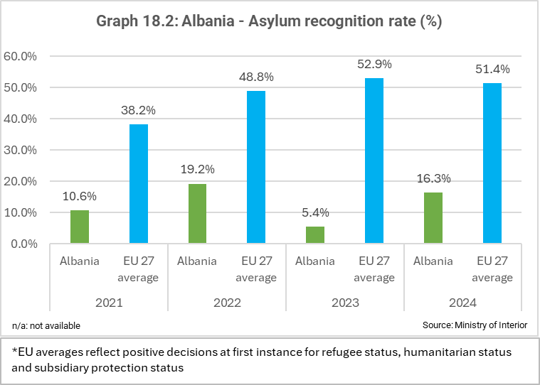
Albania remains primarily a transit country. The number of asylum requests decreased in 2024 compared with 2023, in line with a significant drop in arrivals. Out of all arriving migrants apprehended for the first time, 7.5% lodged an asylum request.
Challenges persist with the capacity of Border and Migration Police to identify and refer people who could be in need of international protection to the adequate services. The Directorate for Migration, Asylum, Anti-trafficking and Foreigners needs more technical capacity and human resources to assess asylum cases and make well-informed decisions.
Since 2018, Albania has granted refugee status to only one person. In 2024, 16 people were granted subsidiary protection.
Visa policy
Albania’s visa policy is still not fully aligned with the EU’s, in particular the list of countries whose nationals require an entry visa. Progress towards alignment is slow.
Albania still has a visa-free regime with eleven countries that are on the EU list of visa-required countries, of which six enjoy permanent visa exemption and five have a temporary visa waiver lasting from April to December (this latter practice is incompatible with the EU acquis). In April 2025, Albania removed Belarus from the list of countries benefiting from a permanent visa waiver (effective as of October 2025) and Bahrain from the list of countries benefiting from a temporary visa waiver., Albania committed to further alignment with the EU list of visa-required countries. In July 2025, Albania proposed a roadmap towards full alignment with the EU visa policy, with the envisaged deadlines for terminating each visa-free regime, both permanent and seasonal, which is a positive development
The Commission’s Seventh Report under the Visa Suspension Mechanism of 6 December 2024 concluded that Albania had taken action to address most of the previous recommendations. Albania is expected to continue actions to further reduce unfounded asylum applications by Albanian nationals to EU Member States, on top of ensuring full visa policy alignment with the EU and proceeding to more rigorous screening of non-EU nationals arriving visa free in Albania.
Schengen governance and external borders
The legislative and strategic framework for the management of external borders is partially aligned with the EU acquis.
The management of borders is broadly satisfactory. However, Albania is expected to advance the work towards the adoption of a Schengen Action Plan to establish a robust national Schengen governance system.
Legal alignment, strategic and institutional frameworks
The revised Law on border control was adopted in June 2025. Rules on advance passenger information (API) and passenger name records (PNR) are now part of a separate law also adopted in June 2025.
Implementation of the Schengen acquis needs to be further enhanced through the development of a Schengen governance system supported by a forward-looking Schengen Action Plan, which is under preparation. Albania has been invited to develop a comprehensive needs analysis to set up a national governance framework in preparation of adopting and implementing a Schengen Action Plan. This would ensure efficient and holistic implementation of its Schengen obligations, including as regards further investment in infrastructure, equipment, staffing, and training.
Implementation and enforcement capacity
The implementation of the updated Frontex Status Agreement of June 2024 is progressing well.
Implementation of the national integrated border management strategy 2021-2027 is ongoing. Border police staffing was significantly increased in 2024. In 2024, Albania carried out 1 063 joint patrols in line with respective protocols with Italy, Montenegro, North Macedonia and Kosovo*, 6% fewer than in 2023.
Following formal approval of the establishment of the National Coordination Centre for Integrated Border Management in December 2024, Albania is encouraged to ensure that it is fully functioning as soon as possible. The total information management system (TIMS) still suffers from security and data protection vulnerabilities, which need to be urgently addressed.
Euro counterfeiting (criminal law aspect)
The corresponding legislation is broadly in line with the EU acquis on the suppression of counterfeit currency.
All aspects of customs cooperation are covered in Chapter 29 – Customs Union.

2.3. Economic criteria

2.3.1. The existence of a functioning market economy
Economic governance
The government remained committed to maintaining macroeconomic stability and boosting growth. In 2024, the fiscal outturn improved compared to previous years and outperformed budget targets, but this was partly the result of under-executed capital spending. The practice of amending the budget via normative acts rather than by using the regular legislative process continued (with three budget revisions in 2024 and two until July 2025). The Medium-Term Revenue Strategy (MTRS) 2024-2027, adopted by the Council of Ministers in December 2024, aims to increase public revenues (by ALL 64.8 billion or about 2.6% of 2024 GDP) mainly by improving tax and customs administration (85% of the expected revenue increase) rather than changing tax policies. Albania submitted its 2025-2027 Economic Reform Programme (ERP) to the European Commission on time in mid-January 2025. The ERP emphasised the government’s commitment to maintaining macroeconomic stability, achieving surpluses in the primary balance and abiding to the fiscal rules set out in the organic budget law. Albania also committed to socio-economic and fundamental reforms to accelerate growth and convergence with the EU.
The implementation of the policy guidance set out in the conclusions of the Economic and Financial Dialogue of May 2024 has been partial. Albania complied with the fiscal rules on the budget balance and on public debt and stepped up the pace of fiscal consolidation given better-than-expected economic and revenue performance. Arrears continued to build up throughout 2024 and, although the end-of-year target for their reduction was achieved, the reliance on ex post clearance through budget reallocations should gradually be phased out. Tax revenue as a share of GDP increased in 2024 and a stand-alone fiscal risk statement has been drafted but not published. The transparency and accountability of state-owned enterprises (SOEs) still needs to be improved. The authorities worked on the public-private partnerships (PPPs) law, but the draft law is pending parliamentary approval. PPPs are not yet integrated into the National Single Project Pipeline.
Macroeconomic stability
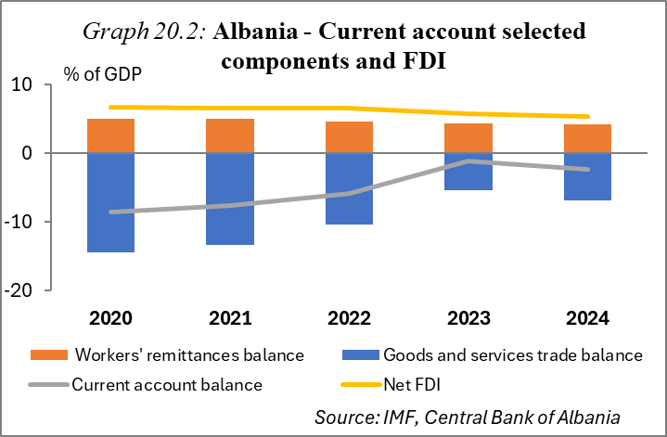
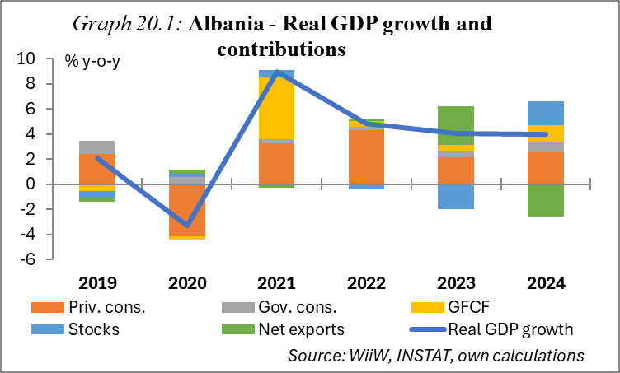
The economy maintained a strong growth momentum. Following 4% GDP growth in 2023, economic expansion remained strong at 4% in 2024, driven by robust domestic demand, good tourism performance and sustained construction activity. The rise in household consumption was supported by increasing real wages amid slowing inflation, and by stronger credit growth. Public consumption growth was elevated on the back of the second phase of the public wage reform. Job creation in the services sector supported employment growth. Exports of services expanded, but goods exports fell significantly due to the appreciation of the lek and an unfavourable external environment. Overall, the contribution of net exports to GDP growth was negative. Most economic sectors recorded positive output growth, but agriculture and industry contracted. Economic activity continued to expand in 2025, with GDP registering an annual growth rate of 3.4% in the first quarter. Albania’s GDP per capita in purchasing power standards stood at 37% of the EU-27 average in 2024 compared to 30% in 2019.
The current account deficit remained moderate. It increased to 2.4% of GDP in 2024, following a historic low of 1.2% of GDP in 2023. The widening of the deficit in 2024 was primarily driven by a rise in the goods trade deficit, due to a decline in exports and a continued increase in imports driven by the rapid expansion of domestic demand. The services balance remained in robust surplus, driven by tourism. The surplus of the secondary income balance fell, with remittances declining from 4.3% of GDP in 2023 to 4.2% in 2024 (despite their nominal increase). The primary income balance was slightly negative at 0.8% of GDP. In the first quarter of 2025, the current account deficit narrowed, with its rolling 4-quarter total standing at 2.1% of GDP (mainly due to an increase in exports of goods and services). Net foreign direct investments (FDI) inflows remained the primary source of financing the current account deficit in 2024. They grew by 7% year on year in 2024, but their share of GDP declined to 5.4%, from 5.8% one year earlier. The real estate sector remained the largest recipient of FDI flows. International reserves increased to EUR 6.2 billion in December 2024, covering seven months of imports of goods and services. The external debt-to-GDP ratio has been on a declining trend and fell by 0.7 pps to 46.8% in 2024.
Inflation fell below the 3% central bank target. Annual inflation averaged 2.2% in 2024, down from 4.8% in 2023 and a high of 6.7% in 2022. This steady disinflation has been driven by lower food and commodity prices and an appreciating domestic currency. Imported inflation reached historically low levels in 2024 amid exchange rate appreciation. On the other hand, domestic inflationary pressures have moderated more gradually amid strong demand and a tight labour market. Core inflation also fell in 2024. The Bank of Albania implemented two reductions in the key policy interest rate in 2024, lowering it from 3.25% to 2.75%, and a further cut in July 2025, to 2.5%. In the first two months of 2025, inflation recorded a slight decline to 1.9% and then picked up to 2.5% in July 2025.
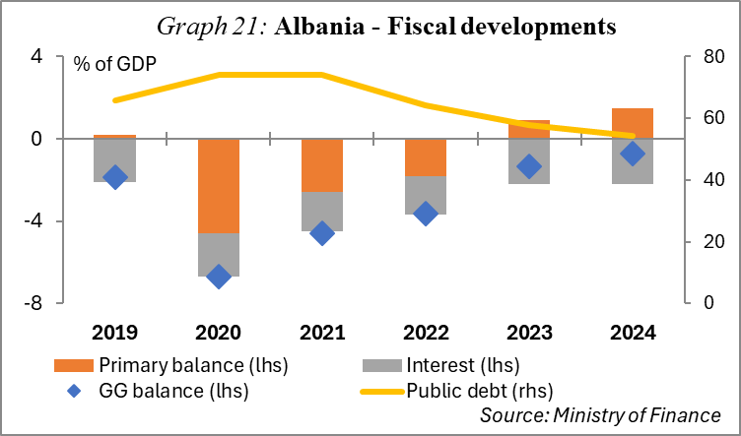
Fiscal consolidation accelerated in 2024, but the budget deficit is set to increase markedly in 2025. The budget deficit fell from 1.3% of GDP in 2023 to 0.7% of GDP in 2024, significantly undershooting the deficit target of 2.3% of GDP. While revenues performed well, this fiscal outcome was partly the result of public investment under-execution. The primary balance surplus stood at 1.4% of GDP (up from 0.7% of GDP in 2023), supporting the decline in the public debt ratio, which fell by 3.4 pps to 54.2% of GDP in 2024. However, gross financing needs remain elevated. The 2025 budget, adopted in December 2024, projects the deficit to increase to 2.6% of GDP. In the first eight months of 2025, the budget execution showed a fiscal surplus of 1.6% of GDP. Tax expenditures, estimated at 4-5% of GDP , and high levels of informality still constrain the revenue base. As part of the MTRS implementation, in June 2025 the government finalized a report on existing tax exemptions, but the assessment has not been made public and concrete proposals to eliminate those exemptions that are not well justified have not yet been developed. In 2025, Albania amended the income tax law and extended its significant tax incentives for luxury hotels, which goes against Albania’s commitment to reduce tax expenditures. A higher public-revenue-to-GDP ratio is crucial to sustain investments in both physical and human capital while firmly anchoring the downward trend in public debt.
The regulatory framework for public investment management (PIM) has been improved in recent years, but challenges remain. In February 2024, the government updated the PIM guidelines introducing clarifications, including on the role of the Ministry of Finance in certain situations, and that of the Agency for Strategic Planning (SASPAC). Changes to the legal framework were also made in March 2025, when the government approved amendments to the Decision of the Council of Ministers (DCM) No 887/2022 on PIM procedures, including quarterly updates to the National Single Project Pipeline (NSPP) and increased flexibility for feasibility studies. Yet, the planning and execution of public investment projects continues to face significant obstacles in the form of capacity constraints, incomplete project proposals, delays and cost overruns, and an occasional lack of adherence to procedures. The recurrent under-execution in capital spending is a clear indication that shortcomings exist in the operationalisation of the new legal framework and of the NSPP.
Albania implemented an overall appropriate macroeconomic policy mix. It helped sustain macroeconomic stability and supported economic growth. On the fiscal side, the budget deficit narrowed, the surplus in the primary balance increased while the public debt ratio continued its downward path. As disinflation accelerated, with inflation falling below the central bank target, monetary policy was eased. At the same time, bank supervision has been prudent, with the countercyclical capital buffer raised twice amid strong credit expansion.
Functioning of product markets
Business environment
The business environment remains challenging. Businesses welcome the fact that there has been some progress on the justice reform and anti-corruption matters, but lengthy court procedures persist (see Chapter 23 – Judiciary and Fundamental Rights). The business environment also remains affected by weaknesses in the rule of law, informality and limited access to finance for SMEs, particularly farmers. Bureaucracy and lengthy licensing procedures, combined with problems of consistency in case law, create burdens for businesses. Clear policies that encourage effective tax compliance and reduce tax evasion would help formalise more businesses and broaden the tax base. Granting of strategic investor status and PPP/concession contracts are often considered non-transparent by businesses. The country also struggles with incomplete and inconsistent property title registration, leading to uncertainty and disputes over ownership which deter investment. Although Albania has made efforts to modernise its property system through cadastre digitalisation, progress has been slow and uneven. Despite efforts towards deregulation and facilitation of business-related services, the responsiveness of public institutions to deliver efficient services is slow, while service delivery remains heavily centralised in Tirana, leaving rural regions underserved. The effectiveness of public consultation processes continues to show room for improvement.
State influence on product markets
The adoption of a unified investment law has been further postponed, while the Law on strategic investment has been extended until 2026. Work on establishing a harmonised legal framework for investments started years ago but progress has stalled. This initiative seeks to replace the existing Law on strategic investment, providing a more cohesive and transparent legal environment for both domestic and foreign investors. Meanwhile, in February 2025, Parliament amended the Law on strategic investment, extending its effects until 2026, and included in the strategic investor category investments worth EUR 50 million or more, irrespective of the sector, provided they received prior approval from the line Ministry. While these measures are designed to boost economic activity, they have also raised concerns about transparency and equitable access, favouritism and lack of competitive processes.
The Bank of Albania introduced an SME financing programme. In early 2025, in collaboration with the government, the central bank launched a financing scheme to improve credit access for SMEs, particularly in agriculture, which is a sector that accounts for only 2% of loans to businesses. The Bank of Albania aimed to finance the programme with EUR 250 million, offering loans through commercial banks. It also included a sovereign guarantee covering up to 70% of loan principals. Interest rates are capped at 3.5% or lowered to 2% if the sovereign guarantee applies. The deadline for applications is end of 2025.
Privatisation and restructuring
Regulation allowing for privatisation of public assets, land or movable assets, has been amended. Albania introduced several amendments to the regulation that provides for the privatisation of public assets. Under the revised rules, entities that have secured long-term lease contracts for public assets at symbolic rates (e.g. EUR 1) and used the state-owned assets/land for over a decade can purchase those assets under certain conditions. The implementation of this initiative should ensure equal treatment of investors. The government also adopted regulations to facilitate the transfer of public assets to the Albanian Investment Corporation for further development and revitalisation programmes in partnership with private investors. In March 2025, Parliament adopted the ‘Mountain package’ legislation. This initiative aims to stimulate economic growth in Albania’s mountainous regions by promoting investments in sectors like tourism and agriculture, by providing fiscal incentives and by offering some benefits on land acquisition for those investing in these areas. It is essential to safeguard Albania’s ecological and biodiversity values and ensuring full transparency throughout the process.
SOEs pose fiscal risks, and their governance still needs to be improved. SOEs, in particular the state-owned energy utilities, receive loans from the central government but repayment is unpredictable, while the financial viability of some of these companies is weak. Due to the risks posed to the budget, monitoring SOEs is crucial. The Fiscal Risk Unit of the Ministry of Finance expanded the number of monitored SOEs to 12. Technical assistance is also ongoing to improve SOEs’ financial reporting practices and the monitoring of their financial performance. The publication of annual financial performance reports by SOEs should become standard practice, while strengthening SOEs oversight remains essential. Weak governance of SOEs contributes to market distortions and unfair competitive conditions. =.
Functioning of the financial market
The banking sector remained well-capitalised and profitable, while the non-performing loans ratio decreased. At aggregate level, banks had a capital adequacy ratio of 19.8% in December 2024, which is well above the Albanian minimum requirement of 12%. Following very good performance in 2023, banks’ profitability continued to improve in 2024, supported by increasing net interest income, higher income from fees and commissions, and the decrease in loan-loss provisions. The non-performing loans ratio stood at 4% in July 2025, down from 4.7% a year earlier. Driven by higher demand and favourable financing conditions, private sector credit accelerated in 2024. Nevertheless, the level of financial intermediation remained low – the share of private sector loans in GDP stood at 33% in the first half of 2025. The high share of government securities among banks’ assets continues to expose them to sovereign risk. Good progress has been made in collecting data on banks’ exposure to the real estate sector and in monitoring credit standards for real estate loans. The Bank of Albania took new borrower-based macroprudential measures to address potential risks in the real estate sector. It has also increased the countercyclical capital buffer to 0.5% (effective from December 2025). Efforts to strengthen oversight of non-bank financial institutions should continue.
In March 2025, the law establishing the Albanian Development Bank as a deposit-taking institution was adopted. The law raises major concerns regarding compliance with EU competition and State aid rules in the field of banking. The development bank must have an operational framework that mitigates moral hazards and fiscal risks from state guarantees, and complies with best practices in terms of governance as well as appropriate supervision and regulation applicable to other deposit-taking institutions, to ensure transparency, sound lending practices, adequate deposit protection and a level playing field in the banking sector.
Functioning of the labour market
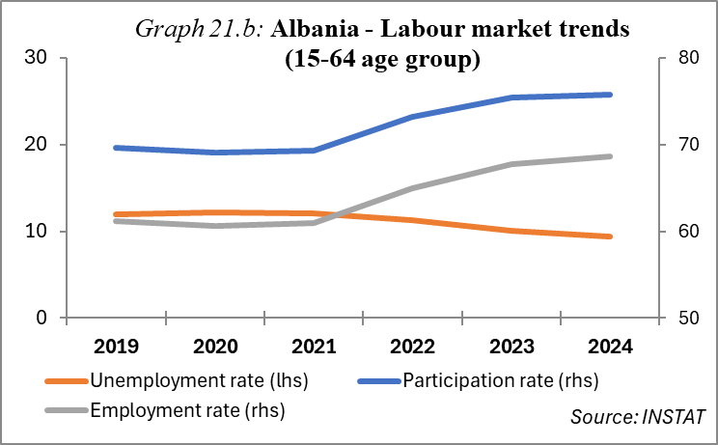
The labour market registered positive developments, but it faces structural issues. Albania’s labour market exhibited notable improvements in 2024, with an increased employment rate (a 1.5 pps year-on-year increase to 68.3% in Q4-2024) and higher wages, alongside a decline in the unemployment rate (a 0.6 pps year-on-year drop to 9.6% in Q4-2024). The youth unemployment rate also improved compared to one year earlier, falling from 21.2% to 19.1%, but it remains elevated. The Youth Guarantee Scheme piloting in three municipalities was extended until 2027. Informal employment remains an issue, with many workers lacking formal contracts, social security, and legal protections, while the underreporting of wages is widespread, eroding pensions. Emigration, especially of skilled workers, exacerbates labour shortages in key sectors, contributing to a brain drain. Insufficient active labour market policies hinder workforce adaptability and limit opportunities for higher-quality employment. The coverage of Albania’s social assistance system remains inadequate. The tripartite collaboration between the State Labour and Social Services Inspectorate, trade unions and employer organisations remains weak. Albania adopted in June 2025 a policy document on aging and an action plan for 2025-2030.

2.3.2. The capacity to cope with competitive pressure and market forces within the EU
Education and innovation
The education system faces challenges, hindering the build-up of a skilled and competitive workforce. Albania continued to implement the National Education Strategy 2021-2026, which aims to improve quality of education and access and adaptation to the labour market. Nevertheless, the education system is faced with low educational attainment and high dropout rates, particularly in rural areas and among marginalised communities. Albania’s not in education, employment, or training (NEET) rate for youth aged 15-29 stands at approximately 24% in 2023, significantly higher than the EU average. The quality of education is often hindered by outdated curricula, insufficient teacher training and outdated infrastructure. Furthermore, there is limited access to early childhood education. The education system also struggles with inclusivity, particularly for children with disabilities and those from disadvantaged backgrounds. The lack of effective vocational education and training (VET) hinders workforce adaptability and limits opportunities for higher-quality employment. Nevertheless, efforts were made to address some weaknesses, by updating curricula, introducing traineeship programmes, and piloting an apprenticeship programme (work-based learning) (See Chapter 26 – Education).
Public spending on research and development (R&D) is limited. Albania aims to spend 1% of GDP on R&D in 2030, but currently figures are way below the official target. In December 2024, Albania adopted the Strategy on Innovative Entrepreneurship. Besides increasing public R&D expenditure, further efforts are needed to incentivise businesses to increase their R&D expenditure and encourage cooperation between the private sector and universities.
Physical capital and quality of infrastructure
Transport infrastructure development is advancing. Albania continued its public investment in infrastructure, mainly roads, but also railways. Progress has been made on major highways such as the Adriatic-Ionian Highway and Corridor VIII, which are part of the trans-European transport network (TEN-T). The construction of the Tirana–Durrës railway and the railway connection to the airport is ongoing (approx. 80% complete), while the construction of the new airport in Vlora through a concessionary contract is in its final stage. According to the authorities, all transport infrastructure projects that are part of the TEN-T for all modes of transport are included in the Albanian NSPP. While infrastructure projects are advancing, gaps remain, and the recurrent issue of the under-execution of public investment is slowing down the build-up of the capital stock.
Investment in digital infrastructure advanced in 2024. Albania completed the authorisation process for 5G services, granting licences to two mobile operators The number of broadband subscribers grew by 10% compared to 2023, and the mobile broadband penetration rate increased by 15.4%. Several operators reportedly upgraded their networks to deliver faster internet services, primarily through advanced fibre-optic infrastructure capable of supporting high and very high-speed data transmission.
Steps have been taken to improve energy efficiency. In June 2025, Parliament approved a Law on energy performance of buildings. Albania also approved a long-term renovation strategy focusing on improving energy efficiency in buildings and decarbonising the energy sector, including also measures to reduce greenhouse gas emissions, integrate renewable energy and improve energy security (see Chapter 15 – Energy).
Sectoral and enterprise structure
The structure of the economy remains similar to the previous year. The structural survey of enterprises shows that, in 2023, micro, small, and medium-sized enterprises dominated Albania’s economy, comprising 99.9% of all enterprises. These businesses employed 82.5% of the total workforce and contributed 78.2% of the total value added by non-agricultural sectors. According to the 2023 data on the trade in goods by enterprise characteristics, SMEs accounted for 65% of total goods exports, marking a decline of 8.9% compared to 2022. The number of newly registered foreign companies (with 100% foreign ownership) reached 1 423 in 2024, reflecting an 11% increase compared to the previous year.
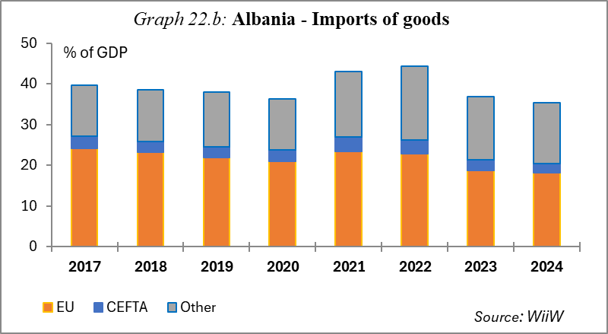
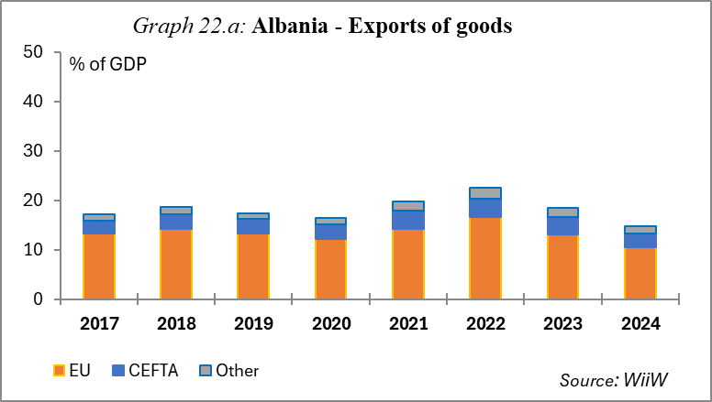
Economic integration with the EU and price competitiveness
The EU remains Albania’s main trading and investment partner. Trade openness (the sum of total exports and imports as a share of GDP) declined from 82.4% in 2023 to 79.5% of GDP in 2024, as exports of goods fell. The EU remained Albania’s main trading partner. In 2024, the EU accounted for 57.4% of Albania’s goods trade, absorbing 71.7% of Albania’s merchandise exports and providing 51.5% of its goods imports. Italy (43.7%), Kosovo (9.9%), Greece (6.3%), and Germany (5.9%) were the leading export destinations. The country’s main import partners were Italy (21.1%), China (10.9%), Türkiye (10.8%) and Greece (7.6%). The EU also remains the main source of FDI inflows, while the EU’s share of FDI stocks stood at 54.1% (from 54.4% in 2023). Albania’s price competitiveness deteriorated, as reflected in the appreciation of the real effective exchange rate, the increase in nominal wages and lower goods exports. Manufacturing exports are sensitive to exchange rate appreciation, due to their low value added and businesses’ low pricing power. They are outweighed by services exports (in particular travel services, which more than doubled in value between 2019 and 2024), which provide some 80% of Albania’s total exports. SMEs accounted for 69% of total goods exports, marking a decrease of 10.3% compared to 2023.

2.4. Public procurement, statistics, financial control

Chapter 5: Public procurement
EU rules ensure that public procurement of goods, services and works in any Member State is transparent and open to all EU companies on the basis of non-discrimination and equal treatment.
Institutional set-up and legal alignment
The legal framework on public procurement is largely aligned with the 2014 EU Directive on public procurement and procurement of utilities. A number of implementing legislations were adopted in September 2024 to implement the amended Law on public procurement (PPL).
The transitional provision in the new PPL authorising central government institutions to negotiate and conclude international consultancy agreements in ‘areas of strategic interest’, thus exempting them from opening competition, continues to raise concerns over its compliance with the EU acquis and with the Stabilisation and Association Agreement.
The Law on concessions and public-private partnerships (PPPs) is partially aligned with the EU acquis. Work on a substantial revision of the PPP law with a view to aligning it with the EU acquis has not yet been concluded.
Implementation and enforcement capacity
Albania’s public procurement market represented 16.5% of GDP in 2024 (compared to 6.7% of GDP in 2023). The use of negotiated procedures without prior publication reduced in 2024, both in number of procedures (2.3% of all procedures from 2.9% in 2023) and in related value (0.4% of total value from 2% in 2023). There was a significant increase in new framework contracts; both in numbers (1 601 in 2024, from 767 in 2023) and in terms of value. This is attributed in part to the start of operations of the newly set-up Central Procurement Organisation.
The application of the most economically advantageous tender criteria (MEAT) for the award of public procurement contracts increased in 2024, both in terms of awarded tenders in which it was used (4.8% in 2024 compared with 3.6% in 2023,), and particularly in terms of value of associated contracts (41% in 2024 compared with 20.3% in 2023). PPA has issued new guidelines on the use of MEAT in September 2024 and has increased related training.
The use of new PPPs and concessions remains at very low levels. In 2024, only one procedure was launched and none was awarded.
The contracting authorities need to continue to build capacity to manage public procurement processes. Work has started on preparation of technical specifications for an upgrade of the electronic procurement system. Ongoing training continued with 3 139 (247 in 2023) participants being registered from 443 (98 in 2023) central, local and independent institutions and private entities in 2024.
On prevention of corruption in public procurement, Albania should focus on further strengthening the functioning of the overall system to increase competition, compliance and professionalisation.
Efficient remedy system
The constitution and the PPL contain provisions on the right to legal remedy that are mostly in line with the directives on remedies. The implementation capacity of the State Appeal Commission (SAC) needs to be further strengthened in view of the significant number of appeals it receives (1 151 in 2024, 1 019 in 2023). In 2024, the Public Procurement Commission (PPC) made 1050 decisions, 42 of which were challenged in court.

Chapter 18: Statistics
European statistics are developed, produced and disseminated by EU Member States, guided by the principles and quality criteria set out in the Regulation on European statistics, such as professional independence, impartiality, reliability, accessibility and statistical confidentiality. Common rules are provided for the methodology, production and dissemination of statistical information, which are further specified in sectoral legislation that constitute the EU acquis on statistics.
On the statistical infrastructure, Albania’s legislation is in line with European standards and respects the principles of European Statistics Code of Practice, and most classifications are in line with EU standards. Staff posts increased to 260 (+24) and recruitment is ongoing, but INSTAT continues to face capacity constraints and staff turnover. INSTAT needs to continue investing in its IT infrastructure, particularly on cybersecurity.
On macroeconomic statistics, Albania completed its benchmark revision of annual and quarterly national accounts from 1995, and revised government finance statistics (GFS) for the time series 2010-2023. Further progress is needed to compile and transmit data fully consistent with ESA 2010. Further efforts are in particular needed to compile and transmit excessive deficit procedure (EDP) and GFS data consistent with ESA 2010 and to address observed anomalies in reported data. In addition, the labelling of GFS data submitted to Eurostat as “non publishable” continues to raise strong concerns on transparency. Data gaps remain in the areas of statistics of R&D, international trade in goods, foreign direct investment and the international investment position.
On business statistics, short-term statistics are produced but some data sets are still not transmitted to Eurostat.
On social statistics, final census results at different territorial levels were released in 2024. Thematic analysis of census data should continue. The 2021 EU-Labour Force Survey methodology needs to be implemented and regular data transmission to Eurostat restored. Crime statistics are published yearly.
Agricultural statistics are partly aligned with the EU acquis. The agricultural census has been postponed to 2026 and work should continue to update work plan and budget, ensure the adoption of the agricultural census law, finalise the questionnaire and ensure the census logistics organised.
Environmental statistics are partly aligned with the EU acquis. Despite some improvements in the area further efforts are needed to comply with the EU acquis. Albania needs to start the compilation of Environmental Goods and Services Sector Accounts and Environmental Protection Expenditure Accounts. Energy statistics are partly aligned, and further work is required to reach full alignment with the EU acquis. Significant efforts should be made on transport statistics, including the organisation of the full scale survey on road freight transport in 2026.

Chapter 32: Financial control
The EU promotes the reform of national governance systems to improve managerial accountability, sound financial management of income and expenditure, and external audit of public funds. The financial control rules further protect the EU’s financial interests against fraud in the management of EU funds and the euro against counterfeiting.
Public internal financial control (PIFC)
A specific strategic framework for PIFC is in place. PIFC reports continued to be prepared annually. The internal control system remains partially effective and further efforts remain needed to advance the implementation of PIFC reforms. Risk management remains at an early stage.
Managerial accountability is embodied in the legislation. However, the number of administrative decisions delegated to lower levels remains very limited in practice.
The legislative framework on internal audit is in line with international standards. The implementation of the new system for the advanced certification of auditors continued. In 2024, the Central Harmonisation Unit assessed compliance with manuals and instructions of the internal audit activities of 20 internal audit units. It found that 37%, were partially or fully compliant, similar as in 2023.
External audit
Albania’s legal framework safeguards the independence of the State Audit Institution. The institutional capacity of the State Audit Institution stood at 216 staff out of a foreseen 243, broadly similar as in 2023. The quality of audit work continued to comply with the standards of the International Organisation of Supreme Audit Institutions (INTOSAI). The impact of audit work progressed. 99% of recommendations issued in 2024 audits were accepted, of which 47% were fully or partially implemented. Albania should improve implementation of external audit recommendations. The parliamentary subcommittee on audit has held several hearings during the reporting period and issued resolutions in relation to a number of audits by the Albanian Supreme Audit Institution (ALSAI), which is a positive trend.
Protection of the EU’s financial interests
Albania has some level of alignment with the EU acquis in the area. However, full harmonisation of its legislation with the EU Directive on the fight against fraud to the EU’s financial interests by means of criminal law remains needed. A national anti-fraud strategy was adopted in May 2025. The national anti-fraud coordination service network met regularly. Yet, there is the need to clarify the role of the authorities of the anti-fraud coordination service (AFCOS) network in relation to protecting EU’s financial interests.
Further efforts remain needed by Albania to develop a solid track record on cooperation with the European Commission on investigations and on reporting of irregularities as well as effective operational assistance to the European Anti-Fraud Office (OLAF). In 2024, Albania reported 60 cases of irregularities via the Irregularity Management System.
Protection of the euro against counterfeiting
No developments were reported regarding alignment with the EU acquis on the definition of counterfeit banknotes and coins on the procedures for gathering, storing and withdrawing them from circulation. In 2024, Albania withdrew from circulation 573 euro coins and 214 euro banknotes, representing 82% of all seized counterfeit currencies.

3. Good neighbourly relations and regional cooperation
Good neighbourly relations and regional cooperation form an essential part of Albania’s European integration process. They contribute to stability, reconciliation and a climate conducive to addressing open bilateral issues and the legacies of the past.
Albania continued to actively engage in a number of regional cooperation initiatives, such as the Central European Free Trade Agreement (CEFTA), the Energy Community, the Transport Community, the South-East European Cooperation Process (SEECP) and the Regional Cooperation Council (RCC). Albania held the chairmanship-in-office of the SEECP in 2024-2025, which concluded with a Summit in Tirana on 16 June 2025. Albanian customs chaired the CEFTA sub-committee on customs and rules and organised in June in Tirana the Second High-Level Conference of Customs Directors General of the Western Balkans and EU Member States reaffirming the commitment to Deeper Economic Integration and Customs Cooperation.
Albania has actively engaged in the regional dimension of the Growth Plan for the Western Balkans, participating in both ministerial and leaders’ meetings, and hosted the February leaders’ meeting in Tirana. The hosting of the European Political Community Summit on 16 May 2025 was a further sign of Albania’s commitment to regional cooperation.
On the Common Regional Market (CRM) at the Berlin process summit in London in October 2025, the leaders of the region endorsed a revised and streamlined action plan to implement the Green Agenda for the Western Balkans, adopted a Western Balkans Climate Adaptation Roadmap and committed to make progress in the promotion of regional mobility and implementation of relevant regional agreements and CEFTA decisions. Albania signed the fifth mobility agreement on access to higher education and admission to studies in the Western Balkans and adopted the CRM action plan 2025-2028. Albania has ratified all five regional mobility agreements. The roadmap for roaming between the Western Balkans and the EU entered the first phase of implementation. Twelve major decisions were agreed by the CEFTA Joint Committee in October 2024, following an agreement between CEFTA members that allowed decision making in the organisation to be unblocked. A decision was finally taken on the appointment of a director for CEFTA after the post had been vacant for two and a half years. This had a significant negative impact of the work of CEFTA and, for a short period, saw the Commission suspend its support.
Albania generally maintains good bilateral relations with other enlargement countries and neighbouring EU Member States.
Relations with Bosnia and Herzegovina were upgraded after Albania opened an embassy in Sarajevo in May 2025, and the two countries’ representatives continue to make high-level visits.
Albania’s relations with Kosovo remained good. In December 2024, the parliaments of Albania and Kosovo held a joint plenary session in Pristina, with the participation of the two Prime Ministers. The two parliaments adopted a joint declaration pledging, among other things, to coordinate their national agendas with the goals of Albania’s EU accession and demanded serious engagement to advance Kosovo-Serbia dialogue in close cooperation with the EU and the US. In March 2025, Albania signed a joint declaration on defence cooperation with Kosovo and Croatia.
Relations with Montenegro remained good. High-level and political contacts continued.
Relations with North Macedonia remained good. Several bilateral agreements are in place on joint cooperation in a number of areas, including security, defence, infrastructure, energy, education, science and culture.
Relations with Serbia remained good overall, with regular high-level political contacts.
Relations with Türkiye were further strengthened with a visit of the Turkish President to the country in October 2024. During this visit, a joint declaration on deepening the strategic partnership was signed. Türkiye provided regular support to modernise the Albanian armed forces including donations in military drones. In July 2025, Albania and Türkiye signed a new protocol on defence cooperation, enhancing the existing cooperation framework Türkiye continued to put pressure on Albania to deliver on dismantling the ‘Gülen’ movement in the country. During his visit to Albania, the Turkish President inaugurated the Namazgah mosque in central Tirana, which is now the largest mosque in the Balkan region. A delegation from Türkiye’s Grand National Assembly’s Foreign Affairs Committee visited Albania.
Relations with Georgia remained good. Bilateral relations are active in international fora. Albania supports Georgia’s territorial integrity and sovereignty.
Relations with the Republic of Moldova remained good. In May 2025 Albania and Moldova signed a Memorandum of Understanding to enhance cooperation on EU accession.
Relations with Ukraine further intensified in the reporting period, with the opening of the Albanian Embassy in Kyiv at the end of 2024. In September 2024, Albania signed the Joint Declaration of Support for the Recovery and Reconstruction of Ukraine along with 30 other countries. A bilateral agreement on security cooperation and long-term support was signed in January 2025. Albania participated in the Ukraine–Southeast Europe Foreign Ministers’ meeting which took place in Kyiv in January 2025 and in the Ukraine–Southeast Europe Summit which took place in Odesa in June 2025. Ukraine’s Deputy Prime Minister for European and Euro-Atlantic Integration of Ukraine who also serves as Minister of Justice and Chief Negotiator visited Tirana in July 2025. In January 2025, Albania and Ukraine signed a Memorandum of Understanding to strengthen cooperation in their EU accession processes.
Relations with Greece remained good overall, and political contacts continued.
Relations with Italy remained very good, as also reflected in the exchange of high-level visits. In September 2024, the two countries signed a bilateral Memorandum of Understanding between the respective national cybersecurity agencies. During the reporting period, implementation of the protocol on migration cooperation between Italy and Albania of November 2023 continued. Four operations to transfer migrants to Italian centres in Albania were carried out. These were legally challenged by the competent Italian judicial authorities.

4. Ability to assume the obligations of membership

Cluster 2: Internal market
This cluster covers: free movement of goods (Chapter 1); freedom of movement for workers (Chapter 2); right of establishment and freedom to provide services (Chapter 3); free movement of capital (Chapter 4); company law (Chapter 6); intellectual property law (Chapter 7); competition policy (Chapter 8); financial services (Chapter 9) and consumer and health protection (Chapter 28). This cluster is key to Albania’s preparations for the requirements of the EU’s internal market and is very relevant for the development of the Common Regional Market.

Chapter 1: Free movement of goods
The free movement of goods ensures that many products can be traded freely across the EU based on common rules and procedures. Where products are governed by national rules, the principle of the free movement of goods prevents these rules from creating unjustified barriers to trade.
General principles
Albania has a national roadmap for alignment of acquis in the area of free movement of goods, with an Action Plan for legal alignment and capacity building in the medium term (2023-2025) and the long term (2026-2030) and should increase the pace of its alignment to the acquis in this chapter.
Non-harmonised area
Albania has extended the scope of its ongoing work on drafting an Action Plan for screening national technical regulations to comply with Articles 34-36 of the TFEU in the non-harmonised area.
Harmonised area: quality infrastructure
In January 2025, further staff were recruited to the ministry responsible (Ministry of Economy, Culture and Innovation (MECI)). Market surveillance needs to be reinforced. From September 2024 to July 2025, 1 295 market surveillance inspections were carried out, resulting in 26 warnings, 15 fines, and one emergency measure.
Albania’s legislation on accreditation, on market surveillance and on conformity assessment remains partially aligned with the EU acquis. It has a high level of alignment in regard to standardisation. Albania’s General Directorate of Standardisation continues to address the issues identified by the peer review of the European Committee for Standardisation (CEN) and the European Committee for Electrotechnical Standardisation (CENELEC) following its application to become a full member of CEN/CENELEC. National standards are adopted in line with EU standards. There are now 115 conformity assessment bodies in Albania that have been accredited by Directorate of Accreditation (DPA), compared with 118 in 2024, including 56 testing laboratories, one calibration laboratory, and 24 inspection bodies. The General Directorate of Metrology is fully staffed and operational. Albania has not prepared its legislation to be aligned with the EU requirements on notification of national legislation.
Harmonised area: sectoral legislation
In the area of ‘new and global approach’ product legislation, there were no developments on alignment with the EU acquis.
On ‘old approach’ product legislation, there were no developments on alignment with the EU acquis, including on registration, evaluation, authorisation and restriction of chemicals (REACH); on chemical classification, labelling and packaging, on motor vehicles, on aerosol dispensers, and on detergents. Albanian legislation remains partly aligned on drug precursors, though the list of controlled substances already complies with the relevant lists in the EU acquis.
On procedural measures, there were no developments on alignment with the EU acquis, including on the return of cultural objects unlawfully removed from the territory of an EU Member State.
Albania has anti-corruption measures in place on transparency on accreditation, conformity assessment, tariffs, legal acts and the activities of public bodies. Some agencies and the customs administration that perform market surveillance have rules on transparency, ethics and conflicts of interest, and are subject to audits. However, more efforts are needed in terms of enforcement.

Chapter 2: Freedom of movement of workers
Citizens of one Member State have the right to work in another Member State and must be given the same working and social conditions as other workers.
On access to the labour market, in the period January-December 2024, 1 314 EU citizens benefited from the simplified procedure. Employment in civil service positions and in the state police require Albanian citizenship.
A national migration strategy for 2024-2030 is in place, accompanied by an action plan 2024-2026. In 2024, Albania issued a total of 11 224 work permits, 1 314 among those were granted to EU citizens. In preparation for joining the European network of employment services (EURES), Albania has put in place an integrated database for its employment services that, upon its connection to EURES, can facilitate exchanges of information between IT departments on civil status, the tax system, the compulsory healthcare system and the economic assistance system. The National List of Occupations has been aligned with the European Skills, Competences, Qualifications, and Occupations (ESCO) multilingual classification allowing for database transfer and connection with EURES and the ESCO classification has been implemented in the IT systems of the Albanian employment service. Early alignment with EURES would help Albania build the necessary infrastructure and expertise to support labour mobility.
On the coordination of social security systems, Albania has agreements on social security coordination in place with 9 EU Member States (Belgium, Luxembourg, Hungary, the Czech Republic, Germany, Austria, Bulgaria, Croatia, and Romania) and 3 enlargement partners: North Macedonia, Kosovo, and Türkiye. New agreements were finalised over the reporting period. Social insurance agreements are in place with Italy (effective as of June 2025) and Montenegro (effective as of July 2025).
Bilateral agreements with Bulgaria, Croatia and Montenegro ratified by Albania in the previous reporting period are yet to enter into force. The agreements with Serbia and Poland have been finalised and are ready for signature and ratification in Parliament.
Albania still has no unified system for data exchange, and no progress was made regarding the creation of an electronic system for data exchange with the European Union countries. Progress on digitalisation process on future participation in the Electronic Exchange of Social Security Information (EESI) was reported. However, no progress was made on the European Health Insurance Card over the reporting period.

Chapter 3: Right of establishment and freedom to provide services
EU natural and legal persons have the right to establish themselves in any Member State and to provide cross-border services. For certain regulated professions, there are rules on mutual recognition of qualifications. EU rules on postal services focus on improving the quality of universal service, gradual market opening to competition, and the establishment of an independent regulator.
On the right of establishment and freedom to provide cross-border services, Albania has in place the National Business Centre, which functions as a one-stop-shop for registering businesses and issuing licences, authorisations, and permits. E-Albania portal serves as a single point of contact for accessing electronic services, enables interactions with several databases, and provides for pre-filled applications forms. The preparatory work to amend the Law on services with the EU Service Directive has continued. This includes adopting the regulatory Impact Assessment, drafting the law, consulting stakeholders and adopting a services action plan to harmonise Albanian legislation with sectoral directives.
In the area of postal services, Albanian legislation is aligned with the EU acquis. The implementation of the 2021-2026 Postal Strategy for the development of the postal sector is ongoing. There is currently one universal service provider (Albanian Post SA) designated until 2025, and 23 other postal service providers on the market. The Electronic and Postal Communications Authority (AKEP) is the independent national regulatory authority, re-affirmed in the 2024 Law on Electronic Communications, which entered into force in December 2024.
No progress was made in the area of mutual recognition of professional qualifications. Albania needs to intensify efforts to align its regulatory framework with the Professional Qualification Directive (PQD). In February 2025, Albania adopted the CEFTA decision related to the establishment of a general system of recognition of professional qualifications. Work on the action plan to align the legislation with the PQD on transparency and proportionality review is ongoing.

Chapter 4: Free movement of capital
In the EU, capital and investments must be able to move without restriction, with common rules for cross-border payments. Banks and other economic operators apply certain rules to support the fight against money laundering and terrorist financing.
On capital movements and payments, Albania has still not met its obligation under the Stabilisation and Association Agreement enabling EU nationals and entities to acquire agricultural land. As part of accession negotiations, Albania has requested a transitional period of seven years from the time of EU accession for implementing this obligation. During the reporting period, the Council of Ministers has amended the regulation that allows for privatisation of public assets (land or movable assets), including those investors who have acquired long-term contracts of leasing public assets at EUR 1. This can raise concerns about the fair price of sale for privatised assets.
On payment systems, the first transactions between Payment Initiation Service providers and banks occurred during the first quarter of 2025, as part of the operationalisation of open banking. Electronic payments have increased by 24% annually in the first half of 2025, boosted by the increase of online payments and card payments. The completion of the necessary alignment with the EU acquis enabled Albania to join the geographical scope of the SEPA schemes in November 2024. In January 2025, the Bank of Albania (BoA) initiated the development of a ‘clone’ of the TARGET Instant Payment System. The BoA has been working on introducing ISO 20022 and SEPA standards for the domestic market, and enhancing the efficiency of electronic payments. In September, the BoA introduced amendments to regulations of the payment systems: AIPS, AIPS EURO and AECH, as well as the SWIFT system functioning, reducing considerably payment costs for citizens and businesses, thereby encouraging the use of electronic channels.
On the fight against money laundering and terrorism financing, Albania continued to implement the FATF recommendations through Moneyval. Albania started the work on completing the Moneyval-FATF questionnaire for Albania’s sixth-round assessment, which is to be discussed by the Moneyval Committee in 2026. Efforts continued by Albania to align the legislation with the fourth and fifth anti-money laundering (AML) Directives, by approving two acts of secondary legislation designated to subjects involved in financial activities and non-financial businesses and professions. Furthermore, the BoA adopted the regulation on information accompanying transfer of funds, and set up a dedicated office on AML and Countering Financing of Terrorism (CFT) risk monitoring. In September, the BoA adopted the regulation on the licensing, organization, activity and supervision of foreign exchange bureaus, in compliance with international standards and Moneyval recommendations on anti-money laundering and countering the financing of terrorism. SEPA debit and credit schemes became operational on 7 October.
Albania continued to implement the Strategy on prevention of money laundering and terrorism financing 2024-2030, and the action plan of the national risk assessment 2024-2026. Inter- institutional technical working group monitoring meetings were held regularly. Albania has legislation in place on risk management and licensing requirements for financial institutions, including non-bank financial institutions and foreign exchange offices, in line with Moneyval recommendations. The register of beneficial owners is operational. The Albanian Financial Intelligence Unit (AFIU) continued to strengthen its capacities through internal trainings. Between September 2024 and July 2025 there were 1 537 suspicious activity reports, and 209 were referred from the AFIU to the Law enforcement agencies. In annual terms, the total number of suspicious transactions reports submitted to the AFIU in 2024 was 1 632 or 5% lower than the previous year, and the number of cases reported to law enforcement agencies was 234 or 6% higher as compared to the previous year. The AFIU carried out 70 inspections of the reporting entities, focusing on compliance review with the AML/CFT law. During 2024, the BoA inspected 50 foreign exchange offices, focusing on the fulfilment of anti-money laundering legislation requirements. These led to 15 fines and eight warning notices, and the revocation of licences to 14 FEOs. Reports by real-estate agencies to the AFIU has seen an increase in 2024 (5 cases) as compared to 2023 (1 case) although more efforts remain needed. The Public Oversight Body has put in place a risk-based approach for AML/CFT supervision, as part of the quality control process of statutory auditors and certified accountants’ compliance inspections.

Chapter 6: Company law
The EU has common rules on the formation, registration and disclosure requirements of a company, with complementary rules for accounting and financial reporting, and statutory audit.
Although there is some alignment with the EU acquis in a range of company law and corporate governance areas, there was no legislative progress during the reporting period. In February 2025, Albania adopted the Regulatory Impact Assessment on approximation of legislation with the EU Codification Directive. Further alignment is needed with the Directive on the use of digital tools and the Directive on cross-border mergers, divisions and conversions, as well as with rules on encouraging long-term shareholder engagement (Shareholder Rights Directive II) and with some aspects related to takeover bids. A corporate governance code for listed companies still needs to be developed in line with the OECD principles.
In the area of company reporting, the Law on accounting and financial statements is partially aligned with the EU 2013 Accounting Directive with progress to be made as regards application to SMEs and public-interest entities, as well as on country-by-country reporting. In addition, Albania should continue aligning with Corporate Sustainability Reporting Directive and the Non-Financial Reporting Directive, bearing in mind ongoing developments in the EU acquis. On statutory audit, in December 2024 Albania adopted the amended Law on auditing, organisation of the profession of the auditor and of the certified accountant, aiming further alignment with the relevant EU directives to ensure stronger oversight, enhanced auditor independence, increased quality assurance, and increased transparency and level of compliance with international standards. Albania should strengthen the capacity of the Public Audit Oversight Board and further align its framework with EU statutory audit rules.

Chapter 7: Intellectual property law
The EU has to a large extent harmonised rules for the legal protection and enforcement of intellectual property rights (IPR), covering notably patents, biotechnological inventions and pharmaceuticals, including supplementary protection certificates (SPCs), trademarks, designs, geographical indications (GIs), including craft and industrial GIs, as well as copyright and related rights.
In the area of copyright and related rights, a new law has been developed and is currently undergoing review.
Four Collective Management Organisations (CMOs) were licenced in September 2024 and together form a one-stop-shop. The methodology on the collection of remuneration on the uses of works protected by copyrights and related rights was finalised and is in force.
On industrial property rights, the laws on trademarks and patents were adopted in July 2025 to align with the EU acquis in these areas. In 2024, the sector of patents and utility models had 742 patent applications, of which 12 were national patent applications with Albanian applicants and 730 were issued by the European Patent Office seeking protection in Albania. In the same period, 4 252 applications for trademarks were filed: 1 575 national applications and 2 677 international applications.
The State Inspectorate for Market Surveillance (SIMS) is responsible for monitoring the enforcement of intellectual property rights. In 2024, the copyright division of SIMS carried out 342 inspections, resulting in 40 administrative sanctions. The industrial property division carried out 407 inspections, resulting in 12 administrative sanctions.

Chapter 8: Competition policy
EU rules protect free competition. They include antitrust rules against restrictive agreements between companies and abuse of a dominant position, and also include rules on concentrations between companies which would significantly impede effective competition. EU rules also set out a system of State aid control. Governments are only allowed to grant State aid if restrictive conditions are met, with a view to preventing distortion of competition.
Antitrust and mergers
Albania’s legislative framework is broadly in line with the EU acquis and the SAA.
In September 2024, to further align its secondary legislation with the EU acquis, the Competition Commission approved the guidelines on the referral of cases related to concentrations. The institutional framework is based on the Albanian Competition Authority (ACA), which is an operationally independent authority. It reports to Parliament and enjoys adequate prerogatives. On enforcement capacity, the ACA has maintained the total number of staff at 46. On implementation, between September 2024 and September 2025, the ACA issued 100 decisions, including four on prohibited agreements, 15 on abuse of a dominant position and 58 authorising concentrations. The ACA has carried out preliminary and in-depth investigation procedures, resulting in significant fines to companies operating in key economic sectors in Albania including construction and agri-business. The ACA should continue to raise awareness and strengthen enforcement of competition rules.
State aid
On the legislative framework, the framework Law on State aid largely reflects Articles 107 and 108 TFEU but the implementing legislation remains partly aligned with the EU acquis only in some areas, such as the General Block Exemption Regulation.
On the institutional framework, the State Aid Commission (SAC) is responsible for implementing the Law on State aid. Its operational independence, which is required by the SAA, has yet to be guaranteed, given that it is an arm of the Ministry of Finance and Economy. In this respect, a policy impact assessment (PIA) was finalised and will serve as a technical blueprint, offering options for ensuring the operational independence of SAC.
The SAC’s enforcement capacity remains insufficient as the staffing of its secretariat needs to be significantly increased. On implementation, in the reporting period, the SAC approved four decisions on the authorisation of State aid including the support to innovative start-ups and SMEs focusing on green and digital transition. The SAC can issue decisions on illegal and incompatible aid and order recovery but has not done so to date. The enforcement track record on State aid control needs to be significantly improved. Advocacy activities among grantors need to be stepped up to ensure prior notification of aid measures.
Liberalisation
The Law on State aid applies to all legal and natural persons performing an economic activity. There has been no investigation of State aid for public undertakings or undertakings with special or exclusive rights.

Chapter 9: Financial services
EU rules aim at ensuring fair competition among financial institutions and the stability and integrity of financial markets, namely in the fields of banking, insurance, supplementary pensions, investment services and securities. They include rules on authorisation, operation and supervision of these institutions.
In the area of banking and financial conglomerates, technical work continued on further alignment with the Capital Requirements Regulation and the Capital Requirements Directive. Work on drafting the Law on financial conglomerates in alignment with the relevant acquis has continued and consultation with stakeholders is expected within 2025. The BoA completed its first step-questionnaire in February 2025 for the technical advice to the Commission on the equivalence assessment performed by the European Banking Authority and has moved to the second-step questionnaire. In November 2024, the BoA amended the legislation on reporting according to the Unified Reporting System, presenting new reporting templates and requirements related to early warning indicators and the operational risk events register. It adopted also new requirements to reporting entities on providing quarterly reporting on the structure of direct and indirect capital shareholders/partners. The Albanian Deposit Insurance Agency has continued to work on amending the existing Law ‘On deposit insurance’ to align it with the EU acquis. There were no developments on further alignment with the EU banks recovery and resolution framework. Thus, the reform effort to align with the EU acquis should be increased.
In December 2024, the BoA communicated to the banks the intermediate minimum requirement for own funds and eligible liabilities (MREL) requirement, to be met during 2025 and completed and updated the resolution plans for the 11 banks operating in Albania. In February 2025, the BoA decided to maintain unchanged the policy on Resolution Fund during the year. The BoA monitors the performance of financial assets of the Resolution Fund each quarter through the Albanian Deposit Insurance Agency. The overall 2027 target of funding level for the Resolution Fund is 0.5% of total liabilities of the banking sector (not aligned yet with BRRD, according to which the target level of the resolution fund should be 1% of covered deposits).
Albania adopted in March 2025 the Law on establishment of the National Development Bank through which deposit collection will not be handled by the Bank but by an entity of the Postal Service without licensing requirements. The supervision/relationship between this entity, the National Development Bank and the Central Bank, should be defined without delay.
On the financial market infrastructure Albania remains partially aligned with financial markets infrastructure legislation. No particular progress has been made during the reporting period in this area which requires immediate attention.
In the area of insurance and occupational pensions, the Albanian Financial Supervisory Authority (AFSA) has launched an indicative roadmap for alignment of legislation with Solvency II Directive. Amendments to the Law on the activity of insurance and reinsurance, were adopted in December 2024 and sent for approval to Parliament, aiming further alignment with Solvency II Directive, and the Insurance Distribution Directive. Efforts to implement these amendments must be intensified. In 2025 AFSA board adopted the regulation on setting risk factors when calculating compulsory insurance premiums for transport sector and one setting the supervisory rules on life insurance activities related to participation in collective investment undertakings with public offering.
On investment funds, Albania has started preparations for drafting a regulation on Investor compensation scheme following an assessment of EU best practices.
On sustainable and digital finance, in January 2025 the BoA signed with the European Investment Bank, a cooperation agreement aimed at developing green finance, including development of Green Taxonomy. The BoA has worked on climate risk stress-testing methodologies to evaluate potential risks from climate-related financial shocks and is closely monitoring how climate risks impact financial and economic stability. In November 2024 the BoA adopted a regulation on operational risk management by banks, payment institutions and electronic money institutions, to address the operational, cyber and ICT risk. During the reporting period, the AFSA has conducted a comparative analysis of the current legislation with the Market in Crypto-Assets Regulation (MiCA) and in July an inter-institutional working group to align with the EU acquis was set up. The BoA and the AFSA have started the work on drafting relevant regulations on digital operational resilience that would align it with requirements of EU’s Digital Operational Resilience Act (DORA).

Chapter 28: Consumer and health protection
EU rules protect consumers’ economic interests and also ensure product safety, prevent dangerous imitations and establish liability for defective products. The EU also guarantees a high level of protection of public health and in particular also ensures high common standards for tobacco control, blood, tissues, cells and organs, and human and veterinary medicinal products. The EU also has rules for upholding patients’ rights in cross-border healthcare and in preparing for and responding to serious cross-border health threats, including communicable diseases.
Consumer protection
On horizontal aspects, Albania has a 2023–2030 cross-cutting Strategy on consumer protection and market surveillance in place. In the reporting period, the Consumer Protection Consumption body (CPC) has received complaints, however, information was not available on how the CPC dealt with these complaints. There have not been any developments on enforcement and redress. On product safety, Albania is yet to align with the new EU acquis on General Product Safety. Albania is only partly aligned on product liability and on consumer protection. (For information on market surveillance, see Chapter 1 – Free movement of goods).
Public health
In 2024 public health expenditure was around 2.8% of GDP. General government expenditure on health remains under 10% of total government expenditure, though absolute terms it increased, compared with 2030 target of 2030. Albania has the highest rate out-of-pocket healthcare expenses in Europe, with citizens paying 59.7% of total health costs. Albania’s demographic shift is towards an ageing population, driven by lower fertility rates, increased life expectancy, and emigration. On eHealth, an electronic system for collecting and reporting health information of medical records (HIS) has been set up.
National legislation on substances of human origin is designed to align with the EU acquis. There was no progress on alignment on human and veterinary medicinal products on medical devices, on health technology assessment, or on patient’s rights in cross-border healthcare, which all remain partly aligned with the EU acquis, or on cosmetics. There has been no progress in the reporting period on antimicrobial resistance (AMR). On tobacco control, Albania still needs to accede to the World Health Organisation’s framework Convention Protocol to eliminate the illicit trade in tobacco products, and to further align with the rest of the EU tobacco control acquis (See also Chapter 16 – Taxation). The ban on smoking in indoor public areas is insufficiently and unequally enforced.
There have been no developments on communicable diseases or on serious cross-border health threats, which remain partly aligned with the EU acquis, and the foreseen new epidemic and pandemic preparedness plan is yet to be adopted, and the country is yet to update ECDC on this. Albania needs to fight disinformation on vaccines. Albania still needs to develop a Health Security Action Plan, but it has strengthened its emergency preparedness. There were also no developments on reduction of harmful use of alcohol, or on drug abuse and prevention, where prevention activities remain sporadic. A national cancer control plan is in place, and three cancer screening programmes are ongoing. Screening programmes are ongoing on colorectal, breast, and cervical cancers. A cancer registry is yet to be created. On mental health, a 2023 – 2026 Mental Health Action Plan is in place. Albania needs to broaden the range of community services for mental health. Malnutrition remains a critical issue, while obesity in children and anaemia in pregnant women remain concerning.
On health inequalities, though the 2021-2025 national action plan for the Equality, Inclusion and Participation of Roma aims at enhancing Roma access to quality health and preventive services, weaknesses in its implementation remain. There have been no new developments on access to health for women, including on sexual and reproductive health.
On anti-corruption, market surveillance bodies have rules on transparency, ethics and conflicts of interest and are subject to audits. On public health there are anti-corruption measures in place on cosmetics, control systems on control pharmaceutical manufacturers and to track veterinary medicine stocks. The health sector was identified as a vulnerable sector in the draft National Anti-Corruption Strategy 2024-2030; however, a comprehensive risk assessment of the sector and development of specific measures is yet to be ensured.

Cluster 3: Competitiveness and inclusive growth
This cluster covers: digital transformation and media (Chapter 10); taxation (Chapter 16); economic and monetary policy (Chapter 17); social policy and employment (Chapter 19); industrial policy (Chapter 20); science and research (Chapter 25); education and culture (Chapter 26); and customs union (Chapter 29).

Chapter 10: Digital transformation and media
The EU supports the smooth functioning of the internal market for electronic communications, electronic commerce and audiovisual services. The rules protect consumers and support the universal availability of modern services.
On electronic communications, no progress was made in implementing the 112 single European emergency number. The Law on electronic communications aiming to further align with the European Electronic Communications Code Directive entered into force in December 2024. The Broadband Competence Office (BCO) is operational since January 2025. However, its staffing is still in process.
By the end of 2024, fixed internet broadband showed a 10% increase in comparison to 2023. A gap in fixed internet broadband penetration between urban and rural areas remains. Rural areas, comprising around 40% of the total population, have only 19.5% of the fixed broadband connections. The broadband penetration rate for families at the end of 2024 was up to 92%, (88% in 2023). By 2024, the data volume of active mobile broadband was increased by 15.4% compared with 2023.
In November 2024, the Electronic and Postal Communications Authority (AKEP) has granted authorisation for the use of frequencies in the 3.5 GHz band by Vodafone and One Albania, thus paving the way for the implementation of 5G technology in Albania. However, the country still needs to release the 700 MHz band from broadcasting use to allow its use for mobile communications, including 5G.
In the area of digital services, as regards online public services, during the reporting period 95% of applications for 1 253 public services were offered online. Albania should enhance its efforts to align with the Digital Services Act (DSA), as well as with the Digital Markets Act (DMA) in line with the steps proposed at a TAIEX meeting held in February 2025. There is a need to address the emerging digital divide and strengthen the ability of citizens to independently use e-services. In March 2025, the government decided to suspend access to a major social media platform nationwide (see Chapter 23 – Judiciary and Fundamental Rights).
Albania has also significantly contributed to cross-border interoperability in capacity building exercises considering the monitoring mechanism under the Interoperable Europe Act.
On digital skills, the ICT curricula for first, second, and third grade are in place and being taught at the smart labs in 100 pilot schools.
Under digital trust and cybersecurity, Albania has continued to strengthen its cybersecurity architecture and capacities. The authorities need to continue their efforts, in the field of critical information infrastructure, both in the public and private sector, and ensure that the new national security operations centre becomes fully operational. In June 2025, the Government adopted an updated list of operators of critical and important information infrastructure.
Cybersecurity capacities need to be further strengthened, including through awareness-raising activities and trainings. The new Cybersecurity Strategy 2025-2030 and its Action Plan 2025-2027 have been adopted. Implementation of the EU 5G Cybersecurity Toolbox measures should continue. Albania should adopt the Law on electronic identification and trust services, to align with the European Digital Identity regulation.
Further efforts are needed for the alignment with the ePrivacy Directive. On media, no legislative developments took place. Authorities need to ensure that the Audiovisual Media Authority is provided with sufficient material and technical resources to increase its media monitoring and reporting capacity.
Albania should fully align with the EU’s Artificial Intelligence Act, ensuring the necessary enforcement structures.

Chapter 16: Taxation
EU rules on taxation cover value-added tax, excise duties as well as aspects of corporate taxation. They also cover cooperation between tax administrations, including the exchange of information to prevent tax evasion.
The Council of Ministers adopted the medium-term revenue strategy (MTRS) 2024-2027 in December 2024. This includes a commitment to complete a comprehensive review of tax exemptions, including under direct taxation, by mid-2025. Albania has completed this evaluation of exemptions in June 2025.
On indirect taxation, the standard VAT rate is 20% and the reduced rates are 6% and 10%. A substantial number of tax exemptions not set out in the EU acquis remains and none were removed in the reporting period. No major changes to the VAT regulations aiming at further harmonisation with the EU acquis were introduced in the reporting period. At the same time the VAT rate of 6% for services provided in five-star hotels was extended till end of 2026.
Excise taxation is partially aligned with the EU acquis regarding excise duty for alcohol and alcoholic beverages, tobacco, energy products and general rules for the production, keeping, storage, movement and controls on excisable products. Alignment on EU excise minima on tobacco products is ongoing, through a gradual and scheduled increase of cigarette excise rates from 2025 to 2033, which continued to be applied. Albania still needs to move to a mixed excise duty structure (ad valorem and specific) for cigarettes. National legislation providing for a preferential rate of tax for ‘Albanian rakia’ produced by private individuals is not aligned with EU legislation. National legislation is aligned with the EU law on excise duty for energy products, with the exception of electricity and natural gas, which are not subject to excise duty in Albania. Excise rate on some fuel products are still below the minimum according to EU directives. The Excise Movement and Control System has been set up at national level.
On direct taxation, the income tax law is partially aligned with the EU acquis. Analysing EU direct tax legislation and transposition into the domestic legislation has started. By December 2025, it is estimated to do the first drafting of alignment, and a full alignment is planned by 2027.
Albania should ensure that any future voluntary tax compliance law is in line with the EU acquis and international standards.
Albania needs to revise the national tax legislation which imposes tax on imported plastic as good/raw material, to ensure alignment with its commitment under the SAA.
On administrative cooperation and mutual assistance, Albania has double taxation agreement with 23 Member States and committed to conclude agreements with the four outstanding ones – Denmark, Cyprus, Portugal and Lithuania.
The Law on automatic exchange of financial account information applies the OECD provisions and Albania has expanded the number of jurisdictions with which it exchanges information. Albania has automatically exchanged financial account information with 80 jurisdictions (including 26 EU Member States) in 2024 and has received information from 65 jurisdictions (of which 22 EU Member States) within the framework of the OECD common reporting standard. A framework for country-by-country reporting as per OECD BEPS (Base Erosion and Profit Shifting) is in place, and initial country-by-country reporting exchange is under preparation for 2026. In March 2025, the Council of Ministers approved in principle the Subject to Tax Rule (STTR) multilateral instrument, allowing the signature procedure to be initiated.
On operational capacity, there were 179 vacancies in the tax administration remains at the end July 2025 (in 2024, and till 31 July 2025 there were 148 recruitments, 97 left or resigned and 15 dismissals). Digitisation of the fiscalisation process is considered fully complete, although further work on the use of the generated data is necessary, as well as increase the use of third-party data. Furthermore, Albania should continue to prepare for achieving interconnection and interoperability with EU system.

Chapter 17: Economic and monetary policy
EU rules require the independence of central banks and prohibit them from directly financing the public sector. Member States coordinate their economic policies and are subject to fiscal, economic and financial surveillance.
On monetary policy, Albania has a high level of alignment with the EU acquis on the prohibition of privileged access of the public sector to financial institutions. The legislation of Albania is partly aligned with the EU acquis on the central bank independence and on the prohibition of monetary financing to the public sector. A working group was established in July to begin work on amending the Central Bank law to align with the acquis. Albania needs to take the necessary steps to fully align its legal framework with the EU acquis regarding full independence of the BoA, prohibition of monetary financing of the public sector and prohibition of privileged access. Albania also needs to ensure that national legislation, including the statutes of its central bank, is compatible with the Statute of the European System of Central Banks and of the European Central Banks.
On economic policy, fiscal rules, including those on the primary balance and the debt ratio, were met in 2024 (see also Section 2.3 - Economic criteria). Budget revisions continued to be endorsed through normative acts in 2024, similar to the practice in the previous years. Albania does not have a fiscal council yet, but preparatory work for setting up such an institution began. Albania works on revising the pension scheme, a process which would have to address the gap in the social insurance scheme, including strengthening long-term fiscal projections and a revision of methodology for setting the minimum and maximum pensions.
Albania is partially aligned with the requirements on the coordination and surveillance of economic policies laid down by the Treaty on the Functioning of the European Union. Its active participation in Economic Reform Programme (ERP) exercise, including the latest one for 2025-2027 has contributed to developing the administrative capacity of the country relevant for this Chapter. Albania’s ERP outlined the country’s key macroeconomic and fiscal policies. The policy guidance jointly adopted at the 2024 Economic and Financial Dialogue has been partially implemented. Albania’s ERP would benefit from the inclusion of long-term sustainability of public finance and productivity indicators, improved analysis of key fiscal measures and their budgetary impact, fiscal risks and a more effective public consultation.

Chapter 19: Social policy and employment
EU rules in the social field include minimum standards for labour law, equality, and non-discrimination, health and safety at work. They also promote social inclusion and social protection, and social dialogue at EU level.
On health and safety at work, Albania has adopted the Policy Document for Health and Safety at Work and its Action Plan 2025–2030, in line with the EU strategic framework on health and safety at work 2021-2027. The establishment of the Interministerial Council of Occupational Health and Safety and its secretariat is still pending. The revised labour law is being implemented.
On labour inspection activities, the launch of intelligent risk assessment matrices led to 75% of total inspections (9 860) being planned on risk-based assessment. Despite the very limited capacities of the social services inspectorate, the number of the inspections increased to 126 in 2024 (comparing to 108 in 2023). The capacities of the social services inspectorate need to be strengthened. In 2024, 90% of work-related accidents were reported by employers, a 2.4% increase from 2023, indicating a steady level of reporting and investigation. The Interface between the Intelligent Risk Assessment Matrices (MIRA) with the e-inspection platform would increase the efficiency of the Labour and Social Services Inspectorate’s work.
On social dialogue, the tripartite consultation process needs to be improved. The National Labour Council convened only twice in the reporting period while the tripartite collaboration remained insufficient. Capacity building for social partners needs to continue.
On employment policy, the implementation of the 2023-2030 national employment and skills strategy continued. The piloting of the Youth Guarantee Implementation Plan is extended until the end of 2027. The amended Law on youth, adopted in April 2025, includes key provisions on young people not in employment, education or training (NEET) and will enable the Institute of Statistics to produce national and regional profile reports. During 2024, 508 NEET (58% women) identified with mapped needs were referred to appropriate offers, with 66% positive exit rate. 13% of them belong to vulnerable groups (mainly Roma/Egyptians, youth with disabilities, or returned migrants). Progress continues in the implementation of the exit strategy for recipients of economic aid. Piloting and implementation of the Employment Promotion Program on Social Reintegration is set to start by the end of 2025.The program targets the inclusion in the labour market of long term unemployed jobseekers.
In terms of vocational training (VET), 4 191 beneficiaries of economic aid were employed, or enrolled in 2024, compared with 4 158 in 2023. The subsidies to the development of digital skills and coding continued in 2024 with 845 participants (out of which 53 were unemployed). Employment rate increased in 2024 to 68.3% (66.5% in 2023).
For labour force participation and unemployment rate see the statistical annex and the section on the functioning of the labour market under 2.3 Economic criteria.
On social protection and inclusion, the Strategy for Social Protection is being implemented. In April 2025, the government organised a Regional Event on Accelerating Childcare Reforms towards EU Accession as a starting point for the Child Guarantee Plan, as part of the strategy. Albania has nominated a national Contact Point for the European Child Guarantee. The Survey on Income and Living conditions published in February 2024 showed that 19.7% of the population was at risk of poverty. In the reporting period, this proportion remained high for children, standing at 26.5%, with girls more affected (27.3%). Measures taken to address poverty have been insufficient. For 2025, total budget for Social Fund increased by 14%, funding for 57 services at the municipal level and 19 Specialised Care Services at the regional level. No mechanism is yet in place on the establishment and implementation of an indexation mechanism of the Economic Aid benefits. Domestic child trafficking forced begging and child labour are a concern despite policies that are consistent with international standards.
Progress was made in the monitoring of the National Action Plan on the Inclusion of Persons with Disabilities 2021-2025. Efforts have been made to ensure accessibility for persons with disabilities to different institutions, although often this is related only to physical accessibility.
On the inclusion of Roma and Egyptians, further efforts are needed to improve the human resources allocated within the Ministry of Health and Social Protection to the coordination of Roma-related policies, as well as to increase labour market mobility and tackle discrimination. The National Electronic Register of Social Care Services is not fully functional. These efforts were also linked with the application and monitoring of the support provided through the Social Fund. Challenges persist, including staffing, hardware shortages, and concerns about the software user-friendliness. In July 2025 Albania appointed a Deputy Minister of Health and Social Protection from the Roma community responsible for social inclusion.
On non-discrimination in employment and social policy, full alignment with EU legislation still needs to be completed, especially with the Employment Equality Directive and the Racial Equality Directive. The number of persons with disabilities registering as jobseekers increased to 8 000 in 2024 (2 656 in 2023).
On equality between women and men in employment and social policy, gender inequality in employment remains, with the employment rate gap between men and women extending to 13% in 2024 (10.4% in 2023). The unemployment rate for men was 8.0%, while for women was 9.6%. The NEET rate among youth remains high with 2.1 points higher for women (25.6%) than men (23.5%). The gender pay gap in wages narrowed to 4.9% as compared to 6.2% in the previous year.
Albania still has to align its legislation with the gender equality acquis in the area of social policies and employment, including work-life balance, pay transparency and women on boards.

Chapter 20: Enterprise and industrial policy
EU industrial policy strengthens competitiveness, facilitates structural change and encourages a business-friendly environment that stimulates small and medium-sized enterprises (SMEs).
On enterprise and industrial policy principles, Albania adopted the Smart Specialisation Strategy in December 2024 (see Chapter 25 – Science and research) and in April a mid-term monitoring report on the implementation of the Business Investment and Development Strategy (BIDS). A decision on amending the BIDS has been approved in 2025, that focuses on SME internationalisation and skills, but hardly remedies reported weak implementation progress. In February 2025 Parliament adopted some amendments to the Law on strategic investment, which among others extended its effects until end 2026. The Albanian Investment Development Agency has completed and put online the Export platform, aiming to support the internationalization of micro, small and medium-sized enterprises.
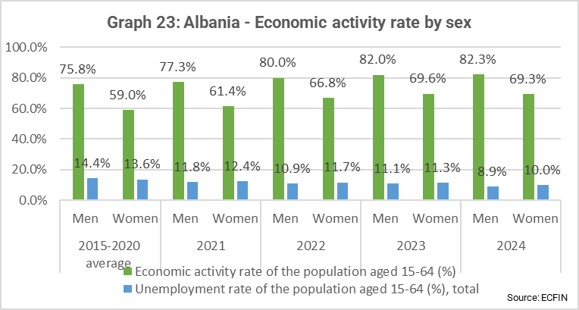
Despite further improvements, concerns remain among business representatives on the level of public consultation by the government and Parliament, especially regarding EU integration. Businesses complain of undue bureaucratic burdens and call for clearer procedures and deadlines. Clarity on implementation of legal acts would eliminate the ‘grey zone’ which might serve as an area on which specific businesses might take advantage in exchange of favours/corruptive actions. Progress on justice reform and anti-corruption are welcomed by business.
On enterprise and industrial policy instruments, further coordination between state institutions which provide financial incentives to businesses remains needed, to ensure better access to information for the beneficiaries and to focus efforts of the BIDS which are related such as AIDA investment promotion, TEDA specialisation and SME supplier support. Further alignment with the EU’s late payment Directive needs be ensured. Albania’s definition of SMEs is partly aligned with the EU Recommendation, on the number of employees, but the national capacity to support SMEs remains limited. Albania was positively assessed in the 2024 OECD competitiveness outlook, marking progress in 14 out of 15 dimensions, stagnating in one, state-owned enterprises.
On sectoral policies, Albania extended to 2026 the period of application for tax incentives to investors involved in the construction/development of 5-star hotels. It introduced also a ‘mountain package’ to enhance investment in the mountain areas which include tax free incentives, that would require high attention on preserving Albania’s ecological and biodiversity values. In March 2025 Albania was the official Host Country of Internationale Tourismus-Börse (ITB) Berlin, the world’s leading travel trade show, marking its rapid emergence as one of the fastest-growing travel destinations in Europe. The government adopted regulations that would facilitate the development of the defence industry. The government adopted regulations that would facilitate the transfer of assets to Albanian Investment Corporation for further development and re-vitalisation programmes, as well as regulations on enhancing privatisation of state-owned assets, including land.

Chapter 25: Science and research
The EU provides significant support for research and innovation. All EU Member States can participate in the EU’s research and innovation programmes and benefit from them, especially where there is scientific excellence and solid investment in research and innovation.
On research and innovation policy, Albania still needs to adopt the required legislation to ensure effective implementation of the 2023-2030 National Strategy on Scientific Research, Technology and Innovation. In addition, Albania needs to adopt standards for research data management established by international organisations.
Albania increased funding for R&D in 2024 to 0.19% of the GDP. This remains below the national target of 1% of GDP that the country intends to achieve by 2030. More actions are needed to increase public funding of research and development, incentives for businesses to increase their R&D expenditure, and to improve cooperation between the private sector and universities. The Institute of Statistics (INSTAT) needs to produce a complete data set on scientific research and innovation. The Albanian Start-Up Agency launched its first call for innovative start-ups in December 2024, of a total value of EUR 3 million, with a priority given to female-led start-ups, as well as start-ups focusing on green transition and/or digitalisation. The Smart Specialisation Strategy was adopted in December 2024 and includes a costed action plan, which should be implemented. Albania was included for a third consecutive year in the European Innovation Scoreboard as an emerging innovator performing below the average of Emerging Innovators in the EU and neighbouring countries. Albania’s score slightly decreased from 41.7% of the EU average in 2024 to 37.9% in 2025.
As regards the EU framework programmes, Albania is fully associated to Horizon Europe. Its participation in the programme reached a total of 46 signed contracts benefitting Albania, worth EUR 7.3 million. The authorities need to further encourage participation of the private sector in Horizon Europe. National innovation efforts need to be aligned with the New European Innovation Agenda and the Competitiveness Compass. Albania opened five European Digital Innovation Hubs and the first European Institute of Innovation & Technology (EIT) community hub serving as a gateway between Albanian stakeholders and the EIT community programmes. The EIT has set up a Raw Materials Regional Innovation Centre in Albania.

Chapter 26: Education and culture
The EU supports cooperation in education and culture through funding programmes and the coordination of Member State policies through the ‘open method of coordination’. The EU and the Member States must also prevent discrimination and ensure quality education for children of migrant workers, including those from disadvantaged backgrounds.
The estimated public spending on education in 2024 represented 2.6% of GDP compared with 2.1% in 2023, remaining under the EU average of 4.6%. Following the approval of the updated Curriculum Framework and its action plan in December 2024, the process continued with an update of key competences, incorporating innovations for primary, lower secondary, and upper secondary education. An updated curricula on the promotion of cultural diversity and the inclusion of Roma and Egyptian history and culture has been adopted.
In the pre-school education, 65 914 children were enrolled, 1.2% less compared with the previous school year (66 711). In the basic education, 250 617 pupils were enrolled, (48% girls), 2.89% less than the previous year (258 072), of which 136 379 (54.42%) in primary education and 114 238 (45.58%) in lower secondary education. 89 190 pupils were enrolled in upper secondary education, showing a decrease of 2.80% (91 755). Overall, according to INSTAT data for the academic year 2024-2025, 528 602 pupils and students were enrolled in formal education, with a decrease of 1% compared with the previous year (533 711). In the same period, 405 989 pupils were enrolled in pre-university education, marking a decrease of 2.57% (416 717).
Albania took part to the Teaching and Learning International Survey. Albania participated in PISA 2025, and the Ministry of Education and Sports developed a roadmap to target low score students.
In the reporting period, the vocational education and training (VET) system has undergone several improvements and was changed to a 3+1 programme. Albania has updated its legal framework to support a dual VET system allowing the involvement of private and public employers. As of September 2024, dual VET programs involving 203 twelfth-grade students (35 girls/168 boys) piloted in ten VET schools. In the academic year 2024-2025, the share of students enrolled in VET public schools represented 19% (16 976) of the general number of students enrolled in upper secondary education, up from 17.90% in the previous school year (2023-2024). The increase aligns with the National Employment and Skills Strategy target of having one-third of pupils in VET. Albania still needs to establish a legal basis for recognizing prior non-formal and informal learning and fully staff the National Agency for VET and Qualifications. These measures allow to develop a quality assurance framework in vocational education and training, aligning the curricula with the European Qualifications Framework (EQF).
On higher education, Albania is a member of the European Higher Education Area (Bologna process). As set out in the 2024 Bologna Process Implementation Report, Albania still needs to work on the full implementation of the key commitments, especially with regards to automatic recognition and quality assurance.
On inclusive education, progress is being noted on the improvement of inclusive and child centred practices in preschool as well as the approximation with the EU “Early Childhood Education and Care Quality” framework. 5 233 students with special needs were attending inclusive classes, 16% more than in 2023 (4 507). Only 453 students with special needs attended special schools in 2024-2025 (518 in 2023). The percentage of students with disabilities attending inclusive education represented 92% of students with special needs compared to 8% of those attending special education. In the reporting period, 2 266 assistant teachers (which is 14% more compared with 2023) were employed in the public pre-university education system. In the reporting period, 13 130 Roma and Egyptian children were registered in pre-university education compared to 12 508 in 2023. To facilitate communication and cooperation between vulnerable groups and schools, 13 mediators and 100 qualified teachers of Roma and Egyptian background are employed.
On digital and green skills, the ICT curriculum was developed in line with the digital transformation plan. This project includes installation of smart labs over 600 public primary and upper secondary schools.
The country benefits from the international dimension of the 2021-2027 Erasmus+ programme. There were 15 higher education capacity-building projects selected for funding, from which 9 are coordinated by the Albanian Higher Education Institutions. Selected mobility projects will fund over 3 700 students and staff exchanges from and to Albania. Albania is participating in all the European Education Area working groups 2021-2025.
In 2025, Albania is not taking part in the European Week of Sport. The amendment of the Law on Youth was adopted in April 2025, while the implementation of the 2022-2029 National Youth Strategy continued.
On culture, the implementation of the 2019-2025 national strategy continued. Authorities have adopted two sub-legal acts for the Law on Cultural Heritage and Museums, but additional implementing legislation is still needed for full operation. Albania continued to participate in the EU 2021-2027 Creative Europe programme and has acceded to the 2005 UNESCO Convention on the Protection and Promotion of the Diversity of Cultural Expressions.

Chapter 29: Customs union
All Member States are part of the EU customs union and follow the same customs rules and procedures. This requires legislative alignment as well as adequate implementing and enforcement capacity and access to and interoperability with the EU electronic customs environment.
On customs legislation, Albania’s customs code is broadly aligned with the EU acquis. However, substantial efforts remain needed and are ongoing to keep up with the further developments in the EU customs legislation, in particular the acts implementing the Union Customs Code. The levying of scanning fees for customs declarations continues to contravene the Stabilisation and Association Agreement, which prohibits customs duties or charges with an equivalent effect on trade between the EU and Albania and is not aligned with the Union Customs Code (UCC). The implementation Plan 2024-2025 of the Business Strategy (2023-27) of the Albanian Customs Administration was approved to address the activities of the Institution for the period 2025 – 2026, focusing on digitalization, trade facilitation and protection of financial interest.
Preparatory work for the development of a National Single Window and the preparations to join the Common Transit Convention are ongoing. An amendment to the legislation has been drafted and a contract was signed to work on the technical solutions for the implementation of the New Computerised Transit System (NCTS) at national level. The request to secure the CCN/CSI connectivity has been made which is the main condition to connect with the common domain and central EU applications for NCTS.
Albania is implementing its authorised economic operator (AEO) programme, with 18 AEOs by end 2024 and further applications under review. Awareness-raising activities on the benefits of the programme continued. Agreements signed with Serbia and North Macedonia on mutual recognition of AEOS (safety and security) can be implemented.
As part of the anti-fraud effort, Albania should strengthen combating customs fraud, in particular smuggling of tobacco products and by cooperating with the European Anti-Fraud Office (OLAF). The country has yet to accede to the WHO Framework Convention on tobacco control protocol to eliminate illicit trade in tobacco products.
Risk Management procedures in place are in line with the UCC and use electronic data processing techniques. A dedicated risk selectivity module (and automated environment that enables a risk-based selectivity) is integrated with the customs clearance system. New modules are planned to be implemented/improved in the Selectivity Module. Improvement of the inspection act has been completed and work is ongoing on the prearrival information module. The national rules on cash and goods transported in travellers’ baggage still differ from the EU acquis and should be aligned. The Albanian Customs Administration can impose sanctions for non-declarations or mis-declarations of cash at the border.
On administrative and operational capacity, the Albanian Customs Administration (ACA) reports 973 employees, and 101 vacancies. After ratification of the Agreement on the participation of Albanian in the EU Customs Programme in June 2025, Albanian customs can participate in the Programme. Albania also participates in different fora at the World Customs Organisation. Several training activities, based on the approved annual training calendar, took place in collaboration with the Tax and Customs Administration Training Center. Albania needs to further align in the area of IT systems in operation and their future connectivity with the EU electronic customs environment. A number of large-scale investments are under way, planned, or finalised including on NTCS and Single Window, integrated tariff management system and upgrades to the customs management and risk assessment systems. To cope with all the investments and upgrade there is a need to upgrade human resources and capacity. An IT strategy and roadmap is essential. Efforts are also undertaken to increase the digital access to customs services and ACA reports that 47 customs services are available through the e-Albania portal. A laboratory information and management system (LIMS) is in place, but it needs funding for upgrades.
In terms of prevention of corruption, a department for anti-corruption and ethics is in place, tasked with processing cases and complaints received. The Code of Ethics sets out the rules and principles of conduct that all employees of the customs administration must follow. Albanian Customs Administration is currently preparing an action plan aimed at strengthening integrity and promoting high standards of ethics and transparency within the customs administration.

Cluster 4: The green agenda and sustainable connectivity
This cluster covers: transport (Chapter 14); energy (Chapter 15); trans-European networks (Chapter 21); and environment and climate change (Chapter 27).

Chapter 14: Transport policy
The EU has common rules on technical and safety standards, security, social standards, State aid and market liberalisation in road transport, railways, inland waterways, multimodal transport, aviation and maritime transport.
Regarding the general transport acquis, the national transport strategy and its action plan for 2026-2030 has not yet been adopted. More efforts are required to fully implement the Intelligent Transport Systems (ITS) Directive, enhance multimodality and implement relevant national laws in compliance with the Transport Community action plans. The development of Sustainable Urban Mobility Plans for larger transport agglomerations in line with EU practice has not yet been carried out.
Albania continued to actively participate in the work of the Transport Community. However, progress in implementing the six Transport Community Treaty action plans and dedicated smart and sustainable mobility strategy for the Western Balkans has been limited. For the period 2025-2027, Albania should focus on the implementation of the next-generation Transport Community action plans endorsed in 2025.
Administrative capacity across the transport sector still requires improvements, based on the five-years action plan launched in March 2023, to enhance the capacities in planning and implementing rail infrastructure projects.
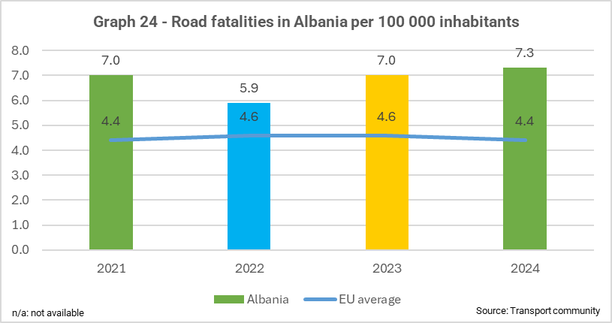
On road transport, national legislation is partially aligned with the ITS Directive, but significant progress remains needed to align with the EU acquis. Road safety remains a concern, with fatality rates above the EU average and discrepancies between national data and WHO’s higher and unresolved estimates. Funding is still needed for a CARE-aligned crash data system, and the creation of a dedicated road safety agency is still pending. The country needs to strengthen its inspection capacity on periodic roadworthiness tests. Albania remains partially aligned with the Directive on road infrastructure safety management, with no significant progress.
During the reporting period, a traffic monitoring centre was set up, but more work is needed to ensure the alignment with the ITS acquis and ensure ITS deployment.
Albania continued implementing a multiannual road maintenance plan. However, the issues regarding the Albanian Road Authority Service Level Agreement, establishment of road asset management system and the adoption of an efficient strategy on the funding sustainability for road maintenance remain to be addressed.
On railway transport, the staffing process of the Railway Safety Authority has proven challenging and is still ongoing. In December 2024, a law was adopted facilitating the separation of the company into two distinct commercial entities: the railway undertaking and the infrastructure administrator. Further efforts are needed to strengthen the institutional framework to ensure its effective implementation.
Albania needs to continue its efforts to fully align with the EU rail safety and interoperability rules, including the electronic register of vehicles and the rail infrastructure asset management system (RIAMS). The National Investigation Authority for Railway and Maritime has been set up, and the Head of the Authority has been appointed.
On maritime transport, Albania remains on the grey list of Paris Memorandum of Understanding on Port State Control (Paris MoU). In 2024, foreign Port State Control authorities conducted 14 inspections on Albanian-flagged vessels, all of which resulted in zero detentions.
Albania still needs to fully align with the EU acquis on the EU vessel-traffic monitoring and information system (VTMIS), with installation ongoing and expected by end-2025. In 2024, an environmental organisation raised concerns over hazardous wastes loaded onto container ships at Durrës Port, highlighting gaps in port oversight and capacity. The case remains under investigation.
Albania still needs to fully align with the Regulation establishing a European Maritime Single Window environment.
No further progress has been made in the area of inland waterway transport, which is limited to two lakes shared with neighbouring countries and governed by bilateral agreements.
On aviation, the EASA inspection conducted in May 2025 confirmed a good level of implementation of the EU aviation safety acquis in the domain of air crew. No further progress has been noted in the implementation of the EU acquis.
On multimodal transport, Albania has not yet aligned with the combined transport Directive.
There were no developments on passenger rights, although the legislation on passenger air rights is largely aligned with EU acquis.

Chapter 15: Energy
EU energy policy covers energy supply, infrastructure, the internal energy market, consumers, renewable energy, energy efficiency, nuclear energy and nuclear safety, radiation protection and nuclear safeguards.
Albania needs to accelerate its efforts to adopt the updated National Energy and Climate Plan (NECP) 2021-2030, as the NECP has a critical role in boosting the deployment of renewable energy and ensuring compliance with the 2030 energy targets.
On security of supply, the national legislation is partially aligned with EU acquis for gas and oil, whereas for electricity the alignment with the Risk-preparedness Regulation is pending. Full compliance with the oil stocks acquis and improvements in reporting and setting up a central oil stockholding body remain needed. A law on safety reserves for oil and its by-products to ensure the alignment with the relevant acquis is expected to be adopted.
On the internal energy market, alignment with Electricity Integration Package is yet to be completed. A drafting of the Power Sector Law is ongoing and the Energy Community Secretariat reviewed the draft law in July 2025. The Regulation on Capacity Allocation and Congestion Management has been approved in May 2025 by the Energy Regulatory Authority (ERE). In 2024, ALPEX updated the electricity market rules to align with the Electricity Market Regulation and the decisions of the Agency for the Cooperation of Energy Regulators (ACER) regarding the Single Day-Ahead Coupling (SDAC) and Single Intraday Coupling (SIDC) markets. In December 2024, these amendments were approved by ERE. The first intraday auction of the Albanian Power Exchange (ALPEX), marking Albania-Kosovo market coupling, took place and delivered in December 2024.
Electricity prices are still not fully liberalised. Customers on 20 kV, 35 kV, and 110 kV grids already benefit from a deregulated market. A December 2024 Ministerial Order, set a roadmap to include 10 kV customers from January 2025 and 6 kV customers. from January 2026. After this date, only low-voltage (0.4 kV) customers will remain regulated.
In October 2024, Energy Regulatory Authority (ERE) expanded its staff and restructured to include new units on renewables and regulatory compliance, improving its capacity to meet sector needs. The new structure has new sectors and departments, meaning new challenges for ERE and new staff to be trained.
On renewable energy, a December 2024 Ministerial Order set a plan for at least 300 MW by 2027, which adds to the 860 MW of capacity already allocated since 2019 through five Competitive Procedures (Auctions).
In December 2024, ERE adopted the Regulation on the Transfer, Settlement, and Cancellation of Guarantees of Origin (GOs), and procured services to provide electronic GOs, now accessible to all market participants. A new law on biofuels and renewable transport fuels, partially aligned with EU rules, was approved by Parliament in June 2025.
Regarding energy efficiency, in June 2025 Parliament approved a Law on energy performance of buildings aiming to align with the relevant EU acquis. It also approved a long-term building renovation strategy, while an action plan is under development to meet the 3% annual renovation target for public buildings by 2030.
However, implementation of existing legislation on the energy efficiency obligation, labelling, increasing electric vehicles and implementing an action plan for public building energy performance remains pending.
Key challenges for developing and implementing energy efficiency plans remain, coordinating the preparation and implementation of the action plan at national level within the NECP with the energy efficiency planning at municipal level, including support for vulnerable groups, and expanding the capacity of certified energy auditors. Additional financing incentives for the annual renovation of public buildings are also needed to achieve targets for renovation of public building by 2030.
In the area of governance, Albania needs to accelerate the finalisation of its updated NECP. Timely completion of the NECP is essential to guide energy reforms, attract investments, and align with the Energy Community’s governance framework.
Albania has made no further progress, in the reporting period, on nuclear energy, nuclear safety and radiation protection. In addition to accelerating efforts to align with Euratom legislation and participate in the European Community Urgent Radiological Information Exchange (ECURIE) and the European Radiological Data Exchange Platform (EURDEP), Albania should focus on strengthening the capacities of the Institute of Nuclear Physics as well as the Institute of Radiation Protection. On nuclear safeguards, upon accession, Albania would need to adjust nuclear material control systems to accommodate Euratom Treaty safeguards provisions.

Chapter 21: Trans-European networks
The EU promotes trans-European networks (TENs) in the areas of transport, telecommunications and energy to strengthen the internal market and contribute to growth and employment.
On transport networks, the strategic framework is partially aligned with the EU acquis. Further efforts are needed to improve administrative capacity for developing and monitoring TEN-T. In 2025, the government approved a Decision of the Council of Ministers endorsing the Document of Priority Policies 2026-2028, which sets out the updated list of priority projects for developing the core and comprehensive regional transport network across all modes.
The core road network development and implementation in Albania notably in the Adriatic-Ionian Corridor and road Corridor VIII continued without significant progress in the reporting period. Further efforts are needed to make full use of the Road Asset Management System.
The reconstruction of the railway network relies heavily on external financing, including EBRD/EIB loans, and WBIF grants. Phases of funding for the projects require careful coordination to ensure timely completion. There are systematic delays, especially in the signature of loan/grant agreements between Albania and International Financial Institutions (IFIs), coupled with important cost increases from the original estimates. Albania needs to include the other rail segments of the Corridor VIII in the list of investments to be supported by the Reform Growth Facility. The rehabilitation of the Durrës-Tirana line and the construction of a new line to the international airport continued to progress in line with contractual obligations. The overall progress was estimated at 87% of construction works. The country continued to implement a five-year action plan with the aim to strengthen the programming and project management capacity, to address bottlenecks and ensure the effective operationalisation of investment grants awarded under the Western Balkans Investment Fund platform.
No concrete steps have been taken to shift freight activities from the ports of Durrës and Vlora to the port of Porto Romano. State budget will be used by the government to fund the new port of Porto Romano rather than a public-private partnership. While construction is yet to begin, the pre-qualification tender of the works for the port of Porto Romano was finalised. Preventing corruption is crucial to avoid criminal infiltration in the transportation and logistics chain.
On energy networks, Albania’s policy does not still align with the objectives of the trans-European Networks for energy policy, as implemented through the TEN-E Regulation. The country still needs to comply with the revised TEN-E Regulation, as adopted in the Energy Community.
Albania does not have gas network on its territory.
For electricity, Albania remains connected to Greece, Montenegro and Kosovo, through high voltage networks of 400 kV, 220 kV, 150 kV, and 110 kV. The construction of the 400 kV interconnection line between Fier, in Albania and North Macedonia and of the interconnection between Fier and Elbasan substations are ongoing and are expected to be completed by mid of 2026. However, delays in compensating individuals for the expropriation related to the Fier substation and transmission line may affect the project completion timeline.
Albania still needs to develop its regional electricity connections in line with the Central and South-Eastern Europe Energy Connectivity (CESEC) action plan on electricity and renewable energy and the Projects of Energy Community Interest (PECI) involving Albania such as closing the 400 kV Albanian internal ring as well as reconfiguration of 400 kV grid and new 400 kV interconnection Albania-Kosovo.
In November 2024, Albania updated its renewable energy deployment framework and plans to revise permitting rules by 2025 to streamline procedures, the net billing support scheme, the rights and responsibilities for renewable energy self-producers. However, in December 2024 the government approved a 170 MW thermal plant in Roskovec, facing opposition from locals and a court appeal over environmental concerns.

Chapter 27: Environment and climate change
The EU promotes strong climate action, sustainable development and protection of the environment. EU rules contain provisions addressing climate change, water and air quality, waste management, nature protection, industrial pollution, chemicals, noise and civil protection.
Environment
In terms of horizontal legislation, Albania needs to significantly improve alignment and implementation, particularly the Environmental Impact Assessment (EIA) and the Strategic Environmental Assessment (SEA) Directives. Institutional capacity for coordinated and strategic environmental planning and investments remains weak, with poor EIA quality, recommendations rarely implemented or monitored, low public participation in decision- making and limited enforcement of horizontal legislation. The 2024 amendments to the Law on protected areas led to unravelling of their protection. Over the reporting period, inspection and enforcement capacity further weakened, especially in tackling environmental crimes in protected areas. Limited funding, high staff turnover, and lack of expertise have eroded the central administration. Albania needs to improve environmental monitoring and strengthen administrative capacity to meet EU standards. Despite challenges, Specialised Anti-Corruption Structure (SPAK) investigations into the Tirana incinerator led to the sentencing of several municipal officials, including a former minister. An investigation into 102 containers of suspected toxic waste returned from Thailand in October 2024 is still ongoing.
In September 2024, Albania adopted legal changes that aligned the spatial data legislation with the INSPIRE Directive. Its National Geoportal has also been completed with the geoinformation layers.
No progress has been observed on alignment with the EU air quality acquis. The air monitoring system remains to be extended and improved, as it still has only seven automatic stations nationwide, non-operational due to insufficient allocation of funds for their maintenance.
On waste management, the government announced in August 2025 the reform of the sector, which will consist in centralising waste collection and management, currently devolved to municipalities. The National Agency for Waste Economy (AKEM) should become a state-owned company in 2026 and operate as national waste treatment operator, with municipalities becoming its clients. AKEM has still very low capacity and expertise. The draft laws on integrated waste management and on extended producer responsibility, aiming the alignment with the relevant EU acquis, remain to be adopted. Urgent action against littering is needed. There is no single-use plastics bans yet in line with the Single-Use Plastics Directive. Since December 2024, a pilot project on municipal waste separation at source runs in Berat.
On water quality, further alignment with nine EU Directives is still pending. Five of seven River Basin Management Plans (RBMP) are implemented (Drin-Buna, Semani, Ishmi, Erzeni, and Mati rivers), with updates expected in 2025; the two others are still pending (Shkumbini and Vjosa). Flood hazard maps cover 96% of areas with significant flood risk (ASFPR) and flood risk maps 84% of high-risk areas. Water abstraction from rivers and protected areas, without consultation with local communities and environmental CSOs, has caused local conflicts. Water supply and sewerage services remain low. To further align with the EU water acquis, Albania needs to boost funding, enhance the implementation capacity and finalise a national water monitoring programme.
Alignment with the EU acquis on nature protection, in particular the habitats and birds Directives, needs further improvement. The 2024 legislative amendments to the Law on protected areas led to deterioration on nature protection. Works for the first large touristic resort in the Buna-Velipoja Protected Landscape, which is in the list of the potential Natura 2000 sites in Albania started amid protests by the local population. The 2015 Law on Strategic Investments has again been extended, with its validity now prolonged until 2027. Its repeated extension continues to raise concerns about possible environmental impacts, particularly in protected areas. The March 2025 ‘Mountain Package’ law may open the way for large-scale construction or investment projects in forests and pastures, reducing forest areas and contradicting the 2020 Forest Law. Additionally, it risks to harm Albania’s ecological and biodiversity values, in conflict with EU’s habitats and birds Directives. The construction of the new Vlora Airport within the Pishe Poro-Narta Protected Area is still advancing, despite the request of the Standing Committee of the Bern Convention in December 2023 and in December 2024 to suspend the works until a new and sufficient EIA procedure is conducted.
In May, concerns were raised about leachate, oil and bitumen spills, gravel mining and water abstraction within the Vjosa River National Park, which may affect the integrity of the protected area. The government referred to work on an Integrated Management Plan but did not address these ongoing activities.
Significant enforcement gaps persist in Albania’s forest and logging laws. Despite moratoria, illegal logging and hunting continued unchecked and have increased in intensity, even within protected areas. The environmental risks of the Skavica hydropower plant project to ecosystem and local communities persist. Albania should advance the identification, pre-designation, and protection of the sites that will be covered by the Natura 2000 network.
On industrial pollution and risk management no progress was made due to persistent capacity and financial constraints, which hinder the implementation of legislation on the prevention of major industrial accidents.
On chemicals, no progress has been made. The REACH implementing legislation on the registration, evaluation, authorisation and restriction of chemicals still needs to be adopted and adequate administrative structures to be set up. The same applies to alignment with Biocides Regulation.
Regarding noise, no progress was made in the reporting period since Albania has not prepared strategic noise maps and action plans. While noise level monitoring has been carried out in the main cities of Albania, data are not accessible by the public.
On civil protection, as Participating State of the Union Civil Protection Mechanism (UCPM), the country actively participates in the relevant activities. Albania's response capacities are often overwhelmed, especially for wildfires, resulting in more frequent requests for assistance to the UCPM. Albania needs to revise emergency plans, upgrade early warning and response infrastructure, and improve operational capacity. The country should establish Trans-European Services for Telematics between Administrations (TESTA) connection as a precondition for connecting to the Common Emergency Communication and Information System (CECIS), alongside better use of the Commission’s Emergency Response Coordination Centre.
Climate change
Alignment with the EU acquis on climate remains limited and no particular development was reported on addressing climate change. The country’s ability to integrate climate change into sectoral strategies and plans is still weak. Deficiencies in the financial and administrative capacities for climate change were not addressed and hamper progress in the sector. Moreover, no emissions register is in place. Albania is expected to adopt the updated National Energy and Climate Plan (NECP) 2021-2030. The Climate Law should be updated to align with the EU’s 2050 climate neutrality target and a long-term low-carbon development strategy until 2050 aligned with this goal should be developed. In September 2024, eight municipalities have prepared their local adaptation plans.
Albania still needs to align with the Monitoring, Reporting, Verification and Accreditation (MRVA) acquis covering the full EU Emissions Trading System’s (EU ETS) scope. It should also fully align with EU acquis on fluorinated greenhouse gases, ozone-depleting substances, and emissions from vehicles and road transport.
In March 2025, Albania approved the construction of a new thermal power plant. This decision could jeopardise the country’s ability to fulfil its climate targets and align with those of the EU. Albania needs also to take decisive steps for introduction of carbon pricing to facilitate joining the EU ETS upon accession.
Albania should without delay, submit its first biennial transparency report and a new and ambitious Nationally Determined Contribution under the Paris Agreement, in line with efforts to limit global warming to 1.5°C.

Cluster 5: Resources, agriculture and cohesion
This cluster covers: agriculture and rural development (Chapter 11); food safety, veterinary and phytosanitary policy (Chapter 12); fisheries and aquaculture (Chapter 13); regional policy and coordination of structural instruments (Chapter 22); and financial and budgetary provisions (Chapter 33).

Chapter 11: Agriculture and rural development
The EU’s common agricultural policy supports farmers and ensures Europe’s food security. It helps tackle climate change and the sustainable management of national resources; maintains rural areas and landscapes across the EU; and keeps the rural economy alive by promoting jobs in farming, agri-food industries and associated sectors. This requires strong management and control systems. There are also common EU rules for marketing standards, quality policy and organic farming.
On horizontal issues, Albania needs to improve its institutional capacity building and to align its financial management and control systems with those of the common agriculture policy (CAP). During the reporting period, no progress was made in developing the integrated administration and control system (IACS). The farm register remains to be fully aligned with the EU acquis. The land parcel identification system (LPIS) should be set up. No progress was made on introducing conditionality requirements for direct payments.
The setting-up of a farm sustainability data network (FSDN) needs to progress, incorporating environment and social data in line with the EU acquis. Implementation of the strategic action plan for the reform of the advisory system should be hastened as capacity remains low.
On the common market organisation (CMO), implementing legislation was adopted in November 2024 on classification of grape varieties used for wine production and on definition of tasks of related responsible institutions, which are partially aligned with the acquis. Further efforts in this area are needed in order to strengthen the limited institutional capacity for implementation.
On rural development, increased capacity and oversight is needed to start the entrustment and the efficient implementation of the IPARD III in full compliance with the principles of sound financial management.
No progress to align the legislation on quality policy with the EU acquis was made during the reporting period.
On organic farming, legislation on organic production, labelling of organic products and their control was adopted in October 2024, further aligning with the EU acquis. Its proper implementation should be ensured.
On the fight against corruption, the IPARD bodies are obliged to prevent, detect and report irregularities.

Chapter 12: Food safety, veterinary and phytosanitary policy
The EU food acquis including hygiene rules for foodstuff production ensures a high level of food and feed safety and a high level of protection of consumers’ interests. Animal health and welfare and the safety of food of animal origin are safeguarded together with the quality of seeds, plant reproductive material, the protection against harmful organisms and animal nutrition and the use of plant protection products.
On general food safety, the legal framework remains partially aligned with the EU General Food Law Regulation. The legislation on official controls has yet to be aligned with the Official Controls Regulation (OCR). Efforts are needed by the competent authorities regarding enforcement of legislation and risk management concerning the placing of food/feed on the market. The National Food Authority (AKU) has yet to strengthen its focus on inspection statistics, data management and transparency. The transparency principle is to be applied to official control systems in line with the OCR. Adequate administrative and financial resources remain necessary to support the performance of official controls also by means of a transparent collection of fees. Albania still has not drawn up a multiannual national control plan.
For the official laboratory network, validated screening methods to guarantee the reliability of results for the relevant species and commodities need to be put in place, and further efforts are necessary to improve developing capacity, accreditation and validation of the methods. Resources must be dedicated to border controls, so they are performed according to EU standards.
On veterinary policy, the Animal Health Law, was adopted in June 2025 but its implementation will only start two years after adoption. Albania has in place the main elements for the veterinary services based on the current national law. The reform of the veterinary sector remains incomplete, with insufficient human resources at the central and local level. Significant efforts are still required to establish the necessary capacities on passive and active surveillance.
Albania did not continue the vaccination campaigns against rabies. Necessary measures should be taken to align the actions following the regional approach on control and eradication of rabies. Albania continued the implementation of programmes for monitoring brucellosis and tuberculosis in cattle herds. While countrywide verification and registration of the number of animals continued, substantial work is still required to upgrade the animal register with additional information on other animals as referred to in the EU acquis, to ensure that solid traceability systems are put in place for food of animal origin.
Albania further aligned the EU acquis on animal welfare, with the adoption of two bylaws in July 2025 on the protection of animals at farm, during transport and at the time of killing. Efforts are needed to work on their proper implementation, ensuring sufficient administrative capacity for enforcement, as well as putting in place the related certificates and approvals required by the legislation.
Regarding the placing on the market of food, feed and animal by-products, Albania has a low level of alignment with the EU acquis. Albania implemented its national residue monitoring plan, but the referred residue monitoring plans are not comprehensive enough. No progress was made on the legal basis for animal by-products (ABPs) and an EU compliant system of collection, storage and processing of ABPs is not yet in place.
On food safety rules, Albania continued to partially align with the acquis on food additives and identification of maximum levels for certain contaminants in food. Regarding pesticide residues, Albania has yet to improve the enforcement of actions taken in the event of non-compliance and increase transparency. No progress was made on developing a national programme to improve milk quality. On specific rules for feeds, Albania made no progress on legislative alignment with the EU acquis.
On phytosanitary policy, the Plant Health Law was adopted in June 2025, but will be applicable only two years after adoption. Albania approved the multiannual pest monitoring plan 2025 - 2028. Additional actions notably in relation to detection and eradication of pests are yet to be implemented.
No progress was made during the reporting period on genetically modified organisms.

Chapter 13: Fisheries and aquaculture
The common fisheries policy lays down rules on fisheries management, protects living resources of the sea and limits the environmental impact of fisheries. This includes setting catch quotas, managing fleet capacity, rules on control and inspection, rules on markets and aquaculture and support for fisheries and coastal communities. Further, it promotes a sustainable aquaculture.
Regarding resource and fleet management and structural actions the vessel register continued to improve, and fishery production data are regularly maintained and updated. There is an advanced level of alignment with the EU acquis. Further efforts are needed on alignment on data collection in particular as concerns reporting on sharks, eel, biological data collection, recreational fisheries and discard plans. Albania continues to be in line with the recommendations of the GFCM for the sustainable exploitation of fish stocks. There is no progress regarding small-scale fisheries.
Inspection and control capacity to monitor 24/7 fishing activity in order to fight against illegal, unreported and unregulated (IUU) fishing has been strengthened, based on a functional and operating vessel monitoring system (VSM). The online electronic inspection system provides for a transparent procedure, secure data recording and transmission to the concerned authorities.
The capacity to interpret and implement the national legislation in this field or the EU common fisheries policy and data collection needs to be further improved, in particular on scientific capacity and data management.
On market policy, legislation concerning market plans remains to be fully aligned. On State aid, no support was made available under the national support scheme, as a separate financing measure for the fisheries sector.
Regarding aquaculture, public open competition was implemented for Vlora and Shengjin, based on the adopted plans on the allocated zones for aquaculture (Shengjin, Durrës, Saranda and Vlora).
Regarding international agreements on fisheries and aquaculture management, Albania has fully implemented the GFCM recommendations on controlling fishing and confirmed as Compliance category 1. Albania should continue to actively participate and implement GFCM recommendations.
As regards the wider blue economy, Albania is encouraged to promote regional maritime cooperation with partner countries in the Adriatic-Ionian Sea.
On maritime spatial planning, a Decision of the Council of Ministers was revised in November 2024. Albania should continue to develop its National Maritime Spatial Plan.
On the fight against corruption, the national Cross-Cutting Anti-Corruption Strategy aims to ensure accountability and ethical governance, including fisheries. Albania has taken concrete steps to fight corruption in the fisheries sector by focusing on transparency, digital tools, and ethics. This includes using online systems for licences and inspections, applying Integrity Plans in the Fisheries Directorate, and carrying out regular internal and external audits.

Chapter 22: Regional policy and coordination of structural instruments
Regional policy is the EU’s main tool for reducing regional disparities and investing in sustainable and inclusive socio-economic growth. It is operating through ‘‘shared management’’ between the Commission and EU Member States. The implementation of cohesion policy programmes requires appropriate administrative capacity on programme and project level, the establishment of systems of sound financial management and control and also the fulfilment of other EU acquis elements such as environmental or public procurement legislation.
Regarding the legislative framework, Albania has achieved partial alignment with EU legislation and policies for the proper implementation of EU cohesion policy. More efforts are needed on State aid and legislation on Environmental Impact Assessments (EIA) and Strategic Environmental Assessments (SEA), including by aligning with the acquis on State aid, full harmonisation with the SEA and EIA directives and significant improvement of the capacity of central and local authorities. Further progress on acquis alignment on territorial classification and the related National Strategy and Plan for Regional Development and post-2030 General National Spatial Plan is needed. The Law on the organisation and functioning of the Audit Authority was amended in March 2025 to align with the requirements under the Financial Framework Partnership Agreement. Single audit arrangements need to be fostered in the legal system and mechanisms need to be established to ensure co-financing of multi-annual programmes in the area of budget planning. Council of Ministers needs to pass a decision on the establishment of the partnership principle in line with the European Code of Conduct on Partnership. Regarding the institutional framework, the Minister of State for Local Government was nominated as negotiator for Chapter 22 in December 2024 after a gap of several months. The performance of the managing authorities responsible for the OPs and Interreg cooperation programmes remains at risk due to insufficient administrative and technical capacities and stakeholder engagement, limited experience with programme implementation, financial management and control under shared management and indirect management by beneficiary country (IMBC), a lack of proper IT systems for monitoring and reporting activities and high staff turnover. Responsibilities at all operational levels need clear definition, the separation of authorisation, control, and accounting for commitments and payments, and execution of payments need to be guaranteed, and functions between the Managing Authority(ies), intermediate bodies and Audit Authority need adequate separation. Particular attention must be given to the independence of the Audit Authority. The Working Group for Chapter 22 met four times since September 2024.
On administrative capacity, strengthening human resources is still critically necessary along with staff retention policy. State Agency for Strategic Programming and Aid Coordination (SASPAC) understaffing, as the National Authority for Cross-Border Cooperation (CBC) and Interreg programmes, requires urgent attention. Managing authorities and implementing institutions must address staffing shortages, retention policy, and capacity to ensure timely and effective project implementation and proper compliance with required separation of functions and duties. Further institutional capacities on central and local level related to project preparation, appraisal and selection process are needed. On programming, public investment management procedures have been strengthened by amendments in 2024 and 2025. The National Single Project Pipeline (NSPP) is regularly updated and categorises projects based on their maturity status but does not include municipal-led projects. Further institutional capacities on central and local level related to project preparation, appraisal and selection process are needed. Albania needs to resolve any issues of securing co-financing. The national policy for regional development to support territorial development and integration into national sectoral policies needs to be finalised. Delays in approving the Financing Agreement for IPA 2024 and the three Operational Programmes put at risk their timely implementation. Lengthy procedures for amending CBC programmes risk delaying cooperation with neighbouring countries and effective use of EU funds. Changes to the approval and signing processes of agreements and amendments are needed to speed up the process. Albania needs to demonstrate efficient implementation of the partnership principle.
On monitoring and evaluation, administrative capacities have been improved but need further strengthening. Regular sectoral and IPA monitoring committees discuss the progress on EU pre-accession programmes. Monitoring and national evaluation systems still need improvement to align with cohesion policy requirements. As regards territorial cooperation, the monitoring role of the National Authority should be enhanced.
On financial management, control and audit, the Law on the organisation and functioning of the EU-Accredited Agency for the Audit of Assistance Programmes was amended in March 2025 to clarify the management responsibilities. The IPA III OPs’ risk management and internal control capacities need strengthening. Albania should improve its track record in following up audit recommendations. Capacities of staff in management and control systems have been improved but need further strengthening. Stronger interinstitutional collaboration is needed to prepare and implement legal reforms for post-accession funds under the PFM strategy 2023-2030 and action plan 2023-2026. Albania should adopt the public accounting law in compliance with the International Accounting Standards for the Public Sector.
On fight against corruption, the anti-corruption and anti-fraud measures need to be effectively implemented, in line with the new Inter-Sectoral Strategy for Anti-corruption (ISAC) 2024-2030 and the National anti-fraud strategy 2025-2027. Closer coordination with the Ministry for Public Administration and Anti-Corruption, the Ministry of Finance and SASPAC is desired.
On visibility, transparency and communication, the single website to communicate about the various programmes supported with EU funding under the National IPA Coordinator (NIPAC) office and SASPAC is online since September 2025. Engagement of the national communication coordinator in the InformEU and Interreg Communication Officers Network (ICON) is desired.

Chapter 33: Financial and budgetary provisions
This Chapter covers the rules governing the funding of the EU budget (‘own resources’). These resources mainly consist of: (i) contributions based on the gross national income of each Member State; (ii) customs duties; (iii) the non-recycled plastic resource and (iv) a resource based on value-added tax. Member States must have the appropriate administrative capacity to adequately coordinate and ensure the correct calculation, collection, payment and control of own resources.
There was some progress in the underlying policy areas that indirectly affect the own-resources system (for progress in these areas, see Chapters 16 – Taxation, 17- Economic and monetary policy; 18 – Statistics, 29 – Customs union, and 32 – Financial control).
On traditional own resources, Albania started the implementation of the new Law on income taxes which entered into force in 2024. Albania has in place the Medium-Term Revenue Strategy 2024-2027 and the Strategy on public finance management 2024-2027. Implementation of the MTRS strategy includes reform measures in both tax policy review and tax and customs administration efficiency. The MTRS objective is an additional increase of revenues by 1.8% of GDP at the end of 2027. Albania completed the evaluation of all tax exemptions in June 2025. This needs to be followed by concrete actions on starting to remove some identified exemptions. As a result of mid-year monitoring of the implementation of the MTRS, Albania assessed some progress in the area of e-invoicing and data exchange with other institutions to identify high-risk taxpayers.
No additional legal development towards further alignment with the EU acquis can be reported. Tax exemptions remain a concern on domestic revenue mobilisation both at central and local level, including the latest tax exemptions introduced to businesses that will invest in mountains and in 5-star hotels. There has been good progress in proceeding quickly with VAT refund for businesses. New instructions on the VAT refund procedures for NGOs operating with EU grants under IPA require effective implementation.
On gross national income (GNI) resource, the Institute of Statistics (INSTAT) continued the regular transmission of GNI and GDP data to Eurostat, under the ESA 2010 transmission programme. INSTAT published Albania’s first full set of annual sector accounts for 2018-2023 in March 2025, extended them also to 2013-2017, and has continued efforts to improve reporting on government financial statistics (GFS) and excessive deficit procedure (EDP). Preparations for establishing Albania’s gross national income (GNI) inventory in line with GNI inventory guide have started.
On administrative infrastructure, progress is needed on creating the relevant institutions involved in the own-resources system and coordination body, and on implementing rules, in line with the EU acquis.
The legal provisions setting out the criteria for initiating public financial inspection, in cases of any irregularities, and serious financial mismanagement situations are in place. The general tax directorate and the general customs directorate continued their work on identification of tax evasion and fraud. (See also Chapters 1, 16, 29 and 32 on actions against corruption). Continued efforts are needed to formalise the widespread informal economy, improve the exhaustiveness of the national accounts and GDP/GNI calculations and combat tax evasion and customs duty fraud.

Cluster 6: External relations
There are two chapters in this cluster: external relations (Chapter 30) and foreign, security and defence policy (Chapter 31).

Chapter 30: External relations
The EU has a common commercial policy towards non-EU countries, based on multilateral and bilateral agreements and autonomous measures. There are also EU rules in the field of humanitarian aid and development policy.
On the common commercial policy, Albania continued to coordinate its positions and align its policies closely with those of the EU, including within the World Trade Organisation (WTO) and its Dispute Settlement Body. During the reporting period Albania intensified preparations for accession to the WTO Public Procurement Agreement (GPA), and in December 2024 submitted to the relevant body the economic offer on the procurement market coverage.
In the area of regional cooperation, Albania continued its constructive role in the negotiations on CEFTA items under protocols six and seven and worked on implementation of the Common Regional Market action plan. In January 2025 Albania adopted in principle the CEFTA protocol seven on dispute resolution. In February 2025, Albania ratified the decision of the joint committee of the Pan-Euro-Mediterranean (PEM) convention on the preferential rules of origin as regards the use of e-certificates.
In the area of dual-use goods, export controls of international transfers of military goods and dual-use items are applied in accordance with the 2018 Law that is currently undergoing an amendment. Despite the amendment, Albania has yet to achieve full alignment with relevant EU acquis. Albania has also yet to align with the EU acquis on screening of foreign direct investments. In this respect, the Law on foreign investment was amended in July, enabling the government to work on provisions that would enforce FDI screening.
As of June 2025, Albania is confirmed as unilateral adherent to the Australian Group. On bilateral agreements with third countries, Albania has 40 bilateral investment treaties in force, 22 of which are with EU Member States. The country has in force five free trade agreements (with the EU (SAA), CEFTA, EFTA, with Türkiye and with the UK). In June 2024, the bilateral economic cooperation agreement between Albania and Azerbaijan entered into force.
The regulatory framework for international cooperation in development policy and humanitarian aid remains to be developed.

Chapter 31: Foreign, security and defence policy
Member States must be able to conduct political dialogue under the EU foreign, security and defence policy, align with EU statements, take part in EU actions, and apply agreed sanctions and restrictive measures.
Albania continued to actively engage in political dialogue with the EU on foreign and security policy issues. In December 2024, Albania signed a Security and Defence Partnership with the EU, establishing a platform for enhanced dialogue on security and defence. In April 2025, the first session of the EU-Albania Security and Defence Dialogue took place in Tirana. In April 2025 Albania participated in the eleventh EU-Western Balkans meeting of Political Directors on common foreign and security policy (CFSP).
The institutional framework enabling Albania’s participation in the EU common foreign and security policy (CFSP) is in place and operational. Albania continued to maintain its full alignment with statements by the High Representative on behalf of the EU and Council Decisions on sanctions, including all EU restrictive measures against Russia and Belarus related to Russia’s war of aggression against Ukraine. In February 2025, Albania voted in favour of the UNGA resolution ‘Advancing a comprehensive, just and lasting peace in Ukraine’, marking the third anniversary of Russia’s full-scale invasion of Ukraine.
Albania has legal and institutional arrangements in place to deal with the implementation of the EU restrictive measures it has aligned with. However, Albania’s capacity for the technical implementation and enforcement of the complex EU restrictive measures should be further reinforced.
Albania’s active cooperation with international organisations continued. Albania is a member of the UN Human Rights Council for the period 2024-2026 and held the chairmanship-in-office of the South East European Cooperation Process (SEECP) 2024-2025. The country hosted the European Political Community summit in May 2025 and will host the NATO Summit 2027. Albania has also adopted its second National Action Plan 2023-2027 on Women, Peace and Security.
A bilateral immunity agreement between Albania and the United States remains in place, granting US citizens exemptions from the jurisdiction of the International Criminal Court. In doing so, it does not comply with the EU common positions on the integrity of the Rome Statute or with the related EU guiding principles on bilateral immunity agreements. Alignment with the EU position remains needed.
On conflict prevention Albania continued supporting EU measures and documents including through contribution to EU missions as well as to UN and NATO missions.
On non-proliferation, Albania continued to implement its national strategy on small arms and light weapons (SALW) and the related action plan for 2022-2024, as well as the 2018 Regional Roadmap and other regional forms of cooperation on firearms. The country should align its national SALW strategy with the new regional SALW Control Roadmap 2025-2030 and the 2020-2025 EU action plan on firearms trafficking.
The implementation of the 2020 national strategy against proliferation of weapons of mass destruction (WMD) and its action plan also continued. A new draft national WMD strategy was prepared by the Ministry of Defence and submitted for consultations with stakeholders. Albania is a member of the Executive Council of the Organisation for the Prohibition of Chemical Weapons (OPCW) for the period 2024-2026. In June 2025, Albania submitted a formal application to join the Wassenaar Arrangement, however completion of accession process is blocked by one of the participating states.
In terms of security measures, Albania put in place the necessary procedures to make the security of information agreement with the EU operational.
Albania stepped up its participation in EU military crisis management missions and operations under the common security and defence policy (CSDP). The country deployed an additional platoon to EUFOR Althea Multinational Battalion in Bosnia and Herzegovina and expressed readiness to contribute to the European Union’s Naval Force (EUNAVFOR) Operation ASPIDES for maritime security in the Red Sea, the Indian Ocean and the Gulf. The country continues to participate with a light company-sized unit to the EU Battlegroup Concept. In addition, Albania contributes to regional cooperation in military medicine through the Balkan Medical Task Force.
Regarding hybrid threats, Albania has a national security strategy in place, with a strong focus on advancing and developing its capacities for defence against hybrid threats. A new National Cybersecurity Strategy 2025-2030 and its action plan 2025-2027 have been adopted (see under Chapter 10 – Digital transformation and media). In June 2024, Albania joined the Helsinki-based European Centre of Excellence for Countering Hybrid Threats (Hybrid CoE). Albania has aligned with the EU’s July 2025 statement condemning Russia's hybrid campaigns against the EU and its partners. Additionally, Albania has actively engaged in negotiations in the UN Open Ended Working group on security of and in the use of information and communications technologies. In July 2025, the first National Strategy against foreign interference and disinformation was adopted by Parliament. Further efforts are needed to close the space for foreign interference and information manipulation, including disinformation, to build societal resilience against this and other forms of hybrid threats.

Annex I – Relations between the EU and Albania
Albania is a candidate country since 2014. The first Intergovernmental Conference on accession negotiations took place on 19 July 2022, following the approval of the negotiating framework by the Council. On the same day, the Commission launched the analytical examination of the acquis – the ‘screening’ process – for which the last report was submitted to Council in March 2025. Intergovernmental conferences were convened to open accession negotiations on cluster 1 – fundamentals (October 2024), cluster 6 – external relations (December 2024), cluster 2 – internal market (April 2025), cluster 3 – competitiveness and inclusive growth (May 2025), and cluster 4 – the green agenda and sustainable connectivity (September 2025). The draft EU Common Position to open cluster 5 – resources, agriculture and cohesion is under discussion in the Council.
Albania has been participating in the stabilisation and Association process since 1999. The Stabilisation and Association Agreement (SAA) between Albania and the EU came into force in April 2009. The transitional period of the SAA ended on 31 March 2019, and since 1 April 2019, Albania is fully associated with the EU. In the reporting period, Albania continued to implement, overall, its commitments under the SAA. Regular political and economic dialogue has continued through the relevant joint bodies under the SAA. The Stabilisation and Association Parliamentary Committee met in October 2024 and in June 2025. The first meeting of the Joint Consultative Committee with the European Economic and Social Council Committee took place in April 2025.
The SAA and its Interim Agreement, applied since 2006, have allowed progressive trade liberalisation and mutual duty-free access for most goods. Since 2000, Albania has also benefited from the ‘autonomous trade measures’. The EU is the main trading partner of Albania, followed by CEFTA countries. Trade integration with the EU is high. In 2024, the EU remained the main trading partner of Albania, accounting for 57.4% of Albania’s total trade in goods (71.7% of total exports and 51.5% of total imports). Albania’s total trade in 2024 was worth EUR 12.6 billion. The country’s trade deficit with the EU amounted to EUR 1.9 billion in 2024. Albania’s trade in goods with CEFTA represented around 9.7% of total trade in 2024, as compared with 10.3% in 2023.
Visa liberalisation for citizens of Albanian citizens travelling to the Schengen area has been in force since December 2010. A readmission agreement between the EU and Albania has been in force since 2006. The Commission’s 2024 seventh report under the visa suspension mechanism concluded that Albania continues to meet the visa liberalisation requirements.
Albania has continued to fully align itself with all EU CFSP positions and declarations during the reporting period. Albania stepped up its participation in EU crisis management missions and operations under the CSDP, notably EUFOR Althea in Bosnia and Herzegovina and the EU’s Naval Force (EUNAVFOR) Operation ASPIDES.
A Security and Defence Partnership between Albania and the EU was signed in December 2024 and the EU-Albania Security and Defence Dialogue was launched in April 2025 in Tirana.
Albania benefits from two bilateral assistance measures under the European Peace Facility (EPF), respectively adopted in July 2024 and July 2025, worth overall EUR 28 million. The objective of EPF support is to strengthen the operational effectiveness, mobility and protection of the Albanian Armed Forces . The Balkans Medical Task Force, in which Albania participates, benefits from a EUR 6 million 2022 support measure under the EPF.
Under the Instrument for Pre-accession Assistance 2021 – 2027 (IPA III), a fourth financing decision of EUR 67.35 million for the Annual Action Plan 2024 supports the fight against corruption, local governance and economic development, food safety, forests, and employment and social inclusion. In addition, the first financing decision of EUR 130 million for three 2024-2027 operational programmes supports efforts in digitalisation, advancing Albania’s green agenda, and youth employment. These programmes are complemented by a significant package of multi-country programmes. The rural development programme IPARD III (EUR 112 million EU contribution) has not yet started, due to delays in the entrustment process. Albania also participates also in five cross-border cooperation programmes, transnational cooperation programmes and EU programmes.
As part of the new IPA III financing decision for 2025-2027 for the Western Balkans adopted in July 2025, EUR 100 million are allocated for programmes in Albania on justice sector reform and human rights, support to rule of law, democracy, and good governance, critical raw materials and the EU integration process.
Under the Reform and Growth Facility, Albania could benefit from an indicative allocation of EUR 922.1 million underpinned by a Reform Agenda. Disbursement of EU support is conditional on compliance with the preconditions and delivery on reforms it sets out. Albania was allocated the amount of EUR 64.5 million in loan prefinancing under the Reform and Growth Facility.
On 21 March 2025, Albania received EUR 30 million out of the EUR 64.5 million as the pre-payment of 7% of the total amount provided for under the Reform and Growth Facility. This pre-financing was disbursed to the state budget as support for the implementation of the reforms envisaged by the Reform Agenda, while the remaining EUR 34.4 million will be injected directly to the WBIF and will be used for infrastructure projects in the country.
The first set of reforms was due in December 2024, consisting of sixteen steps, while the second deadline was June 2025, consisting of twenty steps, across all policy areas of the Reform Agenda. Albania also anticipated five steps that were due in December 2025. In October 2025, the Commission concluded its assessment and considered twenty-one out of the 41 steps as achieved. This led to the disbursement of approximately EUR 99.3 million.
Albania has signed cooperation agreements with all EU justice and home affairs agencies of the EU. Albania participates in two transnational cooperation programmes. Albania participates with IPA support in these EU programmes: Erasmus+, Creative Europe (Culture and Media strands), Horizon Europe and the European Cooperation in Science and Technology (COST – Agency funded under Horizon Europe), Customs 2020, Fiscalis 2020, Single Market Programme, Justice Programme, Citizens, Equality, Rights and Values ​​Programme (CERV), EU Fundamental Rights Agency (FRA) (as an observer), the Digital Europe programme, Union Civil Protection Mechanism, European Solidarity Corps (youth component - volunteering). To improve the sustainability in local public finances and to enhance the implementation of effective green budgeting practices, Albania is participating as an observer in a pilot project under the Technical Support Instrument.
As of May 2025, the Western Balkans Investment Framework (WBIF) has supported Albania to the amount of EUR 476 million. This has been provided in the form of IPA III grants for flagship projects in the areas of clean energy, the environment and climate, the digital future, and sustainable transport. Albania has submitted a pipeline of WBIF projects to be financed under the Reform and Growth Facility, including infrastructures in the energy, sustainable transport, human development and digital connectivity.
The EU provides support via IPA and the Foreign Policy Instrument to strengthen Western Balkans partners’ resilience in facing hybrid threats, including cyber and foreign information manipulation and interference.

Annex II – Statistical data
STATISTICAL DATA (as of 11/09/2025)
Basic data | Note | 2012 | 2020 | 2021 | 2022 | 2023 | 2024
Population (thousand) |  | 2 903 i | 2 846 i | 2 830 i | 2 794 i | 2 762 i | 2 391 i
Total area of the country (km²) |  | : | : | 28 791 e | 28 791 e | 28 791 e | 28 791 e
National accounts | Note | 2012 | 2020 | 2021 | 2022 | 2023 | 2024
Gross domestic product (GDP) (million national currency) |  | 1 324 877 | 1 655 985 | 1 866 672 | 2 149 742 | 2 364 276 | 2 517 820 p
Gross domestic product (GDP) (million euro) |  | 9 529 | 13 380 | 15 243 | 18 068 | 21 731 | 25 001 p
GDP per capita (euro) |  | 3 290 | 4 710 | 5 420 | 6 500 | 7 887 piw | :
GDP per capita (in purchasing power standards (PPS)) |  | 7 727 | 9 270 | 10 287 | 12 189 | : | :
GDP per capita (in PPS), relative to the EU average (EU-27 = 100) |  | 29.7 | 30.5 b | 31.0 | 33.9 | : | :
Real GDP growth rate: change on previous year of GDP volume (%) |  | 1.0 | - 3.3 | 9.0 | 4.8 | 4.0 | 4.0 p
Employment growth (national accounts data), relative to the previous year (%) |  | : | : | : | : | : | :
Labour productivity growth: growth in GDP (in volume) per person employed, relative to the previous year (%) |  | : | : | : | : | : | :
Unit labour cost growth, relative to the previous year (%) |  | : | : | : | : | : | :
*3 year change (T/T-3) in the nominal unit labour cost growth index (2015 = 100) |  | : | : | : | : | : | :
Labour productivity per person employed: GDP (in PPS) per person employed relative to EU average (EU-27 = 100) |  | : | : | : | : | : | :
Gross value added by main sectors
Agriculture, forestry and fisheries (%) |  | 20.3 | 21.4 | 20.8 | 19.7 | 18.7 | 17.9 p
Industry (%) |  | 13.0 | 12.8 | 12.8 | 13.3 | 13.2 | 12.1 p
Construction (%) |  | 16.4 | 13.8 | 13.4 | 13.4 | 13.4 | 13.8 p
Services (%) |  | 50.3 i | 51.9 i | 52.9 i | 53.6 i | 54.8 i | 56.2 pi
Final consumption expenditure, as a share of GDP (%) |  | 89.0 | 88.2 | 84.7 | 83.5 | 82.1 | 81.9 p
Gross fixed capital formation, as a share of GDP (%) |  | 28.6 | 25.2 | 27.2 | 25.7 | 24.3 | 24.4 p
Exports of goods and services, relative to GDP (%) |  | 29.1 | 22.5 | 31.1 | 37.2 | 38.4 | 36.3 p
Imports of goods and services, relative to GDP (%) |  | 47.9 | 37.0 | 44.5 | 47.5 | 43.9 | 43.2 p
Gross fixed capital formation by the general government sector, as a percentage of GDP (%) |  | : | : | : | : | : | :
Business | Note | 2012 | 2020 | 2021 | 2022 | 2023 | 2024
Industrial production volume index (2015 = 100) | 1) | 78.5 w | 89.5 w | 113.0 w | 116.1 w | 106.3 w | 98.3 w
Number of active enterprises (number) | 2) | : | : | 104 031 | 113 460 | 117 291 | :
Birth rate: number of enterprise births in the reference period (t) divided by the number of enterprises active in t (%) |  | 12.0 w | 10.8 w | 12.9 w | 12.9 w | 10.8 w | :
Death rate: number of enterprise deaths in the reference period (t) divided by the number of enterprises active in t (%) |  | : | : | 1.0 w | 0.6 w | 0.7 w | :
People employed in SMEs as a share of all persons employed (within the non-financial business economy) (%) | 2) 3) | : | : | 81.1 | 83.5 | 83.4 | :
Value added by SMEs (in the non-financial business economy) (EUR million) | 2) | : | : | 4 125 i | 5 599 i | 6 877 i | :
Total value added (in the non-financial business economy) (EUR million) | 2) 3) | : | : | 5 424 | 7 141 | 8 794 | :
Inflation rate and house prices | Note | 2012 | 2020 | 2021 | 2022 | 2023 | 2024
Consumer price index (CPI), change relative to the previous year (%) |  | : | 2.2 d | 2.3 d | 6.6 d | 5.3 d | 2.6 d
Balance of payments | Note | 2012 | 2020 | 2021 | 2022 | 2023 | 2024
Balance of payments: current account total (million euro) |  | : | - 1 153.3 | - 1 166.2 | - 1 062.9 | - 269.6 | - 598.1
Balance of payments current account: trade balance (million euro) |  | : | - 2 982.1 | - 3 828.9 | - 4 267.8 | - 4 539.8 | - 5 593.1
Balance of payments current account: net services (million euro) |  | : | 1 056.2 | 1 795.8 | 2 400.4 | 3 351.7 | 3 875.4
Balance of payments current account: net balance for primary income (million euro) |  | : | - 227.6 | - 211.0 | - 314.5 | - 277.9 | - 182.1
Balance of payments current account: net balance for secondary income (million euro) |  | : | 997.1 | 1 077.9 | 1 118.9 | 1 196.4 | 1 301.7
Net balance for primary and secondary income: of which government transfers (million euro) |  | : | 58.2 | 48.6 | 31.4 | 20.3 | 19.1
*3 year backward moving average of the current account balance relative to GDP (%) |  | : | - 7.7 | - 8.0 | - 7.4 | - 4.9 | - 3.2
*Five year change in share of world exports of goods and services (%) |  | : | 5.5 | 21.8 | 24.9 | 53.8 | 56.7
Net balance (inward - outward) of foreign direct investment (FDI) (million euro) |  | : | 893.6 i | 988.8 i | C | 1 253.4 i | :
Foreign direct investment (FDI) abroad (million euro) |  | : | 76.4 | 53.3 | C | 245.2 | :
of which FDI of the reporting economy in the EU-27 countries (million euro) |  | : | 28.5 | 27.3 | C | 98.9 | :
Foreign direct investment (FDI) in the reporting economy (million euro) |  | 665.8 w | 970.2 w | 1 043.3 w | 1 361.9 w | 1 500.4 w | 1 585.0 w
of which FDI of the EU-27 countries in the reporting economy (million euro) |  | : | 535.3 | 679.8 | 736.3 | 912.4 | :
*Net international investment position, relative to GDP (%) |  | : | - 53.5 | - 50.2 | - 47.3 | - 42.0 | - 40.6
Year on year rate of change in gross inflow of remittances (in national currency) from migrant workers (%) |  | : | 5.0 i | 5.0 i | 4.6 i | 4.3 i | :
Public finance | Note | 2012 | 2020 | 2021 | 2022 | 2023 | 2024
General government deficit / surplus, relative to GDP (%) |  | : | : | : | : | : | :
General government gross debt relative to GDP (%) |  | : | : | : | : | : | :
Total government revenues, as a percentage of GDP (%) |  | : | : | : | : | : | :
Total government expenditure, as a percentage of GDP (%) |  | : | : | : | : | : | :
Financial indicators | Note | 2012 | 2020 | 2021 | 2022 | 2023 | 2024
Gross external debt of the whole economy, relative to GDP (%) |  | 57.9 iw | 63.9 iw | 64.0 iw | 54.1 iw | 46.4 iw | 40.6 piw
Gross external debt of the whole economy, relative to total exports (%) |  | 198.6 w | 283.1 w | 205.3 w | 145.0 w | 119.8 w | 111.6 w
Money supply: M1 (banknotes, coins, overnight deposits, million euro) |  | 2 022.7 w | 5 149.2 w | 5 727.5 w | 6 184.6 w | 7 436.6 w | 8 616.2 w
Total credit by monetary financial institutions to residents (consolidated) (million euro) |  | : | 10 696.1 | 12 220.4 | 13 659.5 | : | :
*Annual change in financial sector liabilities (%) |  | : | 7.5 | 11.6 | - 3.4 | : | :
*Private debt, consolidated, relative to GDP (%) |  | : | 58.3 | 54.8 | 49.0 p | : | :
Interest rates: day-to-day money rate, per annum (%) | 4) | 4.47 w | 0.73 w | 0.65 w | 1.55 w | 3.20 w | 2.90 w
Euro exchange rates: average of period (1 euro = … national currency) |  | 139.040 | 123.770 | 122.460 | 118.980 | 108.800 | 100.710
Trade-weighted effective exchange rate index, 42 countries (2015 = 100) |  | : | : | : | : | : | :
*3 year change (T/T-3) in the trade-weighted effective exchange rate index, 42 countries (2015 = 100) |  | : | : | : | : | : | :
Value of reserve assets (including gold) (million euro) |  | : | 654.9 | 938.9 | - 71.8 | 911.5 | 262.5
External trade in goods | Note | 2012 | 2020 | 2021 | 2022 | 2023 | 2024
Value of imports: all goods, all partners (million euro) |  | 3 797 | 4 860 | 6 545 | 8 002 | 8 038 | 8 889
Value of exports: all goods, all partners (million euro) |  | 1 531 | 2 190 | 3 012 | 4 090 | 4 044 | 3 698
Trade balance: all goods, all partners (million euro) |  | - 2 267 | - 2 670 | - 3 533 | - 3 912 | - 3 994 | - 5 191
Terms of trade (export price index / import price index * 100) (number) |  | 98.4 iw | 104.1 iw | 104.5 iw | 99.6 iw | 97.6 iw | :
Share of exports to EU-27 countries in value of total exports (%) |  | 75.5 iw | 74.7 iw | 72.2 iw | 73.4 iw | 70.8 iw | 71.6 iw
Share of imports from EU-27 countries in value of total imports (%) |  | 62.2 iw | 57.9 iw | 54.4 iw | 51.6 iw | 50.9 iw | 51.4 iw
Demography | Note | 2012 | 2020 | 2021 | 2022 | 2023 | 2024
Crude rate of natural change of population (natural growth rate): number of births minus deaths (per thousand inhabitants) |  | 5.0 | 0.2 | - 1.2 | 0.2 | : | 0.5
Infant mortality rate deaths of children under one year of age (per thousand live births) |  | 8.8 | 10.0 | 8.4 | 6.5 | 6.1 | :
Life expectancy at birth: male (years) |  | : | 75.2 | 73.6 | 77.4 | : | :
Life expectancy at birth: female (years) |  | : | 79.6 | 77.7 | 80.9 | : | :
Labour market | Note | 2012 | 2020 | 2021 | 2022 | 2023 | 2024
Economic activity rate for persons aged 20–64: proportion of the population aged 20–64 that is economically active (%) |  | 71.9 ew | 75.3 ew | 75.1 ew | 79.1 ew | 81.4 w | :
Employment rate for persons aged 20–64: proportion of the population aged 20–64 that are in employment (%) |  | 62.4 ew | 66.3 ew | 66.3 ew | 70.4 ew | 73.4 w | :
Male employment rate for persons aged 20–64 (%) |  | 70.1 ew | 74.0 ew | 74.6 ew | 77.4 ew | 79.6 w | :
Female employment rate for persons aged 20–64 (%) |  | 54.9 ew | 58.8 ew | 58.3 ew | 63.7 ew | 67.5 w | :
Employment rate for persons aged 55–64: proportion of the population aged 55–64 that are in employment (%) |  | 56.3 ew | 60.3 ew | 60.0 ew | 67.4 ew | 70.9 w | :
Employment by main sectors
Agriculture, forestry and fisheries (%) |  | 46.1 ew | 36.1 ew | 33.8 ew | 33.9 ew | 39.4 w | :
Industry (%) |  | 9.1 ew | 13.4 ew | 13.8 ew | 14.3 ew | 11.8 w | :
Construction (%) |  | 8.2 ew | 7.0 ew | 8.1 ew | 7.6 ew | 7.2 w | :
Services (%) |  | 36.6 ew | 43.5 ew | 44.3 ew | 44.2 ew | 41.7 w | :
People employed in the public sector as a share of total employment, persons aged 20–64 (%) |  | 15.7 ew | 16.2 ew | 17.1 ew | 16.1 ew | 15.9 w | :
People employed in the private sector as a share of total employment, persons aged 20–64 (%) |  | 84.3 ew | 83.8 ew | 82.9 ew | 83.9 ew | 84.1 w | :
Unemployment rate: proportion of the labour force that is unemployed (%) |  | 13.4 ew | 11.8 ew | 11.6 ew | 11.0 ew | 9.6 w | :
Male unemployment rate (%) |  | 14.6 ew | 11.6 ew | 11.4 ew | 10.6 ew | 9.3 w | :
Female unemployment rate (%) |  | 11.7 ew | 12.0 ew | 11.8 ew | 11.4 ew | 9.9 w | :
Youth unemployment rate: proportion of the labour force aged 15–24 that is unemployed (%) |  | 29.8 ew | 26.5 ew | 27.1 ew | 24.9 ew | 24.5 w | :
Long-term unemployment rate: proportion of the labour force that has been unemployed for 12 months or more (%) |  | 10.3 ew | 7.0 ew | 7.3 ew | 7.4 ew | 6.8 w | :
Unemployment rate for persons (aged 25–64) having completed at most lower secondary education (ISCED levels 0-2) (%) |  | 10.5 ew | 9.6 ew | 9.8 ew | 9.3 ew | 8.3 w | :
Unemployment rate for persons (aged 25–64) having completed tertiary education (ISCED levels 5-8) (%) |  | : | 10.0 ew | 8.4 ew | 8.4 ew | 7.3 w | :
Social cohesion | Note | 2012 | 2020 | 2021 | 2022 | 2023 | 2024
Average nominal monthly wages and salaries (national currency) | 5) | 50 093 ew | 53 662 ew | 57 190 ew | 61 898 ew | 70 539 ew | :
Index of real wages and salaries (index of nominal wages and salaries divided by the inflation index) (2016 = 100) |  | : | 105 ew | 110 ew | 111 ew | 121 ew | :
Gini coefficient |  | : | 33.2 | 33.0 | : | : | :
Poverty gap |  | : | 26.0 | 25.5 | : | : | :
Standard of living | Note | 2012 | 2020 | 2021 | 2022 | 2023 | 2024
Number of passenger cars relative to population size (number per thousand population) |  | : | 191.0 | 212.0 | 232.0 | 292.0 | 328.0
Number of mobile phone subscriptions relative to population size (number per thousand population) |  | 1 937.5 w | 1 176.2 w | 1 239.1 w | 1 357.8 w | 1 608.3 bw | 1 415.1 w
Mobile broadband penetration (per 100 inhabitants) |  | : | 70.4 w | 73.1 w | 77.0 w | 86.7 bw | 87.1 w
Fixed broadband penetration (per 100 inhabitants) |  | 6 w | 17 w | 20 w | 21 w | 26 bw | 29 w
Infrastructure | Note | 2012 | 2020 | 2021 | 2022 | 2023 | 2024
Density of railway network (lines in operation per thousand km²) |  | : | : | 7.8 i | 7.1 i | 8.8 i | :
Length of motorways (kilometres) |  | : | 22 | 25 | 25 | 25 | :
Education, Innovation and Research | Note | 2012 | 2020 | 2021 | 2022 | 2023 | 2024
Percentage of persons aged 30-34 with a tertiary education level (ISCED 2011 levels 5 to 8) |  | 14.3 ew | 33.2 ew | 32.1 ew | 38.4 ew | 36.5 w | :
Percentage of persons aged 30-34 with a tertiary education level (ISCED 2011 levels 5 to 8), males |  | 11.9 ew | 26.7 ew | 25.4 ew | 31.9 ew | 31.2 w | :
Percentage of persons aged 30-34 with a tertiary education level (ISCED 2011 levels 5 to 8), females |  | 16.4 ew | 40.0 ew | 39.3 ew | 45.5 ew | 42.0 w | :
Participation in early childhood education (children aged 3 and over) |  | : | 79.9 w | 76.9 w | 82.2 w | 82.9 w | :
Participation in early childhood education (children aged 3 and over), males |  | : | 81.9 w | 78.5 w | 83.1 w | 84.3 w | :
Participation in early childhood education (children aged 3 and over), females |  | : | 77.9 w | 75.2 w | 81.1 w | 81.5 w | :
Low achieving 15-year-olds in reading |  | 52.3 | : | : | 73.7 | : | :
Low achieving 15-year-olds in mathematics |  | 60.7 | : | : | 73.9 | : | :
Low achieving 15-year-olds in science |  | 53.1 | : | : | 67.4 | : | :
Early leavers from education and training: proportion of persons aged 18-24 with at most lower secondary education (at most ISCED 2011 level 2) who are not in further education or training |  | 31.6 ew | 15.6 w | 16.8 w | 15.5 w | 15.7 w | :
Early leavers from education and training: proportion of men aged 18-24 with at most lower secondary education (at most ISCED 2011 level 2) who are not in further education or training |  | : | : | : | : | : | :
Early leavers from education and training: proportion of women aged 18-24 with at most lower secondary education (at most ISCED 2011 level 2) who are not in further education or training |  | : | : | : | : | : | :
Proportion of persons aged 25-64 having participated in education and training (last 4 weeks) |  | 1.1 w | 0.7 w | 0.8 w | 0.6 w | 0.7 w | :
Proportion of persons aged 25-64 having participated in education and training (last 4 weeks), men |  | 1.4 w | 0.8 w | 0.8 w | 0.7 w | 0.6 w | :
Proportion of persons aged 25-64 having participated in education and training (last 4 weeks), women |  | 0.8 w | 0.6 w | 0.8 w | 0.6 w | 0.8 w | :
Exposure of vocational education and training (VET) graduates to work-based learning (% of population aged 20-34) |  | : | : | 2.5 w | 2.4 w | 1.6 w | :
Share of individuals having at least basic digital skills (% of population aged 16-74) |  | : | : | 23.8 | : | 23.3 | :
Share of individuals having at least basic digital skills (% of population aged 16-74), males |  | : | : | 24.2 | : | 25.1 | :
Share of individuals having at least basic digital skills (% of population aged 16-74), females |  | : | : | 23.5 | : | 21.6 | :
Public expenditure on education relative to GDP (%) |  | 3.3 iw | 3.3 iw | 3.1 iw | 2.9 iw | 2.9 piw | :
Gross domestic expenditure on R&D relative to GDP (%) |  | : | : | 0.19 | 0.20 | : | :
Government budget appropriations or outlays on R&D (GBAORD), as a percentage of GDP (%) |  | : | C | : | 0.06 | 0.19 | :
Percentage of households who have internet access at home (%) |  | : | 87.2 | 90.9 | 98.4 | 97.7 | 98.2
Environment | Note | 2012 | 2020 | 2021 | 2022 | 2023 | 2024
Index of greenhouse gas emissions, CO₂ equivalent (1990 = 100) |  | : | : | : | : | : | :
Energy intensity of the economy (kg of oil equivalent per 1 000 euro GDP at 2015 constant prices) |  | 207.1 | 196.3 | : | : | : | :
Electricity generated from renewable sources relative to gross electricity consumption (%) |  | 72.4 | 100.0 | 94.4 | 103.0 | 105.4 | :
Road share of inland freight transport (based on tonne-km) (%) |  | : | : | : | : | : | :
Energy | Note | 2012 | 2020 | 2021 | 2022 | 2023 | 2024
Primary production of all energy products (thousand TOE) |  | 1 670 | 1 494 | 1 823 | 1 607 | 1 799 | :
Primary production of crude oil (thousand TOE) |  | 1 031 | 758 | 712 | 657 | 642 | :
Primary production of solid fuels (thousand TOE) |  | 1 | 69 | 131 | 148 | 188 | :
Primary production of gas (thousand TOE) |  | 13 | 41 | 44 | 38 | 38 | :
Net imports of all energy products (thousand TOE) |  | 316 i | 793 i | 553 i | 705 i | 488 i | :
Gross inland energy consumption (thousand TOE) |  | 2 023 | 2 183 | 2 298 | 2 209 | 2 202 | :
Gross electricity generation (GWh) |  | 4 725 | 5 313 | 8 963 | 7 003 | 9 006 | :
Agriculture | Note | 2012 | 2020 | 2021 | 2022 | 2023 | 2024
Agricultural output volume index (at producer prices) (2015 = 100) |  | : | : | : | : | : | :
Utilised agricultural area (thousand hectares) |  | 1 195.3 | 1 165.7 | 1 165.6 | 1 164.4 | 1 044.6 | 1 126.5
Livestock numbers: live bovine animals (thousand heads, end of period) |  | : | 362.6 | 336.8 | 297.7 | 263.4 | 272.0
Livestock numbers: live swine (thousand heads, end of period) |  | : | 158.4 | 159.2 | 137.3 | 114.8 | 104.0
Livestock numbers: live sheep and live goats (thousand heads, end of period) |  | : | 2 332.2 i | 2 255.8 i | 2 093.3 i | 1 846.5 i | 1 791.7 i
Raw milk available on farms (thousand tonnes) |  | : | : | : | : | : | :
Harvested crop production: cereals (including rice) (thousand tonnes) |  | 697.4 | 684.0 | 691.4 | 690.9 | 701.3 | 649.9
Harvested crop production: sugar beet (thousand tonnes) |  | : | 27.0 | 24.4 | 21.3 | 20.4 | 17.8
Harvested crop production: vegetables (thousand tonnes) |  | : | : | : | : | : | :

Source: Eurostat and/or the statistical authorities in Albania

 | : = not available
 | b = break in series
 | C = confidential value
 | d = definition differs
 | e = estimated value
 | p = provisional
 | i = Eurostat estimate
 | w= data supplied by and under the responsibility of the national statistical authority and published on an "as is" basis and without any assurance as regards their quality and adherence to EU statistical methodology
 | * = Macroeconomic Imbalance Procedure (MIP) indicator
 | Footnotes:
1) | Based on NACE Rev. 2. Coverage is Sections B to D.
2) | Based on NACE Rev. 2. Coverage is Divisions 05 to 82 and 95.
3) | The data include all size classes, even large enterprises, for all the time series.
4) | Annual average of the Tribor rate – interbank rate for overnight loans.
5) | Public sector only.
 | : = not available

This report covers the period from 1 September 2024 to 1 September 2025. It is based on input from a variety of sources, including contributions from the government of Albania, EU Member States, European Parliament reports and information from various international and non-governmental organisations. It also includes the results of comparative assessments and indices produced by other stakeholders, in particular in the area of rule of law. The report uses the following assessment scale to describe the state of play: early stage, some level of preparation, moderately prepared, good level of preparation and well advanced. To describe progress made during the reporting period, it uses the following scale: backsliding, no progress, limited progress, some progress, good progress and very good progress. Where appropriate, interim steps have also been used.
COM(2025) 900 final.
In line with the terminology of European institutions, the umbrella term ‘Roma’ is used here to refer to a number of different groups, without denying the specificities of these groups.
See judgment of 29 April 2025, Commission v Malta (Citoyenneté par investissement), C-181/23, Judgement ECLI:EU:C:2025:283.
* This designation is without prejudice to positions on status and is line with UNSCR 1244/1999 and the ICJ Opinion on the Kosovo declaration of independence.
In February 2025, Albania issued its seventh Eurobond, amounting to EUR 650 million, with a ten-year maturity and a coupon rate of 4.75%. In March 2025, S&P upgraded Albania’s sovereign debt credit rating from BB- to BB. The public debt-to-GDP ratio continued to decline in the first half of 2025.
According to national sources, such as the MTRS, which makes references to the ‘Tax Expenditures 2021-2022’ report.
Under the recently amended income tax law, four- and five-star establishments are exempt from corporate income tax for a 10-year period, provided they meet specific investment thresholds and obtain a special status as defined in the Law on tourism. These hotels also benefit from exemptions on property tax and infrastructure impact tax and enjoy a reduced VAT rate of 6% on all services offered. Parliament extended the deadline for the application period for these tax breaks from 2024 to 2026.
Under the Reform Agenda, Albania committed to analyse the current legal framework on FDIs, and draft and adopt a unified investment law by December 2026.
The measures also strengthen the role of the Albanian Investment Development Agency in scrutinising and vetting investors.
More details on key SOE issues and developments can be found in the OECD’s Western Balkans Competitiveness Outlook 2024: Albania.
Data and labour market indicators covering 2023 and 2024 have been revised and calibrated using the updated resident population according to the results of the 2023 population and housing census. A reduced denominator (15-64 year working age population) contributed to the rise in the employment rate. According to the census, the population decreased by 14% between 2011 and 2023, from 2.8 million to 2.4 million residents. Population projections show that Albania is likely to record a large fall in population over the next three decades (see United Nations, Department of Economic and Social Affairs, Population Division (2024). World Population Prospects 2024).
COM/2024/571 final.
Council Decision (CFSP) 2024/1979 and Council Decision (CFSP) 2025/1562.
Official Journal L 330, 20.9.2021.

